**Components Included:** **Tools Needed:**

~ Net Bracket ~ Top ~ Philips Screwdriver

~ Net Bracket ~ Bottom ~ 1/8” Allen Wrench

~ Boat Receiver ~ Top ~ Bolt Cutter

~ Boat Receiver ~ Bottom ~ Black Marker

~ (4) 8-32 x 3/8” Screw ~ Pencil

~ (2) 10-24” x 2-1/4” Thumb Screws ~ (2) ¼”-20 screws

~ (1) 10-24 x 1/4” Shoulder Bolt

~ (2) 10-24 washers

~ Pin Kit (optional):

* (1) 10-24 x 1/4” Shoulder bolt
* (2) 10-24 x 2-1/4” Flat Head Screw

**Assembly Instructions:**

1. Attach the “**boat receiver ~ top”** to the “**boat receiver ~ bottom”** using the (4) 8-32 x 3/8” screws; *Phillips screwdriver needed*

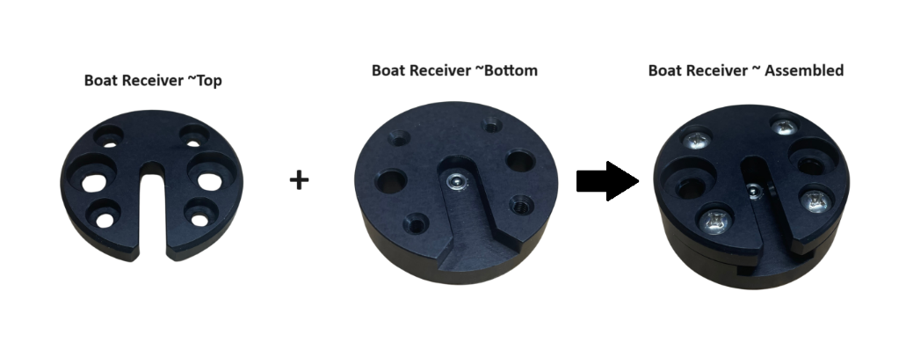

1. Mount the **“boat receiver** **~ assembled”**:
   1. (2) ¼”-20 screws will need to be purchased from your local hardware store
   2. Use the (2) mounting holes located on the **“boat receiver ~ assembled”** to attach to your desired mounting surface using the (2) ¼”-20 screws that was purchased in step 2a.

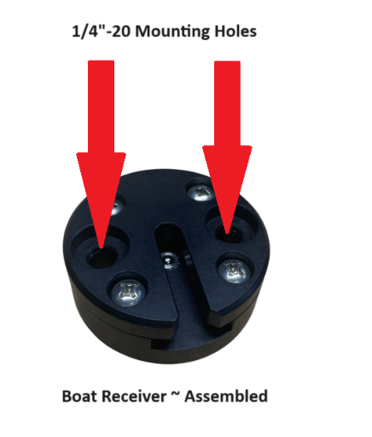

1. Attach the **“net bracket ~ top”** to the **“net bracket ~ bottom”** using the (2) 10-24 x 2-1/4” thumb screws & (2) 10-24 washers.
   1. If the thumbs screws are too long in length:
      1. Install 10-24 washers to build the gap
      2. Cut the excess length using bolt cutters; use with caution
   2. If the thumb screws are too short in length, you can purchase 10-24 thread diameter flat head screw from your local hardware store.

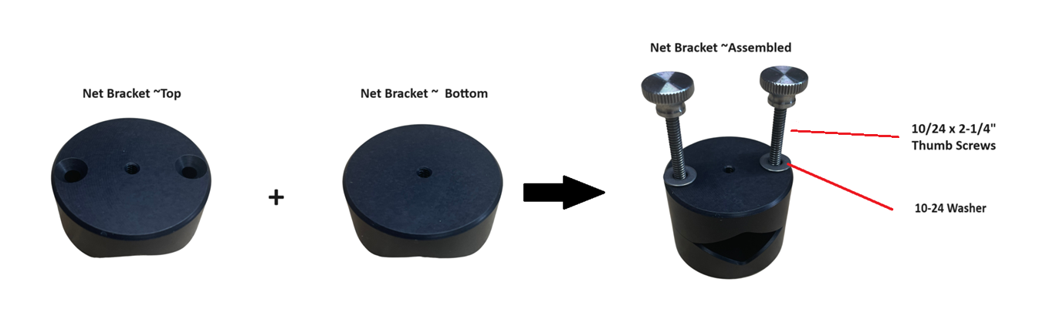4. Screw the 10-24 x 1/4” shoulder bolt to the **“net bracket ~ bottom”**; *1/8” Allen wrench needed*

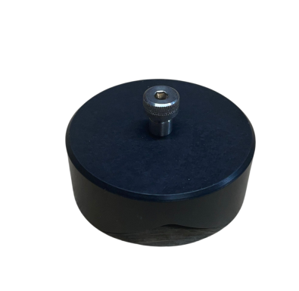

1. Pin Kit (optional)
   1. The (2) 10-24 x 2-1/4” thumb screws & (2) 10-24 washers will no longer be needed.
   2. Attach the **“net bracket ~ top”** to the **“net bracket ~ bottom”** using the (2) 10-24 x 2-1/4” flat head screws; *Phillips screwdriver needed*.
   3. Screw the 10-24 x 1/4” shoulder bolt to the **“net bracket ~ top”**; *1/8” Allen wrench needed*

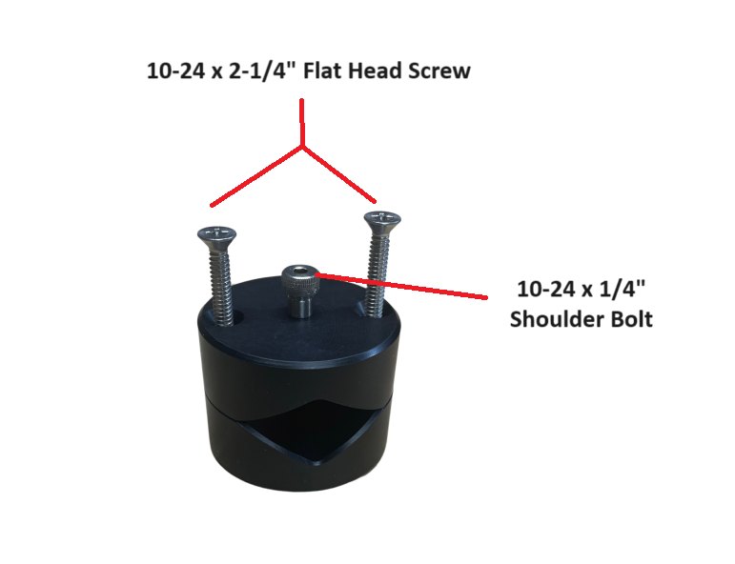

1. You’re all set and good luck on your fishing adventure/s.