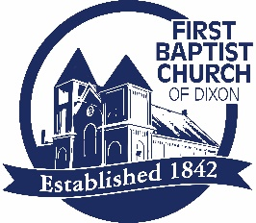
FIRST BAPTIST CHURCH
SCHOLARSHIP APPLICATION

Instruct a wise man and he will be wiser still; teach a righteous man and he will add to his learning. Prov. 9:9

Name: ___________________________________ Date: ___________

Scholarship applicants do not need to be members of the church but must have established a relationship with the church, through worship attendance and other church related activities, at least six months prior to the application deadline. The scholarship will be awarded biannually at the October and January quarterly business meetings.

- Where are you attending school and what is your intended major, or career choice?

- What classes are you enrolled in, and how many credit hours are you taking?

- Please explain how your Christian faith will be enhanced through your studies.

