University Chiropractic and Wellness

PERSONAL HISTORY
DATE: __________________
NAME: ____________________________________________ SOCIAL SECURITY #:____________________________
ADDRESS: ____________________________________________________________________________________________
CITY: __________________________________________ STATE: ___________ ZIP:_____________________________
BEST PHONE NUMBER TO REACH YOU: _______________________________ TXT REMINDER? Y / N
E-MAIL ADDRESS: ___________________________________________________________________________________
BIRTHDATE (MM/DD/YYYY):______________ AGE: _______ SEX: ______ HEIGHT/WEIGHT: _______
NAME OF EMPLOYER: ________________________ TYPE OF WORK: __________________________________
NAME OF INSURANCE COMPANY: ________________________ MARITAL STATUS: __________________
NAME OF SPOUSE: ___________________________ SPOUSE’S EMPLOYER: _____________________________
EMERGENCY CONTACT NAME: ____________________ EMERGENCY CONTACT PH. #: _____________
WHO IS RESPONSIBLE FOR YOUR BILL?
___ INSURANCE ___ AUTO INSURANCE ___ OTHER
___ WORKER’S COMPENSATION ___ SELF
PAST HEALTH HISTORY
PLEASE CHECK AND/OR DESCRIBE THE FOLLOWING (IF APPLICABLE):
OPERATIONS (SPINAL OR JOINT): _________________________________________________________________
_________________________________________________________________________________________________________
ACCIDENTS OR FALLS: ______________________________________________________________________________
_________________________________________________________________________________________________________
HABITS: Sleep (hours) ____ Exercise (days per week) _____ Caffeine (days per week) _____
Alcohol (days per week) ____ Tobacco (days per week) _____
CURRENT MEDICATIONS (PLEASE DESCRIBE IF APPLICABLE): _______________________________
_________________________________________________________________________________________________________
ARE YOU PREGNANT? Y/N IF YES, HOW FAR ALONG ARE YOU? __________________________
DO YOU UNDERSTAND THAT CHIROPRACTIC IS A DRUGLESS, NON-SURGICAL FORM OF HEALTH CARE? Y/N
University Chiropractic and Wellness

CURRENT HEALTH CONDITION
PURPOSE OF THIS APPOINTMENT: ________________________________________________________________
_________________________________________________________________________________________________________
ARE YOU TAKING MEDICATION FOR THIS CONDITION (EX: PAIN KILLERS)? Y/N
HAVE YOU SEEN ANOTHER DOCTOR FOR THIS CONDITION? Y/N
- IF YES, WHO? _________________ RESULTS: _______________________________________________
WHEN DID THIS CONDITION BEGIN? ______________ IS THIS AN ONGOING PROBLEM? Y/N
IS THE CONDITION…. ____ JOB-RELATED ____ FROM AN AUTO ACCIDENT
DATE OF ACCIDENT (IF APPLICABLE): __________

Please circle all of the following symptoms/conditions you have now.
Please underline all of the following symptoms/conditions you have had previously.
Headaches  Neck pain and/or stiffness  Fainting/dizziness  Pins/needles in arms/hands/fingers  Numbness in arms/hands/fingers  Pain in arms/hands fingers  Back pain  Pins/needles in legs/feet/toes  Numbness in legs/feet/toes  Pain in legs/feet/toes  Chest pain/previous heart attack  High blood pressure  Pain between shoulder blades | Asthma  Frequent colds  Sinus trouble  Loss of sleep  Weight Loss  Difficulty breathing  Stomach pain  Joint swelling  Constipation or diarrhea  Faulty Posture  Spinal curvature  Epilepsy  Cancer

University Chiropractic and Wellness

PAIN QUESTIONNAIRE
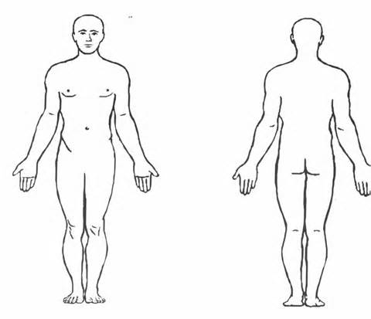
What is your current pain level? ___/10
What is your pain level at its best? ___/10
What is your pain level at its worst? ___/10
How much of the day do you have pain?
___ 25% ___ 50% ___ 75% ___ 100%
How many days of the week do you have pain?
____________
What types of activities aggravate your symptom(s)?
_____________________________________________________________
_____________________________________________________________
What types of activities improve your symptom(s)?
_____________________________________________________________
Mark on the above figure where your pain is located.
_____________________________________________________________
Any additional comments:
__________________________________________________________________________________________________________________________________________________________________________________________________________________

Signature: ________________________________________ Date: _____________________________________________

University Chiropractic and Wellness

ACKNOWLEDGEMENT OF RECEIPT OF NOTICE OF PRIVACY PRACTICES

This notice is effective as of _____/_______/______
HIPPA
I have read the Notice of Privacy Practices and understand my rights contained in the notice.
By way of my signature, I provide University Chiropractic and Wellness with my authorization and consent to use and disclose my protected health care information with the purpose of treatment, payment, and health care operations as described in the Notice of Privacy Practices.
VIDEO SURVEILLANCE
The waiting room of our office is equipped with one video camera for safety purposes. We store these recordings in electronic format for 7-10 days but we do not make or keep videotapes of these recordings. The waiting room is the only room with video surveillance.
By way of my signature, I acknowledge the use of video surveillance.

_________________________________ _________________________
Patient name Date

_________________________________ _________________________
Patient signature Date

_________________________________ _________________________
Authorized Signature of Witness Date
for Facility
University Chiropractic and Wellness

University Chiropractic and Wellness offers a “free first visit” that includes the following:
- Consultation with the doctor
- Exam with the doctor consisting of palpatory and range of motion testing
- One set of X-rays (if needed)
- Fifteen minute massage with a licensed massage therapist
If the doctor feels that you could benefit from chiropractic treatment, most insurance companies cover further exams, X-rays, and treatment. We will need to make a copy of your insurance card so that our insurance specialist can verify your chiropractic coverage.

By signing this, I understand the “free first visit” offer. I also understand that if I receive more treatment than what is listed under the "free first visit" then I waive the free visit.

____________________________________ ____________________
Patient name Date

____________________________________
Patient signature

***Due to federal guidelines, Medicare/Medicaid/Workman’s Compensation restrictions, this free offer is not available to these participants.***

