Beverages  San Pelligrino 3.25  Sparkling bottled water from Italy  Arizona Drinks .99  Canned green tea, grapeade, lemonade, orangeade  Bottled & Canned Drinks 2.99  100% vegetable, fusion energy pomegranate blueberry, fusion energy orange pineapple, Bob Marley’s black or green tea  IceD Tea 2.25  Regular black tea, mango, apricot, or peach  Herbal Tisane (Tea) 2.25  Chamomile, raspberry, lavender lemonade  Fruit Water 2.25  Water infused with fruit of the day  Coffee 2.50  Regular, vanilla spice, orange spice, chicory  French Hot Chocolate 3.50  Thick, rich hot chocolate made with 60-80% cacao  Chai Iced Latte 3.50  Assam black tea with milk, honey, and spices  COOL Stuff  ICE CREAM OF THE DAY 2.75  Scoop of all natural, delicious, cool rich ice cream made fresh  Paleta of the Day 2.95  Ice pops made with fresh fruit  Orange Pineapple Smoothie 3.25  Orange juice, pineapple chunks, milk  Snow Cone 2.75  Shaved ice and natural fruit juice or syrup  Sides  Queso Blanco Dip 4.75  Creamy queso of white cheeses, peppers, and tomatoes  Garden Salad 4.99  Mixed greens with tomatoes, cucumbers, red onion  & dressing served with multi-seed bread  Mexican-style salsa 4.99  Traditional salsa of tomatoes, peppers, onions, cilantro served with tortilla chips  Lobster Grapefruit Salad 9.75  Salad greens topped with lobster pieces, grapefruit  wedges, and avocado slices  Deviled Eggs of the Day 4.75  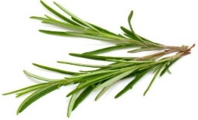  2 deviled eggs |  |  |  |  |  | 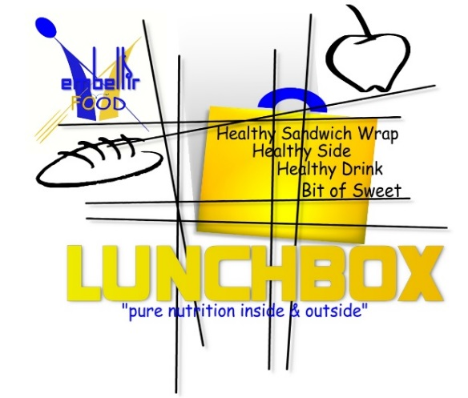  pepper bistro  French Inspired | World Infused  LUNCH MENU  (déjeuner menu)  TO PLACE LUNCH ORDER  For Pickup, Delivery, or Dine In  901.687.3310  lebistropepper.com  Relax, it’s Pepper!  A Healthier Fare  359 Main Street  Gallaway TN 38036  pepper@lebistropepper.com  lebistropepper.com
Wrap  Delightful Veggie 9  Carrots, celery, veggies, and herbs in a light cream cheese sauce in a flour tortilla  Spinach salad 9  Baby spinach, egg, mushrooms, beef bacon, and mozzarella with fresh red wine dressing in a flour tortilla  SPICY Tuna 9  Sweet, spicy tuna with carrots, tomatoes, lettuce, fresh basil with a creamy Italian dressing in a tomato tortilla  Seasoned Catch 15  An Indian spice seasoned grilled halibut or cod with green cabbage slaw with a touch of cilantro, flour tortilla  Roasted Red pepper chicken 10  Roasted chicken breast with roasted red peppers, tomatoes, herbs, lettuce with a green goddess dressing in a green tortilla  Chicken Finger Wrap 9  Chicken tenders, lettuce, tomato, cheese in a flour tortilla  Zesty Pastrami Italian 12  Shredded beef pastrami with pepperoni, black olives, tomatoes, pepper jack cheese with a zesty Italian dressing in a flour tortilla  Lord Forgive Me French Wrap 10  A distressing filling of French fries, meat, cheese, sauce, and salad greens are enclosed in a flour tortilla.  (each wrap comes with gourmet potato chips)  Hearty  Classic Buffalo Wings 9.75  6 hot wings served with ranch or blue cheese dressing and celery sticks  French Bistro burger 10  Grass-fed beef on a brioche bun with caramelized onions with Roquefort cheese aioli  Classic burger 9  Sesame seed bun of grass-fed beef, classic trimmings  of lettuce, tomato, cheddar cheese, pickles, sauce  Lobster Roll (fridays Only) 16.50  Lobster tail chunks in a split top toasted bun with  tarragon and chive aioli  Salmon Terrine (fridays Only) 12  Layers of ingredients, such as meat, fish, herbs, eggs, veggies, or fruit.  Crab meat baked potato 11.50  Large russet potato topped with fresh crab in a cream sauce  (burgers served with gourmet chips or duck fries) |  |  |  |  | CLASSIC QUICHE  Loaded cheeseY spinach 9  Loads of spinach with Swiss cheese  MexicAN Beef 10  Sautéed beef with Swiss and cheddar cheeses  (quiche served with house salad or gourmet chips)  SOUP  Loaded POTato 4.99  Traditional loaded potato soup with all the trimmings  Tomato Basil 4.99  Traditional loaded potato soup with all the trimmings  Chicken Cordon Bleu 5.75  A French specialty of chicken, veggies, and cheese  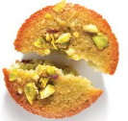  dessert  Pecan financiers 1.75  A rich two-bite French pastry that melts in your mouth  ricotta orange pound cake 4.25  A warm, moist cake flavored with orange zest  Yogurt Vanilla Panna Cotta 3.50  A cool, creamy mix of Greek yogurt, vanilla, and cream  Layered FRESH Fruit Terrine 4.25  Cool refreshing layers of fresh peaches, blueberries, and raspberries in a gelatin cocoon  Pecan Pie 4.75  A loved tradition of pecans, filling, & flaky crust  Ultimate Rum Cake 4.99  A moist, textured cake infused with Bacardi Black rum  Macaron 1.50  A French meringue cookie  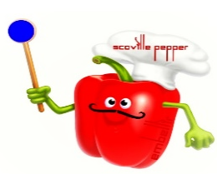  Scoville Pepper KIds  Chicken Fingers 7  3 baked chicken fingers with dressing  Grilled Cheese 7  Gooey cheddar cheese between butter brioche slices  Peanut butter & jelly 5  Peanut butter with private select jelly between slices  Japanese Fruit Sandwich 6.75  Delicious fresh strawberries with pastry creme  Cookie Cheesecake Bites 3.75  Cheesecake and pastry cream with an Oreo bottom  Fresh Fruit Cup 3.75  Mixture of fresh fruit  Chicken Lollipops 7  3 Spicy, soy-marinated chicken wings
