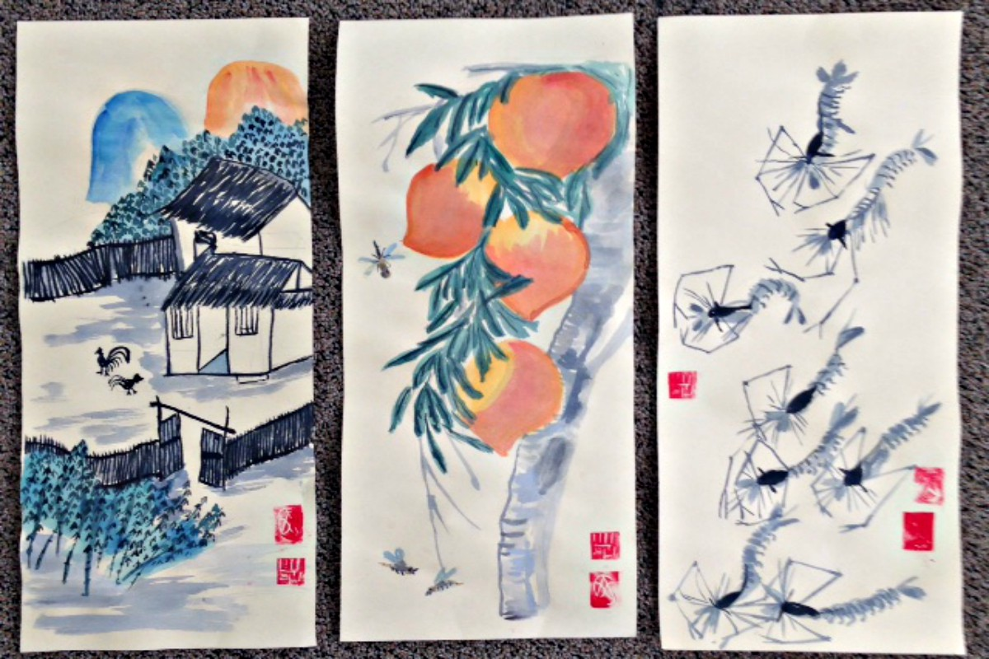  BOWERS MUSEUM  VIRTUAL VISIT AND ART instruction PROJECT  - ANCIENT ARTS OF CHINA  ART AND HISTORY ENRICHMENT CLASS  Students will discover the diverse arts of ancient China, a 5,000-year journey that begins with a single step into our curated collection of works from the Neolithic period to the 19th century. Viewing ceramics, sculpture made at the height of the Silk Road, silk court robes, and carvings, students are immersed in one of the world’s oldest living civilizations.  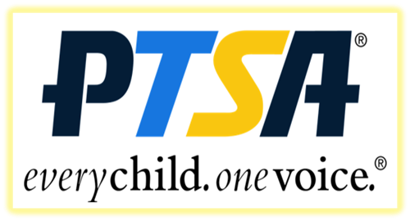 | SOUTH LAKE PTSA FREE ENRICHMENT CLASS FOR YOUR CHILD  Social emotional learning through the arts. Virtual 30 minutes tour with accompanying 60-minute art instruction.  FREE ART KIT  Provided materials: scroll, watercolors, sharpie, chop stamp.  Art education builds confidence and stronger critical thinking skills.  organized by south lake ptsa  LED BY BOWERS MUSEUM DOCENTS  CLASSES WILL BE IN APRIL 2021 DATES AND TIMES TBA

