NIAGARA FRONTIER ANTIQUE & CLASSIC BOATS, INC.
(A Chapter of The Antique & Classic Boat Society, Inc.)

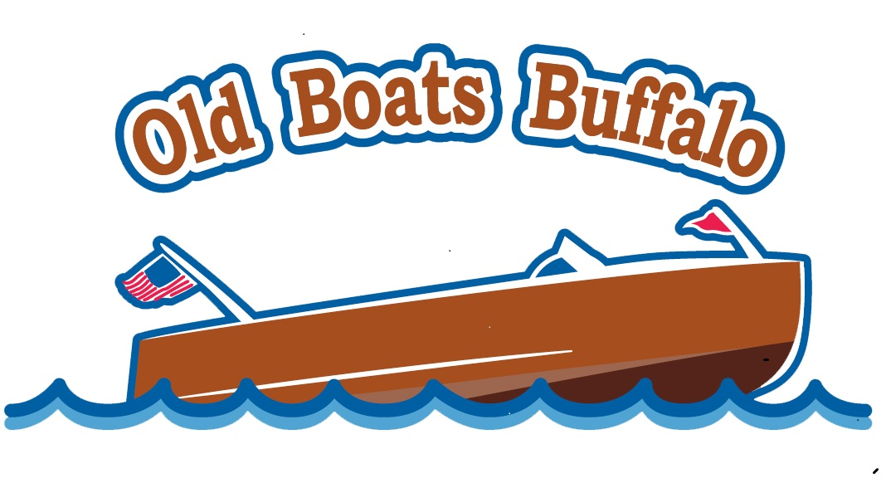

Membership Application

Name _____________________________________________________Date ____________
Address ________________________________________City _______________________
State ________ Zip ________Phone ______________ Email_______________________

Boat(s) Owned: Builder_______________________________ Year _____ Model ___________________ LOA ______ Hull # ____________ Engine Make ___________________ Cyl ______ HP ________
Boat Name _______________________
(List additional boats on separate sheet.)

Annual Dues – (Circle membership option)
ACBS, NFACB $75.00
NFACB $20.00

Amount enclosed $________

Make check payable to: Niagara Frontier Antique & Classic Boats

Mail to: Niagara Frontier Antique & Classic Boats, Inc.
c/o Jennifer Frederick Kelly
600 Northrup Road
Elma, NY 14059

If you have any questions, please feel free to contact Sharon Dickinson at 716-574-0435

