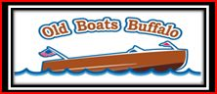
Join us for our Spring Work Shop and Open House
Located in Buffalo Maritime Center
60 Arthur Street, Buffalo, 14207
Saturday, March 28, 2020 9am-1pm
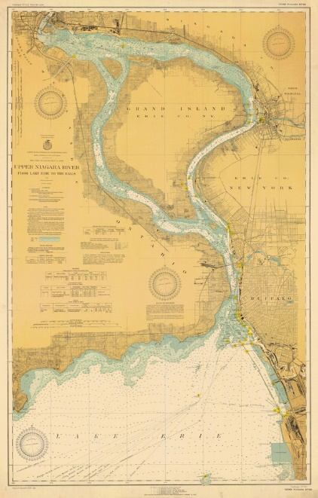
Guest Speaker:
Holger Stave, Canandaigua Coast Guard
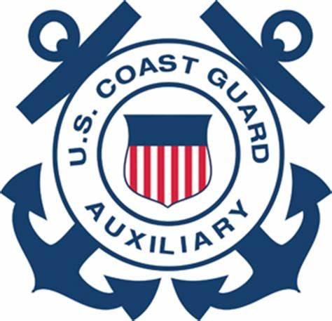“First Mate Safe Return”
And
Navigational Charts,
Navigating Buffalo Harbors, and the Upper Niagara River
PLUS:
Showcasing member boat projects from our own shop:
- Steve Rubach, planking on his 17’ 1963 Century Resorter
- Adam Curcio& Jim Holler, restoration of 17’ 1962 Grady White Hatteras
- Rocky Nagle, strut replacement 1963 Century Coronado
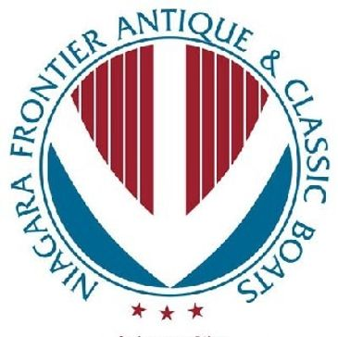
Coffee, donuts, and Lunch provided
$ 10.00 Donation requested @ door

Contact: Margie Marasco 716-866-5756

