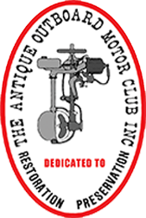
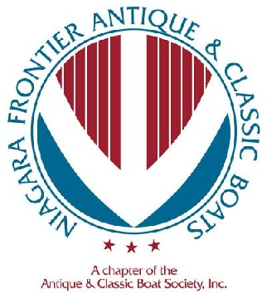
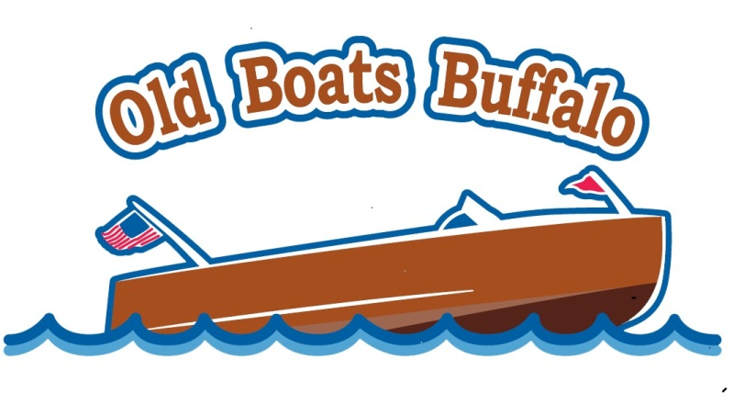
SATURDAY May 2nd, 2020 8am-3pm
Outboard Motor Show and Swap Meet
Featuring Members Motors for Show and Sale
Presented by the Niagara Frontier Antique and Classic Boat Chapter of Antique and Classic Boats, along with the Finger Lakes Chapter of the Antique Outboard Motor Club, Walt Chute, President.

Located in the NFACB workshop at the Buffalo Maritime Center
90 Arthur St., Buffalo, NY 14207
$10.00 Donation Includes: Donuts, Coffee and a Pizza lunch
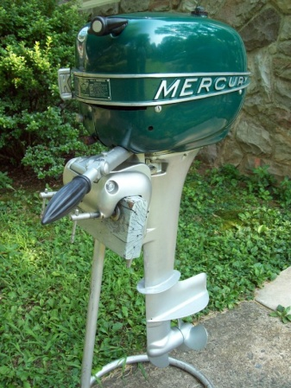
* 50/50 Raffle **Motor Auctions
BRING your boating accessories, parts & motors for sale-
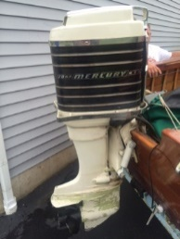
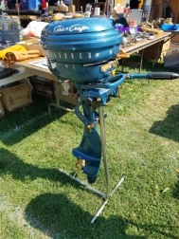

Contact:
Jim Barrick – (716) 909-9463 – jamesbarrick61@gmail.com
Walt Chute – (716) 238-0463 – menderman1947@yahoo.com

