Love Is In The Air

Men Are Everywhere
Love is in the air and men are everywhere
Fat ones, tall one, rich ones, bald ones
Poor ones, small ones,
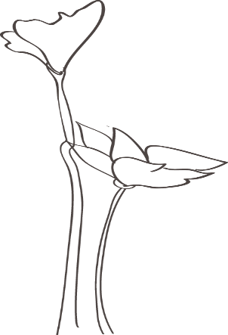
Everywhere, Everywhere
Men are everywhere, and love is in the air
This one, that one, having fun, on the run, Eating, sleeping, reading, meeting, Greeting, teaching, everywhere, everywhere,
Men are everywhere and love is in the air
Working, shirking, making, taking,
Living, giving, sitting, hitting,
Loving, sharing, everywhere, everywhere
Men are everywhere and love is in the air
At home, in the store, on the job, wanting more
Stealing, wheeling, weeping, killing,
Whistling, crying, everywhere, everywhere
Men are everywhere, while love is in the air
Over here, over there, around the corner
But who cares, there lonely, frustrated,
Hungry, sedated, in church, in jail,
So much to give, so much to tell,
Searching for heaven, while living in hell,
Looking for the woman - he can’t fail
Yes men are everywhere, everywhere,
and love is in the air
But a real man won’t be found - until God and you are there.
© 2008 Kathy A. E. Jones

