Special Needs, Disability, and Medical Conditions in a Disaster

- Know that an emergency may worsen medical or mental health conditions. Make talking about preparedness and what you’ll do in an emergency part of what you discuss with your physician or therapist. This is part of healthcare.

- Make sure you’re signed up for receiving emergency alerts, and that regardless of the time of day or disability, you are still able to receive emergency notifications in a timely way. Your city or county likely has alerts you can sign up for. Make sure you can hear them even at night.

- It may take you longer to evacuate, and you will want to know as soon as you can what’s happening and what you need to do. Since health conditions and disabilities may make your evacuation slower, be prepared and go early. If you’re worried, leave an area ahead of everyone, before an official notification, that’s okay too. No need to wait for the official notification.

- Get in the habit of refilling all needed prescriptions early. In a major disaster, it may be hard to refill prescriptions. Try and always have at least a 1 week’s supply. For some medications, sudden discontinuation can be a health issue in itself. You can refill early so there are always some extra, or ask your doctor for extra for your emergency supplies.

- In an evacuation-type emergency, there’s a chance that you and a family member might get separated in the chaos. Think about putting some kind of ID onto clothing or backpacks so that if a person is injured, or can’t speak, everyone can be more easily reunited. An indelible marker in the glove compartment can be useful, but you can also do it ahead of time.

- Many communities aren’t close, but sometimes it’s useful to tell trusted neighbors about a disability so they can be of help in an emergency. For example, you might need extra help if you have a movement disability. If they know you are hearing impaired, a good neighbor might notify you of something going on that you might not be able to hear. A neighbor might be able to evacuate with you if you are sight impaired, or have a family member who is frail.

- If you are hearing or sight impaired, make sure that you are still able to receive emergency messages in a timely way. If you aren’t sure, ask your city officials such as police what the notification plan is for those with hearing or vision impairment.

- If it’s an evacuation-type disaster, and you can’t, immediately call 911 and let them know you can’t evacuate, tell them the reason and your address.

- If you’re unable to evacuate, you can have a ready-made sign that you put in the window that says, “HELP” so that first responders going door-to-door see it.

- If you can be heard, you can be found. Think about getting an emergency whistle. Many are small and fit on a keychain or around a doorknob. It’s sounds that can help alert search and rescue to where you might be.

- Tell the first emergency responders that you see about the special or additional needs, or medical situation. There might be one shelter that is better than another.

- Have information about the diagnoses and medical needs on hand so that if you require treatment by someone unfamiliar with the situation, they have some idea of the past and present medical issues. You can write that down and take a cell phone photo of it to show those who are there to help you. You can put it on a wallet-sized card.

- You or your loved one may not wear a medical bracelet on a regular base, but consider one during an emergency that includes vital information. Examples of vital information: name, if the person is non-verbal, has cognitive issues, the clinic or hospital in which they normally get their care, medical number, list of conditions or medications, and contact information. If there are important food or medication allergies, that should be known to everyone too.

- One option for ID bracelets: https://www.roadid.com 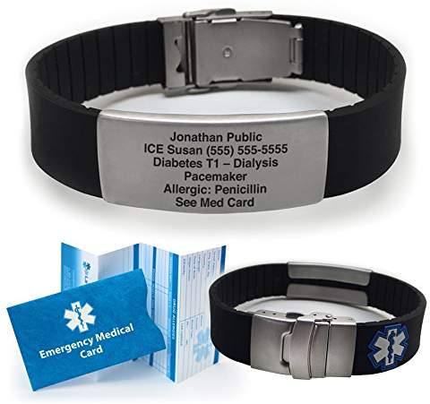

- If the disaster requires you to shelter in place, have emergency supplies of water and food. An adult needs about 2000 calories a day. Water is essential, as you’ll use it not only to stay hydrated, but might be using it to clean scrapes, wounds, and cutting down on the passage of infections.

- If there is something very important to the person with the disability that would comfort them, try and evacuate with that thing, this could be photos, a blanket, a toy, etc.

- If assistive devices are in use, try and keep those with you in an emergency. This can be hearing aids, walker, iPad, assistive language support, cane, wheelchair, support dog, etc.

- In an emergency, it may feel more secure to stay close to the affected area. Slogans after a fire such as “our love is thicker than smoke” are one example of communities pulling together. The long-term effects of molds after a flood, of contaminated water, inhalation of smoke, or exposure to fire retardants are not fully known. So while love and community are powerful, prioritize your current and long-term health.

