SANKOFA WORLD TOURS
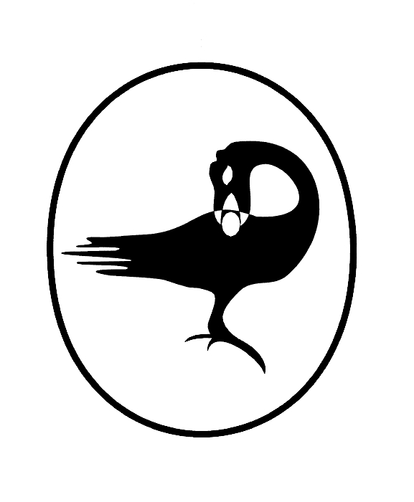

MEMORIABLE MOROCCO TOUR
December 28, 2026, to January 7, 2027

RESERVATION FORM
PLEASE PRINT
Name (as it appears on your passport; no nicknames, please)
Address: Apt. #
City: State: Zip:
Phone No. (Home) - (Work) - (Cell): -
E-Mail Address:
Passport Data page : (For ticketing purposes):
Gender: [ ] Male [ ] Female
[ ] I am a smoker [ ] I am a non-smoker
Meal request on international flights: [ ] Vegetarian [ ] Non-vegetarian
Seating Request (Aisle - Middle - Window) based on availability
REFERRED BY:
$4,695.00 PER PERSON (double occupancy)
$ 795.00 (single supplement)
$ 5490.00 (single occupancy)
$3,995.00 child (age 2-11 sharing with 2 adults)

Please check one:
[ ] I am reserving double occupancy (roommate).
[ ] I am reserving single occupancy (no roommate). ADD $795.00 as the required SINGLE SUPPLEMENT.
[ ] I am reserving child occupancy (age 2 – 11 sharing with 2 adults)

NOTE: YOU MUST OPT FOR THE SINGLE RATE IF NO ROOMMATE IS AVAILABLE OR IF YOUR ROOMMATE CANCELS.

[ ] ENCLOSED IS MY (NON-REFUNDABLE) DEPOSIT OF $300.00 PER PERSON.
Travel Insurance (optional) is strongly recommended.

ALL PAYMENTS (VIA CHECK OR MONEY ORDER) MUST BE MADE TO:
SANKOFA WORLD TOURS. (Please do not mail cash)
MAIL TO: SANKOFA WORLD TOURS, P.O. Box 473592, Brooklyn, NY 11247
1. | Feb 28,2026 | $300.00
2. | March 30, 2026 | $488.33
3. | April 30, 2026 | $488.33
4. | May 30, 2026 | $488.33
5. | June 30, 2026 | $488.33
6. | July 30, 2026 | $488.33
7. | August 30, 2026 | $488.33
8 | Sept 30, 2026 | $488.33
9 | October 30, 2026 | $488.33
10 | November 15, 2026 Final pymt | $488.33

A COMPLETED RESERVATION FORM, DEPOSIT, A COPY OF THE DATA PAGE OF YOUR PASSPORT (for ticketing purposes) are Required
Passport must be valid for 6 months from date of the end of the tour.

.

