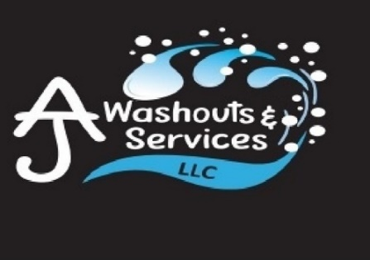

AJ Washouts & Services LLC
Trailer Washouts
Dry Van Trailer
Reefer Van Trailer
Dump Trailers
The Food Safety Modernization Act (FSMA),
published in 2011, is the most sweeping reform of US food safety laws in more than 70 years. The aim of FSMA is to prevent food safety problems rather than reacting to them. The FSMA contains 7 foundational rules, including the Sanitary Transportation of Human and Animal Foods, known as the STF Rule. The goal of the STF rule is to prevent practices that create food safety risks during transportation. If you are a shipper, receiver, loader, or carrier of food products for human or animal consumption, then the STF rule most likely applies to you.
Hours of Operation: 8am-5pm Monday through Friday
Saturday 8am-12pm

(920) 912-5242
ajwashoutsandservices.com
N4560 State Road 57
Plymouth, WI 53073

Cost of washouts START at $42.00 plus tax (based on degree of contamination)
Located: 2 miles south Cty Rd PP on State Road 57, just north of Highway U.
Veteran Owned and Operated
This Photo by Unknown Author is licensed under CC BY-NC
This Photo by Unknown Author is licensed under CC BY-NC

