12 Oaks Annual HOA Board Meeting Minutes
(July 21, 2025)

Attendance
Kenny Stout
Mike O’Neill-Absent due to work commitment
Steve Puccini
James Hamilton
Jack Catlin
Mike Kaufman
Raymon Whittington
Alicia Anderson
Feotis Gilbert II

Agenda items

Opening and Welcome: 6.59
Vice president Steve Puccini opened the meeting and welcomed residents in attendance

Finance Update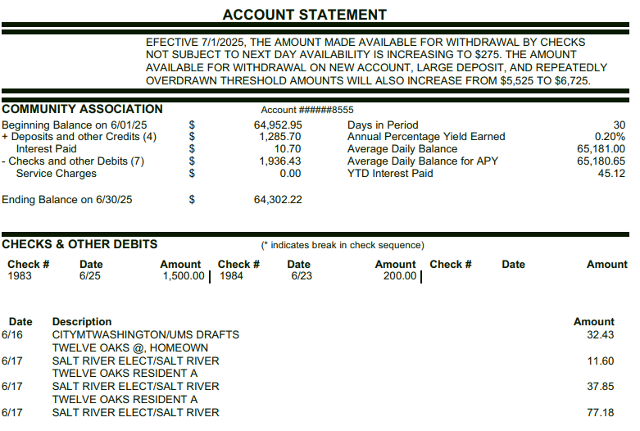

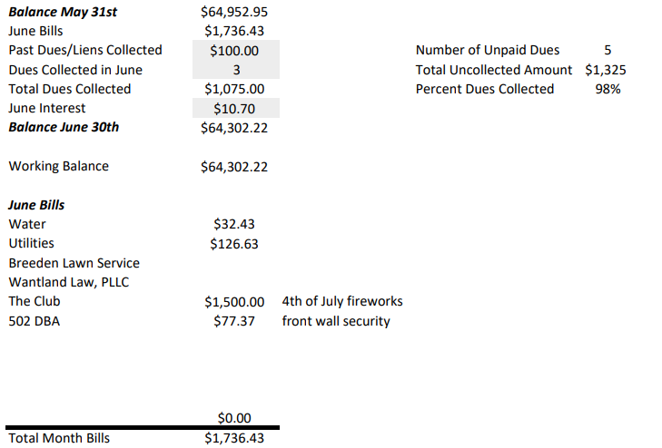
Agenda Items
Uncollected Dues Update and plan
- Delinquent Dues: Multiple homes have been provided multiple letters from TORA and Lawyer. Those that are/were still delinquent have had invoices sent from Watland and/or liens placed on their homes.

Web Site Access plan-Resolved

Complaints since the last meeting-None

Discussion on Neighborhood Dog Leash Challenges-Jack shared the importance of Dog Leash ordinance.

Follow up -Playground Update
- Jack shared that the playground equipment needs stain. Rusty will check on the warranty and report back.

Software Upgrade for front camera
- Discussion in this issue will be included in the next HOA meeting

Complaints since last meeting
- Parking on lawn-need to determine ordnance
- Realtor signs
Follow up - Landscape Update
- Steve hosted a lengthy discussion on the work that has been done to push our landscape contractor to up their game.
- Some residents felt that more should be done by the landscape contractor
- Board members and residents need to continue roaming the neighborhood to ID area's of need.

Bridge lighting upgrade
- Bridge lighting: lights (8) have been ordered. Anticipated receipt to be in next week or so.

Mailboxes
- Jack to arrange for a sign update on the mailboxes

Vacant Lots
- A discussion was held on the need to ensure all vacant lots are maintained by the Developer.

Street Lights
- The Developer provided information on where he obtained 12 Oaks Light poles. The Board to follow up on the information and replace those that are missing or damaged.
- A discussion was held on the light pole with a light at a 90 degree angle (Willowwood Dr).

Electronic Sign to replace the current front entrance sign
- Feoitis shared a $16,900 quote for the sign.
- Due to budget constraints there was no interest in proceeding

Public Discussion Items
- Residents participated through much of the meeting. We appreciate the candor and desire to maintain our neighborhood.

Previously Discussed Aspirations & Proposed 2025 Projects for funding consideration
  - Aspirations previously discussed
    - Stain for the playground
    - Provide electric power for the Back Entrance
    - Software upgrades for the front wall cameras
    - License plate camera for front wall
    - Electronic sign that provides information on both front and back sides
    - Landscaping for the islands
    - Front Entrance electronic sign – Both sides
    - Repair the back of the Front Entrance sign
    - Additional funds to replace dead landscaping
    - Section 5 Bridge wall
    - Replace light poles
    - Back entrance Power Meter and aesthetics
    - Poles for Neighborhood Watch Signs
    - Speed Bumps

Executive Session: None

