12 Oaks Annual HOA Board Meeting Minutes
(September 18, 2025)

Attendance Yes / No
Kenny Stout Yes/No
Mike O’Neill Yes/No
Steve Puccini Yes/No
James Hamilton Yes/No
Jack Catlin Yes/No
Mike Kaufman Yes/No
Raymon Whittington Yes/No
Alicia Anderson Yes/No Meeting commenced:
Feotis Gilbert II Yes/No
Agenda items

Opening and Welcome

Finance Update
April 2025 Account Statement

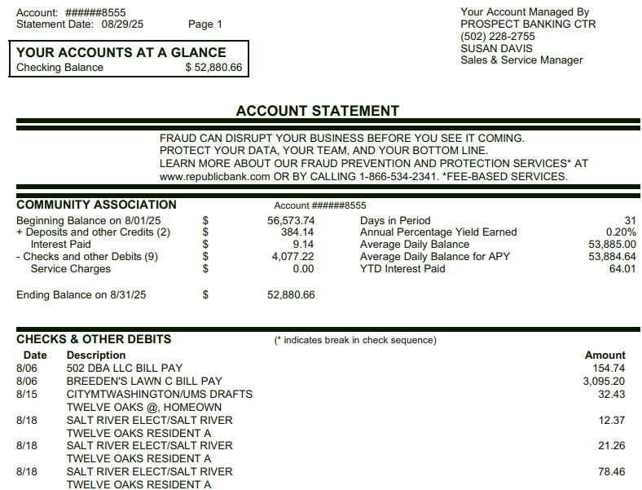

August Budget Summary
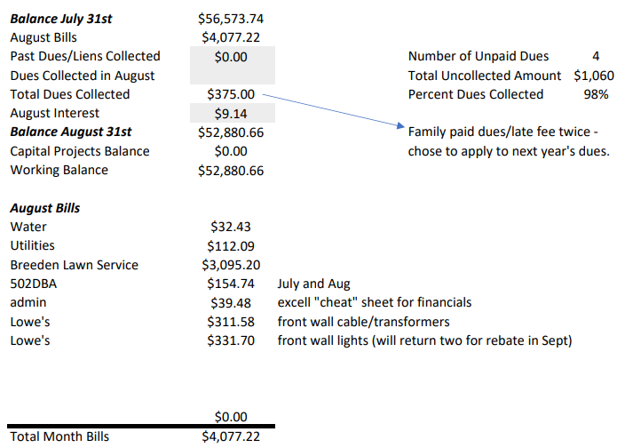

Compare 2024 Actuals to 2025 Actuals
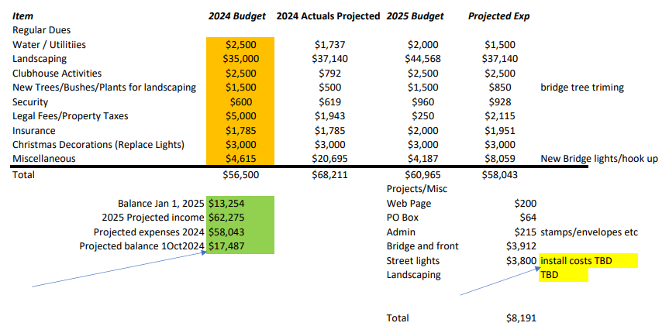

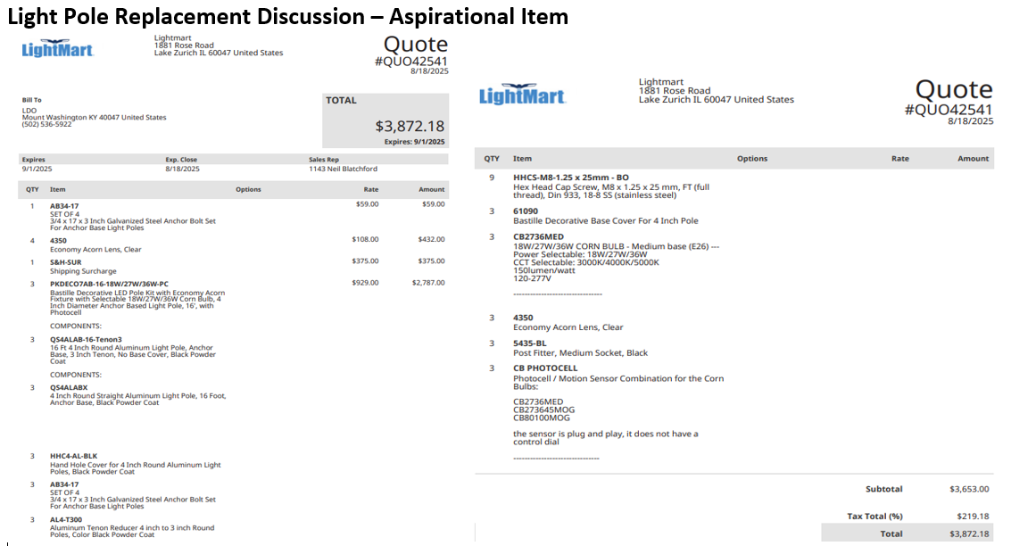
Light Pole discussion
- There are several light poles in our neighborhood that are tilted or missing. We are working with Salt River Electric to determine how to get them repaired/replaced. To have the new ones match, several new poles and associated hardware need to be ordered at a cost of $3872. Once we have more information on repair/replace costs, we’ll need to have a Board vote on the overall expense.

Agenda Items
Uncollected Dues Update and plan
- There are 4 outstanding uncollected dues. Liens have been placed on two of them and one is in the process of being reprocessed.

Facebook Page and HOA Meeting Processes
- The HOA Board recognizes that disagreements will occur and encourages open, respectful discussion by all involved parties. Incendiary, personal and disrespectful communications cross a line that needs to be avoided. The HOA Board requests that all parties express their opinions in a respectful manner.

Landscaping Discussion
- The landscaping in our traffic calming islands has suffered since the hard freeze of 2023. Replacing the landscaping in all the islands is prohibitively expensive. The Board is looking to making a transition over several years to utilize river rock in the islands. This will minimize weed growth and helps us stay within our annual budget.

Follow up - Playground Update
- The playground needs to be restained to ensure it weathers the upcoming winter. Work is underway to obtain a quote from the vendor and other interested parties.

Animals (dogs) requirement to keep secured in owners’ property
- The Board requests that dog owners keep their dogs on a leash and follow good etiquette when walking their dogs.
- Mount Washington ordinance 90.15 cover animals running at large and is listed below for reference
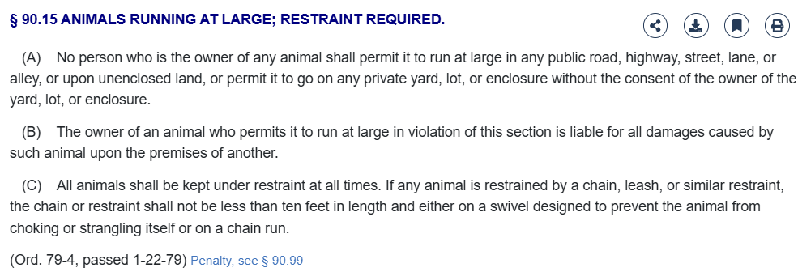

Mailbox Plan
- A community committee headed by Michelle Gilbert will be organizing volunteers to obtain votes on mailbox colors and guidelines.

Public Discussion Items

Previously Discussed Aspirations & Proposed 2025 Projects
  - Aspirations previously discussed
    - Stain for the playground
    - Provide electric power for the Back Entrance
    - Software upgrades for the front wall cameras
    - License plate camera for front wall
    - Electronic sign that provides information on both front and back sides
    - Landscaping for the islands-being addressed over time
    - Front Entrance electronic sign – Both sides
    - Repair the back of the Front Entrance sign
    - Additional funds to replace dead landscaping
    - Section 5 Bridge wall
    - Replace light poles-under review – See above
    - Back entrance Power Meter and aesthetics
    - Poles for Neighborhood Watch Signs
    - Speed Bumps

Executive Session: None

