12 Oaks Annual HOA Board Meeting Minutes
(February 4, 2026)

Attendance
Mike O’Neill, James Hamilton, Jack Catlin, Mike Kaufman Rusty Whittington

Agenda items

Opening and Welcome

Finance Update
TORA Financials
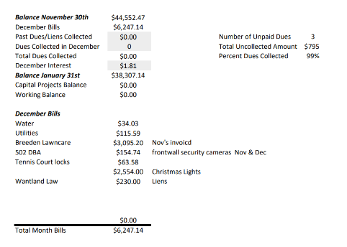
Highlighted during the meeting

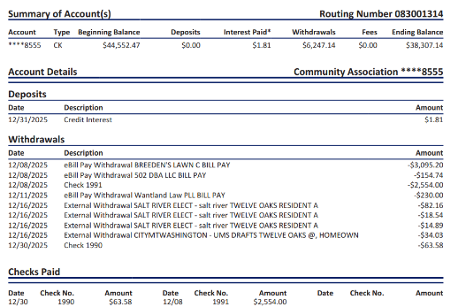

Draft 2026 Budget
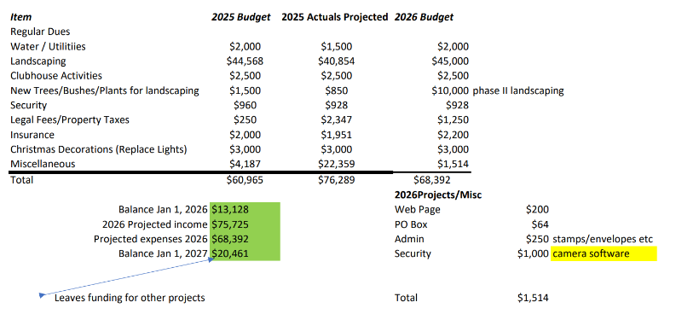

Finance Notes of interest:
- Nationwide Insurance increase of $572 over last year
- December Landscaping Payment Disposition?

2025 Uncollected Dues Update
- There are three homes with unpaid dues. After multiple attempts to collect the 2025 dues, Liens were placed on the three homes.

2026 Dues Letter Update
- 2026 Dues will be due No Later Than March 31st with a $50 late fee beginning April 2nd.
- Mike requested an update to the front entrance sign to encourage early HOA dues payments.

Preparation for Annual Meeting in March
- Need a current Member who will facilitate the process
- Setting a date for the meeting
- Community awareness

Light Pole Discussion
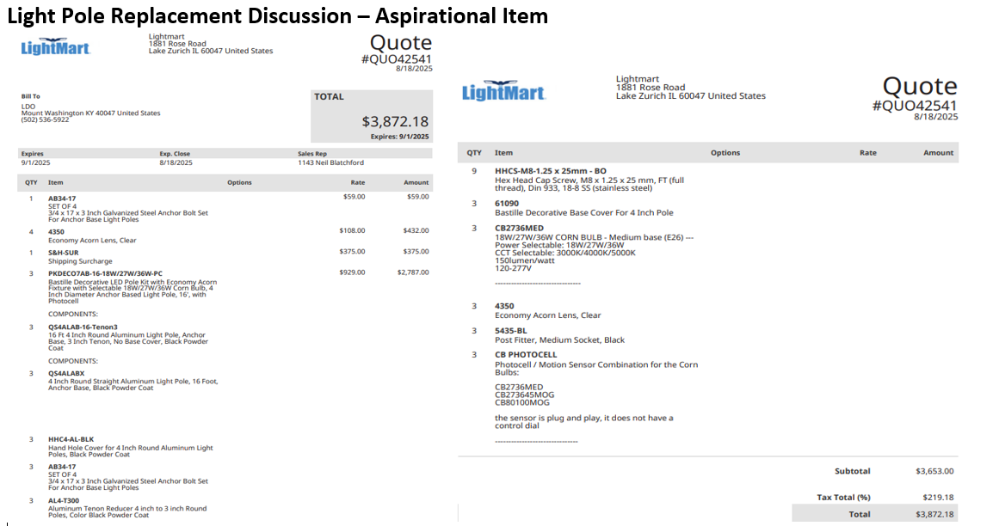

Other Agenda Items

Mailbox Plan
- Status on resident run committee-Michelle Gilbert. (Heather A. volunteered to assist)
- The process will involve ballots from 80% of Twelve Oaks Residents detailing two specific color selections (Twelve Oaks Green & Black). One ballot from each home will be signed and the resulting votes will be tallied. Once the votes are tallied and a community-based decision is made, implementation plans will be created.

Facebook Page and Twelveoaksfyi.com complaint system update
- No recent complaints

Follow up - Playground Update (Stain strategy for Spring)
- The cost of staining needs to be determined.

Public Discussion Items

Previously Discussed Aspirations & Proposed Projects
  - Aspirations previously discussed
    - Light pole repairs/replacements
    - Stain for the playground
    - Provide electric power for the Back Entrance
    - Software upgrades for the front wall cameras
    - License plate camera for front wall
    - Landscaping for the islands
    - Front Entrance electronic sign – Both sides
    - Repair the back of the Front Entrance sign
    - Additional funds to replace dead landscaping
    - Section 5 Bridge wall
    - Replace light poles
    - Back entrance Power Meter and aesthetics
    - Poles for Neighborhood Watch Signs
    - Speed Bumps

