12 Oaks HOA Annual Meeting Minutes
(July 17, 2026)

Attendance
Kenny Stout Yes Mike O’Neill Yes Steve Puccini No
James Hamilton Yes Jack Catlin Yes Mike Kaufman No
Raymon Whittington Yes Alicia Anderson No Feotis Gilbert II No
Agenda items

Finance Update as of May 31st close-HOA Treasurer shared the information below and highlighted the working balance.
TORA Financials
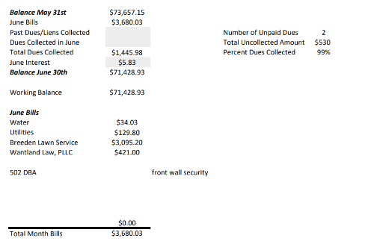
-Landscaping Startup

2026 Dues and New Lots Update

- All 2026 Dues have been collected
  - Liens had to be applied to ensure Dues payments were made
  - There are no 2026 Liens for non-payment of 2026 dues
- 2025 Liens due to non-payment need to be investigated and resolved-HOA President requested details on the 2025 Liens so courtesy reminder letters could be sent to the owners.
- Recently sold lots discussion-There was a discussion of the lot numbers that had been recently sold or where construction had begun. The unverified numbers are 176, 246, 167, and perhaps 194.
June Deposits and Withdraws

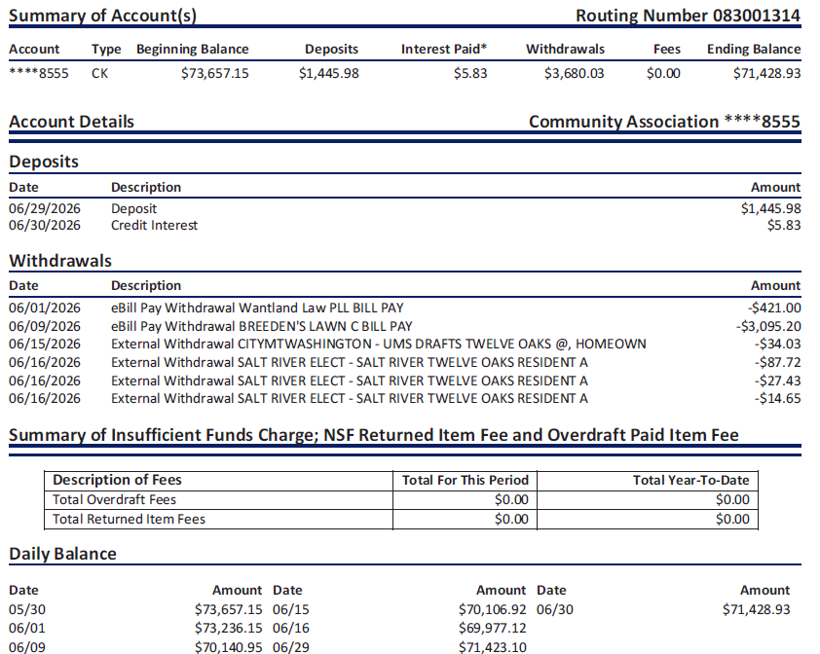

Mailbox Plan & Status
- Status on resident run committee-Michelle Gilbert. (Heather A. volunteered to assist)
- The process will involve ballots from 80% of Twelve Oaks Residents detailing two specific color selections (Twelve Oaks Green or Black). One ballot from each home will be signed and the resulting votes will be tallied. Once the votes are tallied and a community-based decision is made, implementation plans will be created.
- HOA President has transferred the data to Excel and Alicia Anderson has been asked to lead. Mike will share the details for the paint color(s) with Alicia. No current timeline for completion

Follow up - Playground Update
- Discussion on using Facebook to ask for volunteers using a Saturday in to stain the playground and fix some stones on bridges.
- Rusty has a quote for $1,100 to complete the work. Angela O’Neal will be contacting a resource for a second quote

Tennis Courts Maintenance Strategy Discussion

Action Item – Jack and Rocket to get pictures for the board to review
- Plan is to continue research on next steps and costs for tennis court maintenance

Complaints since Last Meeting

- Resident identified a street sign that had broken from the pole-Gary O. Resolved THANK YOU Gary!!!
- Resident expressed concern on the upkeep of a traffic island located at the intersection of Twelve Oaks Drive and Cedar Point Drive-Some weeding was done.
- Resident expressed concern about tall weeds at the corner of Oak Valley Ct and Oak Valley Drive-A discussion with the responsible part was conducted
- Resident expressed concern about noise coming from the tennis court area after 10pm-It is hoped that this was a one-time issue.

Public Discussion Items – None were brought up.

General Maintenance Plan Discussion
- HOA President shared the general plan to separate Landscaping contracts from Mowing contracts
- Plan is to have Feotis or HOA Treasurer’s electrician dig into light pole without a light head and provide costs for a solution.
- Plan is to repair masonry on the bridge wall

Previously Discussed Aspirations & Proposed Projects
  - Aspirations previously discussed
    - Light pole repairs/replacements
    - Stain for the playground
    - Provide electric power for the Back Entrance
    - Software upgrades for the front wall cameras
    - License plate camera for front wall
    - Landscaping for the islands
    - Front Entrance electronic sign – Both sides
    - Repair the back of the Front Entrance sign
    - Additional funds to replace dead landscaping
    - Section 5 Bridge wall
    - Replace light poles
    - Back entrance Power Meter and aesthetics
    - Poles for Neighborhood Watch Signs
    - Speed Bumps

Executive Session was conducted

