12 Oaks Annual HOA Board Meeting Minutes
(November 17, 2025)

Attendance
Kenny Stout Yes/No Mike O’Neill Yes/No Steve Puccini Yes/No
James Hamilton Yes/No Jack Catlin Yes/No Mike Kaufman Yes/No
Raymon Whittington Yes/No Alicia Anderson Yes/No Feotis Gilbert II Yes/No

Meeting commenced:

Agenda items

Opening and Welcome
- Six residents were welcomed to the meeting
Finance Update
- Rocket described, in detail, the account statement and both the 2025 Budget and the Draft 2026 Budget
October Account Statement
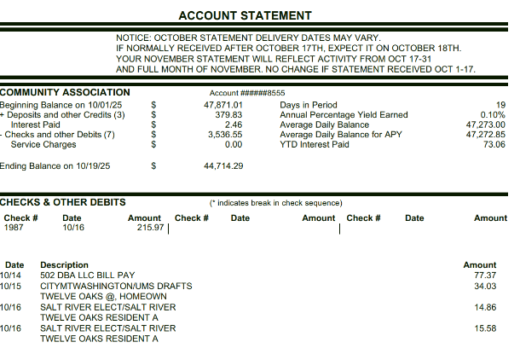
TORA Financials
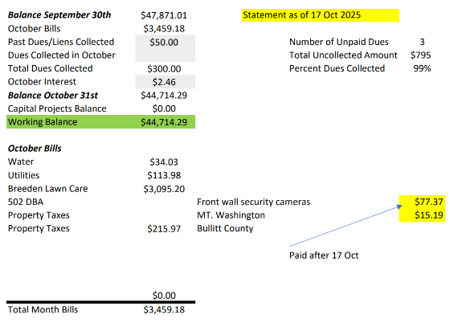
2025 Budget
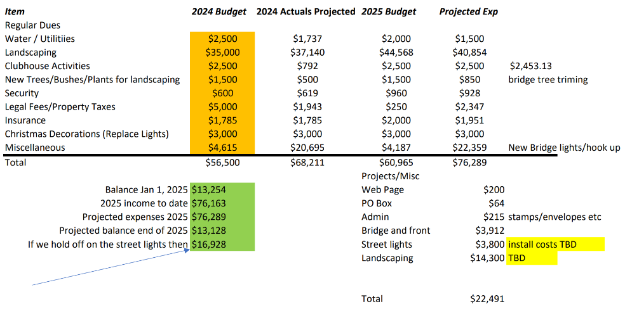

Draft 2026 Budget
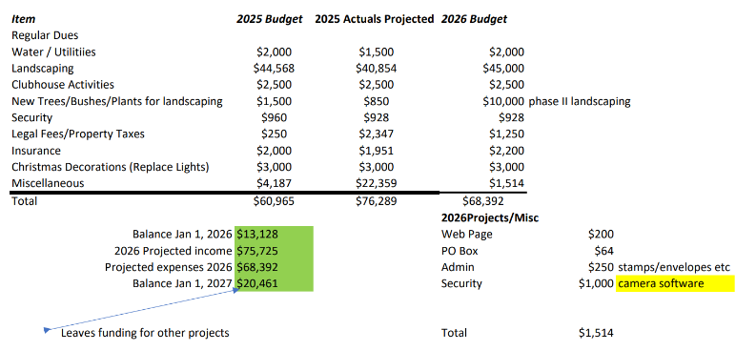

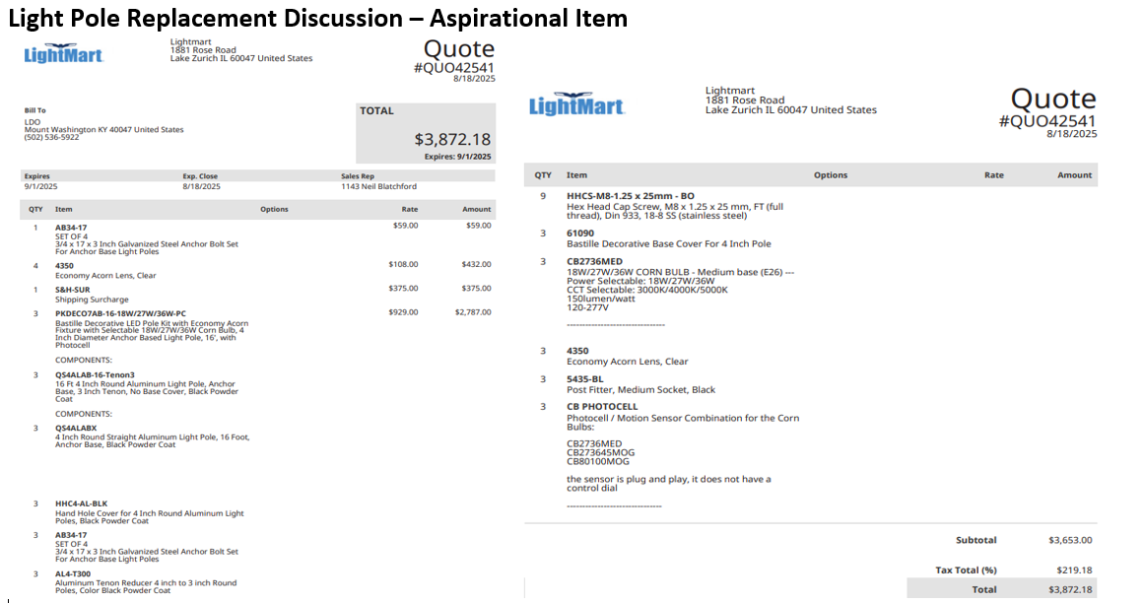

Agenda Items
Uncollected Dues Update
- There are three homes with unpaid dues. After multiple attempts to collect the 2025 dues, Liens were placed on the three homes.
- One of the Liens is on a home that is involved in a reposition process by the bank holding the loan. A portion of the 2025 dues will likely be collected once the bank resells the home.
- There are no planned increases to Dues for 2026.
- 2026 Dues will be due No Later Than March 31st with a $50 late fee beginning April 2nd.

Traffic Speed Discussion
- Traffic speed in Twelve Oaks is a significant issue. The Board and those in attendance discussed the possibility of speed humps. Individuals observing speeders should refer their concerns to the non-emergency number for the Mount Washington Police department.
- In response to a recent referral, an electronic speed tracking sign has been placed near the Clubhouse.

Facebook Page and Twelveoaksfyi.com complaint system
- The Board noted the positive and respectful wording that is being used by those utilizing the Twelve Oaks Facebook page and the Complaint System on Twelveoaksfyi.com.

Landscaping Discussion
- The Board held discussion on landscape strategies that involved a multi-year process of updating limited portions of Twelve Oaks public spaces landscape. There was general agreement of a 3-4 phased approach beginning in the Spring of 2026. The first year cost estimates will need to be firmed up in the next few months.

Follow up - Playground Update (Stain strategy)
- The cost of staining needs to be determined. Rusty to follow up and obtain an estimate.

Animals (dogs) requirement to keep secured in owners’ property
- The Board has received no recent complaints.

Mailbox Plan
- A neighborhood, resident run committee headed by Michelle Gilbert is in the process of forming. The process will involve ballots from 80% of Twelve Oaks Residents detailing two specific color selections (Twelve Oaks Green & Black). One ballot from each home will be signed and the resulting votes will be tallied. Once the votes are tallied and a community-based decision is made, implementation plans will be created.

Public Discussion Items
- Several items were raised by the public
  - Unlicensed youth are driving motorized mopeds have been noted. Residents are encouraged to contact the Mount Washington Police non-emergency number to resolve this type of issue.
  - Trash Can Pickup issues relative to the number of trash cans was raised. Some residents have been told that only one trash can is picked up while others have not experienced issues with the pickup from multiple trash cans
  - Heather A. volunteered to participate in the Mailbox committee
  - Christmas lights will be going up the week after Thanksgiving.
  - The next board meeting will be set up for the second week in January

Previously Discussed Aspirations & Proposed 2025 Projects
  - Aspirations previously discussed
    - Stain for the playground
    - Provide electric power for the Back Entrance
    - Software upgrades for the front wall cameras
    - License plate camera for front wall
    - Electronic sign that provides information on both front and back sides
    - Landscaping for the islands
    - Front Entrance electronic sign – Both sides
    - Repair the back of the Front Entrance sign
    - Additional funds to replace dead landscaping
    - Section 5 Bridge wall
    - Replace light poles
    - Back entrance Power Meter and aesthetics
    - Poles for Neighborhood Watch Signs
    - Speed Bumps

