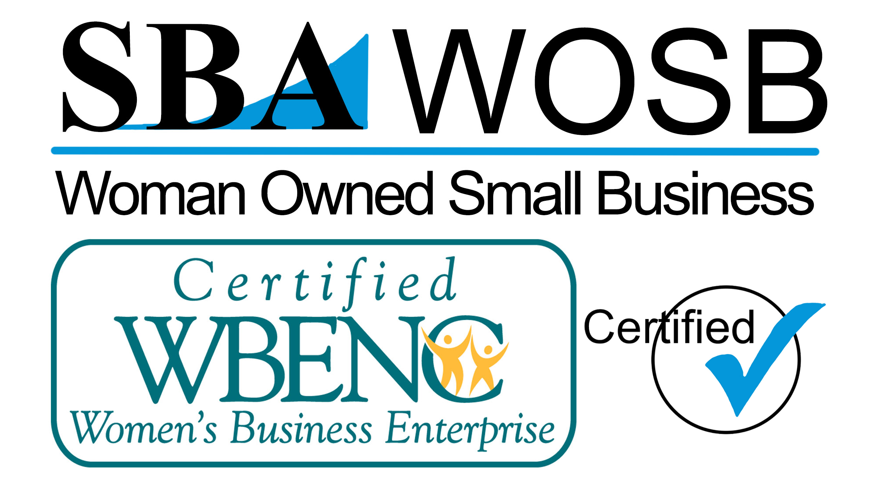

Post Office Box 366
Trenton, Florida 32693
Phone (352) 463-0788
CGC1520396

Employment Addendum
Equipment/Property Policy
Date:
I, Click here to enter text.HAVE BEEN TOLD AND FULLY UNDERSTAND THAT
(PRINT EMPLOYEE NAME)
while any TCB Services., LLC equipment is in the care, custody or control I as the employee have the responsibility to act in a manner not to abuse, misuse, lose or loan out any equipment or property,monies owned by TCB Services, LLC. This also includes rented motel/hotel rooms, apartments, condos, houses, etc. In the unlikely event that any one of above mentioned happens TCB Services LLC., reserve the right to recover losses and damages from the employee through payroll wage deduction in full, 100%.

Click here to enter text. _______________________________
PRINT EMPLOYEE NAME EMPLOYEE SIGNATURE

SIGNATURE WITNESSED BY TCB SERVICES, LLC: _____________________________
TCB SERVICES, LLC

