
For Trip Information, contact Gail L. Hoffman at 215 696 7071 gail849@aol.com

MISSION TRIP COST & FINANCIAL POLICY
I understand that I am responsible for raising and/or paying for 100% of the funds required for the trip. The total trip fee is $3,300. This fee covers airfare, airport transfers, lodging, ground transportation while in Uganda, security guards, breakfast, dinner, bottled water, and on-site trip ministry activities. I am responsible for passport, visa, immunizations, lunch (when available), church offerings, and food/drink expenses while traveling to and from Uganda. These items are not calculated into the total trip cost. I am also responsible for any fees connected to any changes to my air ticket.
Financial donations to the Faith Equals Works, Inc. (F.E.W.) mission team’s accounts are not mine; they belong to God. They have been given to F.E.W. Inc. in order to pay my trip expenses and accomplish the mission work of the ministry.
Trip prices are based on projected cost and could be subject to change up until the departure date, as travel & accommodation prices fluctuate. The trip application deposit of $100 is due as soon as possible and is non-refundable if I am not able to to attend the mission trip.
If, for some reason that I am not able to go on the trip, I understand that monies already donated to my trip cannot be refunded to me or to the donors due to the Non-Profit status of the Organization. We are a 501(c)3 non-profit organization. The funds that I raise will be donated towards the trip mission projects. Airfare reimbursements will follow the Airline policies of ticket reimbursement. We strongly advise that you purchase travel insurance.
Payments can be made in cash, money orders, or checks. All checks or MO donations made in support of my trip must be payable to Faith Equals Works, Inc. Donors should write my name in the memo section of their check.
I will submit $1,200 by October 31, 2024, to ensure the lowest airfare. This will be used to purchase my air ticket. The balance of $2,000 will be due one month before departure. Total cost of the trip is $3,200. You can make partial payments.
I understand that I may not make direct personal donations to any of our Host, Pastors, or any person while traveling in
Uganda. All donations must be cleared by your trip leader and pass through F.E.W. Inc. for documentation) before being distributed.
I have read the above and agree to the above statements, policies, procedures, and financial terms.

(Signature) _______________________________________________________________ (Date) _________________

________________________________________________________________________________________________________
(Witness – F.E.W./UMP Staff)

Mission Trip Application
Name__________________________________________________________________________
(Exactly as it appears on your passport)
Address_________________________________________________________________________
City_____________________________________ State__________________ Zip Code_________
Home Phone______________________________ Cell Phone______________________________
Email____________________________________________________________________________
Occupation______________________________________________________________________
Date of Birth_________________________________ Gender____________Male________Female
Passport #______________________________Issue date/Expiration date__________/_________
(Please attach a copy of your passport with your application.)
In case of emergency, please notify:
Name________________________________________________Relationship____________________
Address_______________________________City___________________State________Zip_______
Home Phone______________________________________Cell Phone_________________________
Email______________________________________________________________________________
Church Affiliation/Membership________________________________________________________
Are you the Pastor? ______Yes ______No If no, Pastor’s name__________________________
Are you an ordained minister? _____Yes _______No
Church Phone Number _______________________________________________________________

Personal Reference

Name______________________________________________________________________________
Relationship______________________________________Phone Number_______________________
How did you hear about our trip?________________________________________________________

Spiritual Information
Are you a Born-Again Believer? _____Yes _____No ____Not sure
Have you been on a Mission Trip before? _____Yes _____No
If yes, please indicate the organization, where, when, and how you were involved.
Tell us a little about why you would like to serve on this mission to Uganda.
What are some ways in which you feel prepared to minister to the people of Uganda? (i.e., prayer, music, praise dance, adult/children’s ministry, teaching, evangelism, preaching, etc.)
What other spiritual gifts, talents, or professional skills do you have that you feel may be useful on this mission trip?

Do you serve in any volunteer leadership role in any Ministry or organization outside the church? If yes, please explain.

Do you work well with large groups, small groups, or both?_____________________________________ Briefly explain what you hope to see the Lord do in and through you on this mission trip.
Are you prepared to commit yourself to the training, conference calls, and several team meetings for this trip? Please explain any life circumstances that may prevent you from fully participating in the team-building trip preparation process.
Are you prepared to work long hours on the mission field? _________Yes ________No
Can you withstand very hot weather? Possibly 85 -90 degrees on most days’ _______Yes ______No
If no, what accommodations do you need?

Are you flexible? _______Yes _______No (i.e., if you are asked to work in another area other than your assigned area of the Ministry, would that create a problem for you)


How do you envision staying connected to the F.E.W., Inc. Ugandan Mission Project after the trip? (Volunteer at events, do related work in your field, consulting, fundraising, mobilizing your community, etc.

Note: Please feel free to use extra paper to finish answers if necessary
Health Status Record

Name: ________________________________________________________________________

Vaccinations Received: Please include a copy of your COVID-19 vaccination record.

Height: ______________________________________ Weight: _______________

Allergies of any kind:

Please answer yes or no to the following:
*Lift or carry 25 lbs to 50 lbs.
*Climb two or more flights of stairs
Stand for 2-hour periods
Sit for long periods
Walk on uneven terrain
Bend and stoop
Sleep on a cot or floor
Work and live with little or no privacy
Tolerate extreme weather conditions
Have you had any of the following conditions in the last 24 months?

____Heart attack/heart disease  ____High Blood Pressure  ____Migraines//Headaches  ____Skin Problems/Lesions  ____Stomach/Intestine/Hernia  ____Urinary Issues  ____Asthma/COPD/Emphysema  ____Uncorrected Vision  ____Hearing Loss/Hearing Aid | ____Weakened Immune System  ____Bleeding Disorders/Treatment  ____Stroke(CVA/TIA)  ____Anxiety/PDS/Bipolar Disorder  ____Neurological Disorders (Seizures)  ____Sleep Disorders  ____Mobility Issues  ____Bone or Joint Issues (Back, Arthritis, etc.)  ____Active Infection ____Other
____Diabetes
Have you had any visits to the ER, hospitalizations, surgeries, or ongoing therapy during the last 12 months?
List all prescription and over-the-counter medications routinely taken.
MEDICATION GENERIC NAME DOSAGE CAUSE
_____________________ _____________________ _____________________ _____________________
_____________________ _____________________ _____________________ _____________________
_____________________ _____________________ _____________________ _____________________
_____________________ _____________________ _____________________ _____________________
_____________________ _____________________ _____________________ _____________________
_____________________ _____________________ _____________________ _____________________
List all medical equipment or assistive devices used (crutches, cane, nebulizer, CPAP, oxygen, braces, wheelchairs, service dogs, etc.)

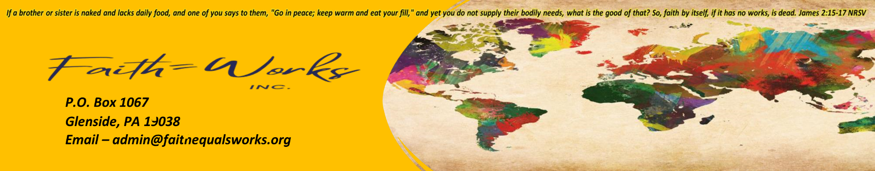
For information, contact Gail L. Hoffman at 215 696-7071 gail849@aol.com

I understand that while health insurance is not required, I will be financially responsible for my health care expenses. We advise you to inform your insurance carrier of this trip.
Applicant Signature: _____________________________________ Date: _______________________________

Regarding your Patient: (Required Upon Request)
After reading the patient information, do you feel this individual is able to endure a trip to Uganda or will have any problems with the mission trip to Uganda?
Doctor's Signature: _______________________________________________________ Date:____________

Printed Name: ___________________________________________________________

Adress: _________________________________________________________________

City: ___________________________________ State:_____________Zip Code_______

Telephone Number: _______________________

For Trip Information, contact Gail L. Hoffman at 215 696-7071 gail849@aol.com

LIABILITY RELEASE/ CONSENT FOR TREATMENT
As with any mission endeavor of this type that includes travel, both inside and outside the USA, I realize there are certain risks involved. I have considered the cost, sought God’s direction, and am fully persuaded that God has called me to be part of this TEAM. In signing this form, I ___________________________________, agree not to hold Faith Equals Works, Inc., their officers, employees, or volunteer assistants liable for any accident, illness, death, loss, or property damage that I might encounter while on a mission trip to Uganda.

Signature:_____________________________________________________ Date __________________
- I take full responsibility for my own health, safety, and well-being, medical/dental insurance, and prescription drug costs that I might incur.
- I, _________________________________, being of legal age, authorize a representative of the F.E.W. Inc. to act on my behalf should I be unable to do so and to consent to reasonable medical/dental care and treatment, including but not limited to diagnostic tests, x-rays, anesthesia, surgery or other procedures which may be deemed necessary for my medical well-being for the duration of the trip.
- This consent is given in advance of any specific diagnosis, treatment, surgery, or hospital care is required. Still, it is given to provide authorization and specific consent for medical/dental treatment on my behalf.
- Any consent by F.E.W., Inc. or their authorized agents shall have the same force and effect as if I had personally given the consent. Such authorized agents shall act as “in loco parentis” for the duration of the mission trip.
I am aware that serious illness requiring return by air transportation could cost more than $10,000. I agree that I am solely responsible for any expense that may arise from my return by air ambulance or other extraordinary means that is not covered by travel insurance.
NOTARY REQUIRED:
On this ______day of _______________, 20____, before me personally appeared
______________________________to be the person who executed the above release and consent form and acknowledged before me that he/she voluntarily executed the same.
Notary Public:
My commission expires: ___________________________________________________

We are thrilled that you are prayerfully considering going on the mission trip with us to Uganda. We are joining you in prayer that God would work in you and through you during our ministry time as a TEAM.
Please return the entire completed application as soon as possible with a copy of your passport and a non-refundable deposit of $100, made out to Faith Equals Works, Inc. Note: Passport must be valid thru 6 months prior to the trip, and have a minimum of 2 blank pages in the back of the book.
This Trip Application includes the following documents
To be signed and returned:
- Trip Cost & Financial Policy
- Trip Application
- Health Status Record
- Physicians Release
- Liability/ Medical Consent
- Team Covenant Agreement

Also Included– Please Read:
Trip Preparation, Trip Documentation, Optional Fund-Raising Letter
Please mail all forms and deposits to Gail L. Hoffman, 6419 Clearview St, Phila. Pa. 19119. Checks or Money orders made payable to Faith Equals Works, Inc. Paypal @TheFEWministry, Cashapp $The FewMinistry, and Zelle at Faith Equals Works Inc. If you have any questions, please contact Gail L Hoffman, Project Director 215 696 7071 gail849@aol.com.

May God Bless you as you prepare for a life-changing MISSION.
Gail L Hoffman
Project Director

For Trip Information, contact Gail L. Hoffman at 215 696 7071 gail849@aol.com

MISSION TEAM COVENANT
AS A MEMBER OF THIS TEAM, I AGREE TO:
Remember that I am representing Faith Equal Works, Inc., and more importantly, Jesus Christ. I will seek to model Jesus in my behavior and attitude.
Remember that I am a guest visiting at the invitation of my host. I will respect their culture without judgment.
Refrain from complaining, as I recognize that traveling to a foreign country can present unexpected and undesirable circumstances; instead of complaining, I will be flexible, constructive, and supportive.
Abstain from using, purchasing, and possessing alcoholic beverages, tobacco, and illegal drugs from the beginning of the trip to the end, including the departure airports and en route.
Do not use profanity at any time.
Adhere to the dress code already established by the ministry, and only bring luggage and possessions that are determined by the ministry to be appropriate for the service needs of the mission and the country’s culture.
Respect my team leader(s) and his or her decisions.
Attending all team meetings, prayer conference calls before the trip, and any follow-up meetings.
Refrain from the teaching or practice of any belief that the F.E.W. Inc. would not endorse.
Abide by any additional guidelines that may be deemed necessary by the team leaders during the mission trip.
_____ ______________________________________________________________ __________________________
(Signature) (Date)

(Faith Equals Works, Inc. staff person)__________________________________________________________________

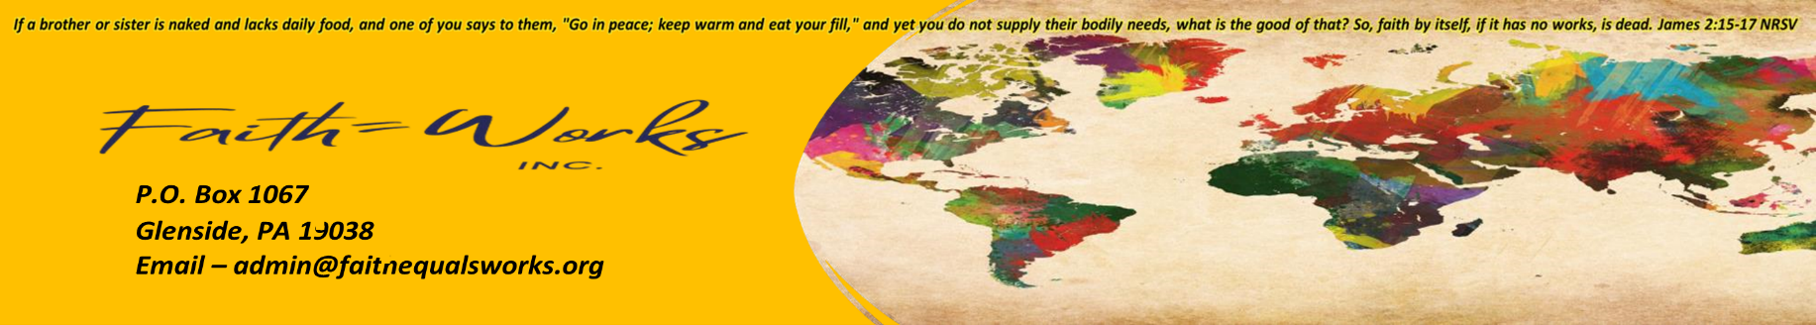
For Trip Information, contact Gail L. Hoffman at 215 696 7071 gail849@aol.com
Date:
Dear Friend:
I am so excited about preparing for one of the most challenging experiences of my life! On January 31, 2024, I will be traveling with a group of missionaries to Uganda, Africa, for 15 days. I have partnered with a Christian humanitarian aid organization called Faith Equals Works, Inc. Uganda Mission Project. This organization provides monthly food, clothing, education, medical care, and emotional support in this severely improvised country where child mortality rates are skyrocketing at alarming rates…many due to AIDS and MALARIA. The need is overwhelming in Uganda, but we intend to make a difference one person at a time.
We will be based in Kampala, Uganda, and travel to several villages during our stay. While there, we will give personal testimonies, minister, and encourage the children and adults in any way needed. We will take supplies and other miscellaneous gifts. The greatest gift we can offer is the matchless love of Jesus Christ! We want each person to understand that their life matters and that God has a plan for them to be with Him for eternity.
Well, now you know the facts. Here is how I am praying you can help. The cost of my trip with airfare, food, lodging, ground transportation, water, and ministry projects will be $3,200. Your gift of any size is greatly appreciated and tax deductible. We also want you to partner with us in prayer, knowing this is a God-sized opportunity requiring great faith. We are asking you to pray for our physical safety, spiritual growth, protection, and places to share Jesus Christ’s love with the people of Uganda.
If you can donate, please fill out the form I have attached. This form will allow me to keep track of who has contributed towards my trip. Also, it will give me the needed information to send you a thank you note and detailed letter about the mission trip after I return. Please mail the attached with your donations by___________________________as I will be leaving for Uganda on January 31, 2024...
As Jesus said in Matthew 25:35-40, “for I was hungry, and you gave Me food; I was thirsty, and you gave Me drink; I was a stranger, and you took Me in; I was naked, and you clothed Me; I was sick and you visited Me; I was in prison and you came to Me’ Then the righteous will answer Him saying, ‘Lord, when did we see You hungry and feed You, or thirsty and give You drink? When did we see You a stranger and take You in, or naked and clothe You? Or when did we see You sick or in prison and come to You? “And the King will answer and say to them, ”Assuredly, I say to you, in as much as you did it to one of the least of these My brethren, you did it to Me.” Thank you for your support and prayers!
Sincerely,
(Your Name)

DONATION FORM (please print)
Name__________________________________________________________________
Address__________________________________________________________________
Phone #____________________________Email________________________________
Amount of Donation $_________________________

Make check or Money order payable to Faith Equals Works, Inc. You may also make payments to Paypal@TheFEWMinistry, Cashapp4TheFEWMinistry, and Zelleat Faith Equals Works Inc.

In the memo section of your check or transaction, please write: For ( Your Name)

Re: Uganda Mission Project Trip Donation

*****Your Donation is Tax Deductible***** Mail form and donation to:

(Your address)

God’s Pattern of Provision: Financial Support for Your Trip
Understanding the Biblical Precedent for Support Development:
So, you want to go on a mission trip, but you need to raise all or some of the money you need to be able to GO? Rest assured that you are not the only one. You will also be in the good company of people like the Apostle Paul, who needed the support of the church body to carry out His ministry.
The Uganda Mission Project believes that general financial support for your mission trip should be sought from friends and family members who 1) are believers and 2) that you have a close relationship with. Your trip leader will supply you with a “sample” support letter to get you started on raising the funds needed for your trip.
You may have many questions and even some fears, but we believe that as you read and follow the steps outlined below and trust in the Holy Spirit to guide and help you, you will be greatly encouraged. The following paragraphs provide the biblical rationale behind the practice of raising support. Once you understand this, you can better raise support with boldness and confidence. It is our prayer that in this process, you will see the faithfulness of God, who provides for the work that He calls you to do.
Developing a Vision:
Raising support is not about raising money; it is about sharing a vision. It is about sharing the excitement of God’s call and the opportunity He has set before you, and it is about giving others a chance to participate in God’s plan to reach the poor in Uganda.
The basic principle you need to understand is that people are giving to the Lord (His work), not to you for a vacation. You need to have a sense of purpose when you ask…and there is no greater purpose than God’s will or his work. Do you have a vision or idea of how the Lord may use YOU on the mission trip? God desires for all to enter His Kingdom and for every person to have a chance to hear about His mercy and forgiveness. If you help lead one person one step closer to Christ on this trip, then You are doing the greatest work on earth.
Support Raising is Biblical:
Throughout Scripture, we find that God expects His people to support those involved in full-time service. He instituted a tithe as the means to support the Levites (Num 18:24, Neh 13: 10-13). And throughout the history of Israel, God promised to Bless those who invest in this work. (Prov. 3: 9-10, Mal 3:10) Paul said emphatically to the Corinthians, “The Lord has commanded that those who preach the gospel should receive their living from the gospel” 1 Cor 9: 14 NIV). At times, especially at turning points in his ministry, Paul explicitly asked other Christians for financial support. “When I go to Spain….I hope to have you assist me on my journey.” (Rom 15:24 NIV) Jesus had financial supporters. As a carpenter, he could have funded his ministry by building furniture. But as far as we know, He did not. He relied on people such as Mary, Martha, and Lazarus, who helped…” support Him out of their own means.” (Luke 8: 3 NIV). Jesus gave His disciples specific directions, forcing them to depend on others for their needs. They were to accept gifts from others, as Jesus said. “Eating and drinking whatever they give to you; for the worker deserves his wages” (Luke 10: 4-7 NIV) Including Others in the Mission:
Romans 10: 14-15 (NIV) speaks of the need for us to Go and preach so that others might be saved. Verse 15 specifically asks, “And how can they preach unless they are sent?” Have you considered that your trip and the act of praying for and supporting you financially may be the way someone else can fulfill part of God’s call on their lives? Your trip may be the only mission trip they ever “go on” personally through your experience. By including others in your mission, you are giving them the opportunity to prayerfully consider how God would have them follow Him. Sending You may be the way someone else can be obedient to what God is asking them to do.
Living by Faith Today:
All Christians must live by faith (2 Cor 5:7, Heb 11:6 NIV), regardless of how they receive their finances. The bottom line is that you need to be willing to do whatever it is the Lord asks you to do. Raising support is a matter of obedience to God’s word and calling, not of following your feelings. If God calls you to GO ON this mission, then He Will provide everything you need to fulfill your ministry, including emotional strength and perseverance. (2 Thes 5:24 NIV).

Fundraising Steps
- Begin with your church home by contacting your Pastor and Elders first as your spiritual leaders to seek their approval on proceeding to enlist support in the church. You need to have your church’s counsel, and you need to have your church on your TEAM. ! Articulate how God led you to be a part of this mission trip, share your financial goal, gain a clear understanding of the steps you should follow to request church support and identify ways to present your mission trip to the church.
- Determine who to ask for support by making a list of potential donors (i.e., Church friends, home and other churches attended, relatives, school contacts, employment, and service providers. Review your phone, email, and Facebook contacts.
- Mail out your first Mission Donor letter along with a self-addressed stamped return envelope.
- Follow up with a phone call or visit to your potential donors. They want to hear how excited you are about this assignment from God. Give a financial update on how much more you need to meet your goal.
- Lastly, pray and expect God to work above and beyond your expectations and strategy.

God Bless you as you serve Him through Missions.


In preparation for our mission trip, please let your trip coordinator know if you feel that you cannot physically maneuver two 50lb. Suitcases in addition to your own personal bag. These extra suitcases allowed to missionaries are what enable us to bring our supplies for the mission outreach activities. The more supplies we can bring with us, the more people we can assist when we are there.
Coming together in agreement as a team before the Lord prior to the trip is a priority when participating in a mission trip. As the date approaches, we will have weekly prayer meetings. Distance can prevent some team members from attending regular pre-trip activities, so in order to include everyone, these are done by conference call or Zoom. These dates and times will be set for each team according to availability. The conference call or Zoom information will be sent with the first date's announcement. A team in unity with God and each other is a successful team.
A pre-trip meeting will be scheduled so the team can meet in person, where you will meet your Project Director and team leaders, receive instruction, a travel schedule for the trip, and ask any questions you may have. The last segment of the meeting will be to organize our supplies and pack them properly into the cases. Please attend this meeting if logistically possible. We understand that people do come from long distances and cannot always secure travel, but if you are close enough, or it is not a financial burden, we highly recommend that you attend. This is your first contact with some or all of your fellow team members.
When traveling as a team internationally, please keep your passport and other ID in a quickly accessible but secure place and always be aware of the location of your team leader and other members. Please do not stray from the group at any time without specifically notifying the team leader and taking a partner with you.

Trip Leaders are accountable to you to ensure you are always supervised; please assist us in doing this with ease.
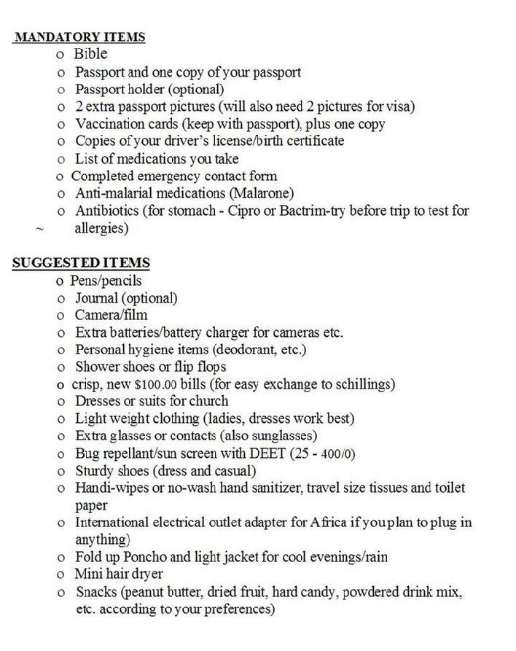
Passport Photos MAY be required

Be Safe, Be Prepared, Be Blessed (Cont’d)

PREVENTING INFECTIOUS DISEASE
While in Uganda, or any developing country, some precautions are necessary that may not be normal for you. Following these common-sense suggestions will give you the best possible experience.

WATER: Be aware that tap water is not fit for us to drink. Only boiled water, as is in tea or coffee, has been boiled hot enough to kill germs. So, any other water needs to be bottled. Anything that you may do with water that is going into your body needs to be done with bottled water. This includes brushing your teeth and not opening your mouth in the shower. Use hand sanitizer for hand washing. Do not order ice to put into your drinks.
FOOD: Fresh fruits & vegetables are OK to eat if they originally had a peel. Do not eat meat or fish that has not been very well cooked. Eat absolutely nothing from street vendors. Pack snacks that do not expire quickly or need refrigeration for road trips.
SAFETY: it is a good idea to follow these suggestions:
At every place that we sleep, find a secure place for your documents, electronic devices, and cash at every place we stay. Some places have a safe. Wherever we are ministering during the day, our security or driver will remain with our vehicle.
This is your safe place in the field.
Bring flip-flops for showering.
Be mindful of malaria conditions. Instruct your cleaning people to leave your windows closed during the day and at night. Most mosquitos carrying this disease are out only at dawn or dusk. We make every attempt to be in at night, but when our schedule is such that we cannot be inside by dark, this will help prevent them from getting in. Also, wear mosquito repellent as your perfume or cologne night and day as a precaution.
Never venture outside of the hotel or Ministry areas where we are working.
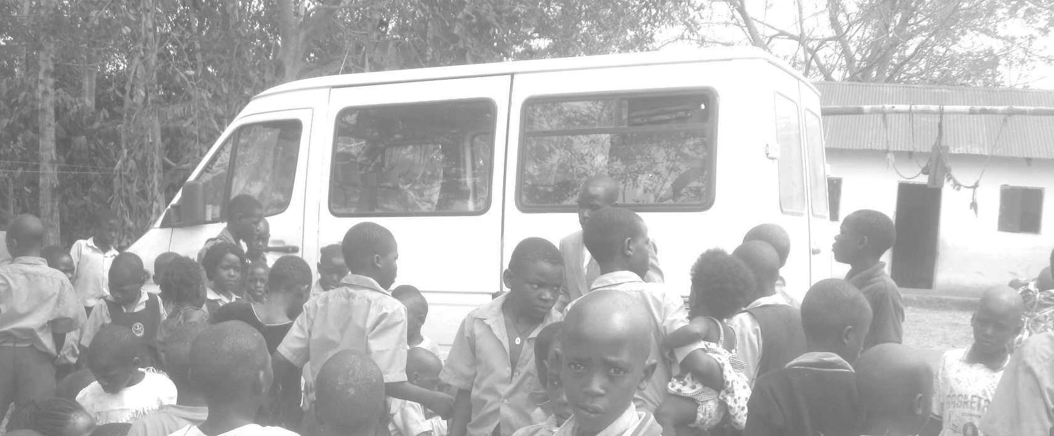
DOCUMENT YOUR TRIP
Help Us Make Our Trips More Successful

PLEASE READ
Please take a moment to read the items listed below. Our generous donors do require us to report back to them when we come home.
They like to have stories, photos, and videos of our Mission activities.
After every trip, we hope to post your experiences that really stood out for you on this trip. Testimonies of sharing your faith with someone, praying for salvation with someone, a particular sight that affected you, or any experience you feel compelled to share on our website. This gives people thinking of going on a future trip a good idea of what to expect and encourages them to participate in something that will both bless others and be a blessing to themselves as it was to you. So, keep this in mind as you move through your trip activities.
. If you have a testimony about a situation that really stands out in your mind, please consider sharing it with us. Photos & first names of people are appreciated.

