N

w

**BA**

Baptist Association

s



J U LY/ AU G U S T,: 2 0 2 5,, I S SU E

**A Moderator's Musings...**

*tt*k ee.-toinly-worm!ngup· thi.:,timeoCy�r and itk ou, proyer that youore �tayilig coot c:mdeomlorto� t,om the he-al M you o� W/0'$t', ThUr:idoy, Ju1\e 19"' woe Df.Blue'eIOet day ii\ the office.We*w«e* able to hoonor him and Mrt:. Vickie at o rore-1,1ell h.11'\Cheo,,. &eti� it o, not.he woe\.lt'IClb!e to e�k (only o few l'l'Wlutes • LOL) due to �11,9o�rwhell'l"led withemo110,,. We were ce,toi.l\ly b&e-eeedr,y hie tlrr'1eof �Meewith ou, Me.ociollon.

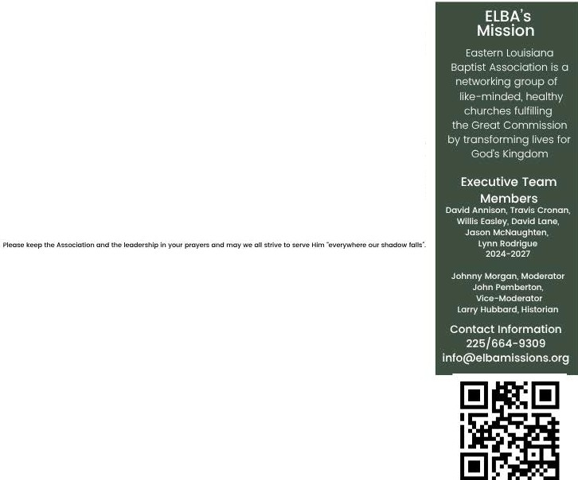

At our eemi•Ol'lnu<J1meeting the follov.ing ite-,ns wereopprove-d. � eol'\gregotlon 1eeog,,ited 810. Joeon MeNOugtnet't 'Mth � Executive Teamond mode the toflowing Ol'lno�em: the b:e<:uli�Te-omtne<t'l'lbere l'\d�a,g,eed to eerveoe the-Seo.rch

Committee 10.-the �itionolthene•t Meoclotlol'I Mleslone Strott:,giel Alo,. o,�1n�olion that therule be eu�en<k-d and thttt"�ou'! that the m�rolOI'Ohd�IY\Oderoto, be allowedol'I o<Sditi01\oJ yt,01of �iee toprovideeontil"I\Jity to the� c.onffllutlol\ ond by•klwe. The Bi� telleue in 1Corinthlone 14!AO·eut all thlnga ehould bo donedecently and in order: and�

!:trMng to e�e Orderly.

C-. 81oe led the o"oeiotion wellduringhe tet'll.lre-and it ie � prayer of your Otecuti..-� lt-Om and ome�e tha1the et,e-om•lned

.ehcmg�mu� 10 the �tme will ,xow tobeeffect!�OM! godly a:, we �k thelOfd*to,* the future ol E.tBA. The*Eireeutlve* Team hm 01,eody begunthe�e ol ,e�ivlng re:c:umee for the AMSpoei1ion. *'Vie* will meet on July 15"' Ot\d begin the�,eh. 8eoo lhesookout to, upd01e-,!

II you hO'Veany qu�neregording ELBA o, how the �eoclatlOl'l eon o"IU your church, pie-oeeknow that the *Executive* Teamit avOilOble to *you* now uod in the ru1ure. You eon ea,,t(l(:I 1ne, Moderator Johnny MOf9ot\ onytwne.or the ll.8A olflee. l(oJtethO hoe

begun working the *f'tlt'II* echeckde to ,xovide*o* dolypre---�nce in the omi::::e. The hOure eweCle follOW$: MOndCry•Tue--..cloy: 8!30•4!30: we�t:doy�Thu,-eday: 8:30--12.:30. M ueuol, tN of� le e10U<:1on F'rid�.

Alwc::ry,e�em�,. � eerveaGod Who ie fOithlul and loving. He hoe goodplone for Hie peo�. Jo,emlah 29�1"'for I know the plane I hovelor you,doeloroe the lord. pkiMlo, wotlaroand not for evil, to givo you o h.rturo ond a hOpe.9

John"Y MOrgon

ElBAM�ratOt 2024•2026

## A Special "Thank You!"

Vickie and I wereoverwhelmed by those who came to celebrate my retirement. Thank you to our Moderator, Johnny Morgan, and Administrative Assistant, Karetha Kelley, and many others who made theRetirement Luncheon such a blessing. Thank you also for your retirement gift as well. I have beenhonored to serve our Lord together with you and our ELBA churches. May God order your steps in His ways and leadyou to your next Associational Missions Strategist. Thank you again, and may God bless!

--Richard Blue

JULYIAUGUST 20251 ISSUES

Church Happenings

|  |  |  |
| --- | --- | --- |
| Church 2025 | May | YTD |
| 4001- Amite | **$800.00** | $4,800.00 |
| 4003 • Bethel | S131.97 | $691.82 |
| 4005 • Carroll | **so.oo** | $217.72 |
| 4006 • Central | **$0.00** | so.oo |
| 4007• Christ Community | **$3,100.00** | $7,791.00 |
| 4008 - Colyell | **so.oo** | $6,969.65 |
| 4009 - Denham Springs FBC | $1,806.92 | $10,236.99 |
| 4010 - Don Avenue | $663.94 | $3,389.96 |
| 4012. Emmanuel | $675.00 | $1,600.00 |
| 4014• French Settlement | $0.00 | $745.00 |
| 4015 • Gray's Creek | $1,609.00 | $2,618.00 |
| 4016• Greater Third Zion | $0.00 | $0.00 |
| 4017• Head of Island | $0.00 | $883.19 |
| 4018• Hebron | $477.75 | $2,742.06 |
| 4019 • Holden | $0.00 | $378.62 |
| 4020• Judson | **$0.00** | $4,041.58 |
| 4021• live Oak | $6,281.85 | $16,568.37 |
| 4022• Livingston FBC | **$700.00** | $3,450.00 |
| 4023 • Macedonia | **so.oo** | $0.00 |
| 4024 - Magnolia | s200.00 | $1,000.00 |
| 4025 - Maurepas | **$193.00** | $471.00 |
| 4026• Midway | **so.oo** | $0.00 |
| 4027- New Bethlehem | **$75.00** | $375.00 |
| 4028 • Grace Covenant | **$600.00** | $600.00 |
| 4029 • Northside | $399.69 | $2,159.28 |
| 4031- Pine Grove | $425.37 | $2,461.96 |
| 4032• Red Oak | S100.00 | $500.00 |
| 4033 • River of Life | $0.00 | $0.00 |
| 4034• Riverside | $210.49 | $1,138.02 |
| 4035. Salem | $0.00 | $0.00 |
| 4036. Satsuma | $0.00 | $0.00 |
| 4037• South Walker | $0.00 | $593.25 |
| 4038• Southside | $521.00 | $1,252.00 |
| 4039 • The New Beginnings | $0.00 | $661.87 |
| 4040• Victory | $0.00 | $770.62 |
| 4041• Walker | $2,4TI.55 | $10,992.23 |
| 4042• Watson | $514.29 | $1,950.89 |
| 4043 • The Way Church | $225.00 | $1,125.00 |
| 4044 • Community Church of | $0.00 | $0.00 |
| 4046 • Wholly Grounds Ch,xc | $0.00 | $300.00 |

Judson Baptist Church Caring *8.*

Learning Center

Wehove the following spots available in our Preschool program for the 2025·2026 school yeor:

PK3 • 3 spots PK4 • 2 spots

Please call 225·664·2657 to get your registration paperwork emailed over to you! Tuition is

$210/monthly and the Registration Fee is S250 to hold your spot.

Presc.hool

opehlh95



Come and join us for practical oonversation about how to read o.nd u:nderstond yourBible. Reserve your seat today!

Biblical Uterocy Workshop for Women

July 19th 10om-12pm

Wholty Grou.nd Coffee House Walker, la

Aeglster Here:

!J.ttR•Jlmell>J>ob.elgot�om/

wotkshol?..§..

�...

The way church Donham springs 9270 Cockerham Rd, Donham springs,LA

{225) 369-2832

Como celebrate our freedom as Americans and our froodomIn Christ! This free ovcmt is so that our church and community can gather and enjoy somo family friendly time together and enjoy

.

*'•-t*

*�*

' v'

***CElEIJ/lATE* ti/**

***IJS***

**5°An.ilMY, .71M**

***un,***

.• •....

* • �I'

*1/*

some fireworks! Wo'II be providing free foodas well as o drawing to win $100 worth of fireworks!

111mun-rnmmrmr-Tl!Iil-.1l

ICI. 1,ftu: tnlt '"U,l.llt

•

## Macedonia Baptist Church has called Shane Picou as Pastor

Randall Gill has resigned as pastor of New Bethlehem Baptist Church

Total Churches Contributions $22,182.82 $93,475.08

JULY/AUGUST 2025 I ISSUE 5

*,iJinisLry·Ha1>1>eni1igs*

ReGroup - Small Group Leaders Conference

**THE** •

**d** The ReGroup Conference is designed as an Outcome Based

E

.., ..;;;;..,.;,;;;;,;;;;_, ..., Conference. Most traditional modelsof training start with

FORG

**ONE D�A""**  ~~�~~

your position and we train youHOW to do your job. This will help the leaders to determine the best strategy to leadtheir

* + group/class" to accomplish a desired outcome. Who should

attend? Pastors, Church staff,Sunday School Leaders.

***-4*** � I'

Discipleship leaders, Small Group Leaders, CellGroup leaders, Men·s Group leaders, Women's Group Leaders,

# Scan

**G** � �� ChurchPlanting Group leaders, Spanish Speaking Group

�� Leaders. Missional Group Leaders, Compassion Ministry Leaders, etc. It will be held Saturday, August 9th from 9am to



**r:,**

**L:J**

•

1

**Thi** Ill **t** 8 **k** Noon at Franklin Avenue Baptist Church, New Orleans. See

**here with**

**S W**

**you to the**

* more details and to Sign•up below.

# your phone camera.

•

registration form.

https://louisianabaptists.org/cvcnts/regroup•conference• south/

https://[www.eventbrite.com/e/2025](http://www.eventbrite.com/e/2025)•regroup•new•or1eans­ tickets-1363383319209?affooddtdtcreator

Or Call Mike Fielding 225-243-6138 [mlke@llveoakbaptlst.org](mailto:mlke@llveoakbaptlst.org)

**Sign up before Friday, August 15th to receive the eary bird discount of**

**$20 per Student.**

**After that, It Is $30 per student at the door.**

**Adult leaders are free.**

**Price Includes T-shirt and Lunch.**

**Held at Amite Baptist church. 9am-5pm. August 23rd, 2025.**

**Do not register at Amite Baptist web page.**

**JULY 2025 August 2025**

**1-4 Kids Camp** - Tall Timbers 3 **SEND Relief Sunday**

**4 Independence Day** 9 **REGROUP** - **Franklin Ave., NO**

6 Religious **Liberty Sunday 23** FORGE - **Amite Baptist Church**

**15** AMS Search Team **Meeting 24** Global **Hunger Sunday 21-24** Children's **Mission Camp-Tall** Tbs

**25 Lifeway Women's Event** - **NOTBS**