Alberto’s Pizza Shop & Tim’s Corner Restaurant
Presents a FUN SUMMER challenge for school-aged children, K-12
GROW YOUR BRAIN, EARN FREE FOOD. It is a WIN-WIN
1 | 2 | 3 | 4 | 5 | 6 | 7
8 | 9 | 10 | 11 | 12 | 13 | 14
15 | 16 | 17 | 18 | 19 | 20 | 21
22 | 23 | 24 | 25 | 26 | 27 | 28
29 | 30
Let’s GO | Great job | You are so smart | Reading is cool and so are you. | I am proud of you | Pat yourself on the back almost there | Look at you all smart and stuff
NAME:
Rules are simple. Read 20 minutes a day, any book of your choice, for THIRTY days over the summer. You can use this form or create your own. Parents/guardians initial each day after your child completes 20 minutes of reading. Then bring your completed form & coupon to Alberto’s Pizza Shop and/or Tim’s Corner Restaurant to redeem! Have fun with this. I have kids of my own and was inspired by a similar program that made reading fun and rewarding when I was a child.
Any questions, contact us on Facebook at Alberto’s Pizza Shop or Tim’s Corner Restaurant

COUPON EXPIRES AUGUST 31, 2022 COUPON EXPIRES AUGUST 31, 2022
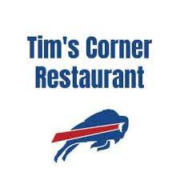
Free Kids
Waffle
FREe SLICE Of cheese pizza

