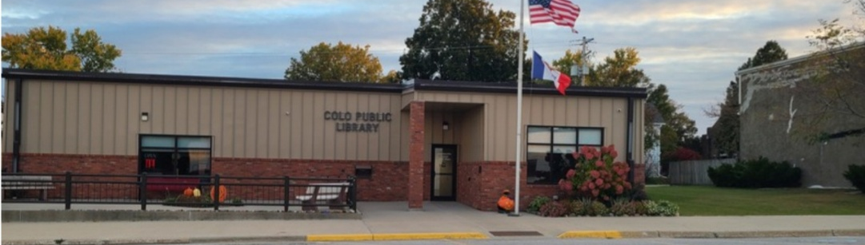

Current Community Center
& Library

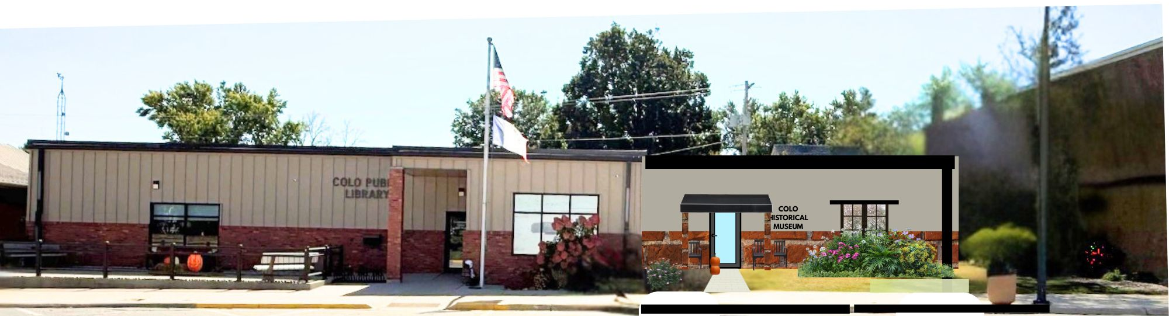

This is a drawing of our vision of the Colo Community Center and Colo Public Library with the Colo Historical Museum addition

Greetings!

The town of Colo has a rich and meaningful history—one shaped by the people, places and stories that came
before us. The Colo Historical Association (CHA), formed in 2016, has worked to preserve that history for future generations, and now have an opportunity to further preserve that legacy for future generations by building a local history museum. We are reaching out to you now to ask for your support.

The proposed museum will serve as a space to honor our past, showcase historical artifacts and photographs and provide educational opportunities for students, families and visitors.
It will be a place where stories are shared and remembered—strengthening our community pride and understanding of where we come from.

To make this vision a reality, we are raising funds to support the construction and development of the museum. In October we asked and got the approval of the Colo City Council to build a museum onto the existing Community Center. We are excited how the museum will add so much to Colo’s Main Street. We contacted several contractors about building the museum, and chose the one who came back with a bid of $200,000. The donations and grants we receive will go directly toward building costs, exhibits and preservation efforts. The Colo Historical Association will start the building fund with money from our funds. Every contribution, no matter the size, brings us one step closer to creating a lasting resource for our community.

Your support will help ensure that our history is not lost but preserved and celebrated. We are a 501©3 non-profit, so any donation you make is tax deductible.

Thank you for your time, generosity and commitment to helping us leave a meaningful legacy for generations to come.

With appreciation,
Sincerely,
Colo Historical Association

