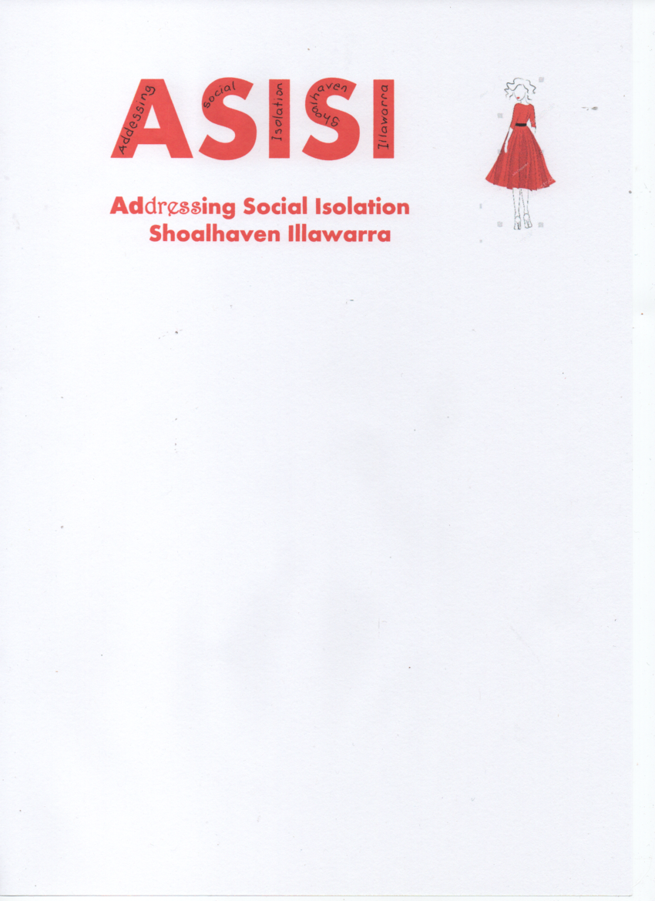
Amanda Smith
PO Box 528
Nowra, NSW 2541
Mobile: 0479180486
Email: amanda.smith@asisi.com.au
Website: asisi.com.au

I would like to make a referral for the following services:
Support Coordination
- Support Coordination 07_002_0106_8_3_T
- Psycho Social Recovery Coaching 07_002_0106_8_3
- Support Connection 07_001_0106_8_3_T
(Please be aware if Support Coordination/Connection no other items eligible for referral)
Improved Daily Living:
- Life Transition Planning, including Mentoring
and Individual Skill Development 09_006_0106_6_3
Assistance with Social and Community Participation
- Assistance to access community, social, and
civic activities – weekdays 04_500_0104_1_1_T
- Assistance to access community, social, and
- civic activities – Saturdays 04_502_0104_1_1_T
- Assistance to access community, social and
civic activities – Sundays 04_503_0104_1_1_T
- Assistance to access community, social and
civic activities – Public Holidays 04_504_0104_1_1_T
Email address for contact regarding this referral:
____________________________________________________________________________________
Are you the person requiring support:
- Yes
- No

Name of Person Requiring support:
First: ___________________________________ Last: ______________________________________
Preferred Name: ____________________________________
Date of Birth: ______ / ______ / ______
DD MM YYYY
Gender of Person requiring support:
- Male
- Female
- Other
- Would prefer not to specify
Does the person requiring support identify as Aboriginal or Torres Strait Islander Origin?
- Yes
- No
- Unknown
- Would prefer not to specify
Does the person requiring support identify as being Culturally and Linguistically diverse?
- Yes
- No
- Unknown
- Would prefer not to specify
Person requiring support current address:
Street Address:

City:____________________________________________ State: ________________________________
Postal Code: ______________ Country: Australia
Person Requiring support phone number:
Mobile: ____________________________________ Home: _______________________________

Please tick the items that apply to the person requiring support:
Please provide further information regarding the services that you are seeking:

- Psychosocial / Mental Health Disability
- Intellectual Disability
- Physical Disability
- Neurological Disability
- Other
Is the person requiring support a participant in the NDIS?
- There is an existing NDIS Plan
- NDIS Plan in progress
- NDIS Eligible
- Seeking assistance to apply to the NDIS
NDIS Reference Number: ________________________________
Please provide information in regards to the person requiring supports level of mobility:

Privacy and Consent:
- By completing this form, I consent to ASISI collecting and exchanging personal information about the person requiring support with relevant third parties, for the purpose of assessing eligibility for services being requested. I confirm that I have the authority to provide this consent. I understand that the collection of information for this referral is voluntary, and that ASISI is bound by Federal Privacy Legislation.

Signature:
Referrer: ____________________________________

Referrer Name: (Please Print) ______________________________________

Date: ____________________________________

Person Requiring Support: _________________________________________

Person Requiring Support Name: (Please Print) ______________________________________

Date: ____________________________________

