**Futsal** is the only small-sided game that is recognised and supported by FIFA and UEFA. Futsal began on the streets of South America and most of the world’s best players grew up playing the game. Players such as **Messi, Xavi, Ronaldo, Iniesta, Pele and Ronaldinho** all attribute Futsal as the key element that helped them become the **world’s greatest players**.

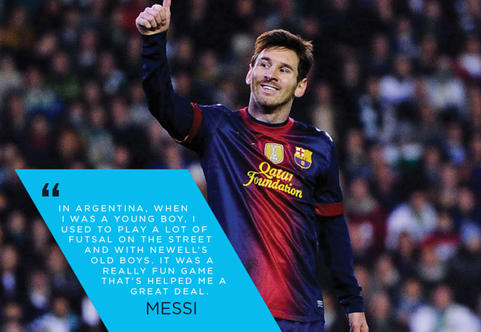

**Futsal** encourages children to become more **agile, faster, stronger** and to have **better balance**. The nature of the game places a large emphasis on technical skill and ability in situations of high opponent pressure. It creates players who are more comfortable with the ball, speeds up their decision making and gives them a much greater number of opportunities to practice **passing, dribbling, turning, shielding, ball control** and **shooting**.

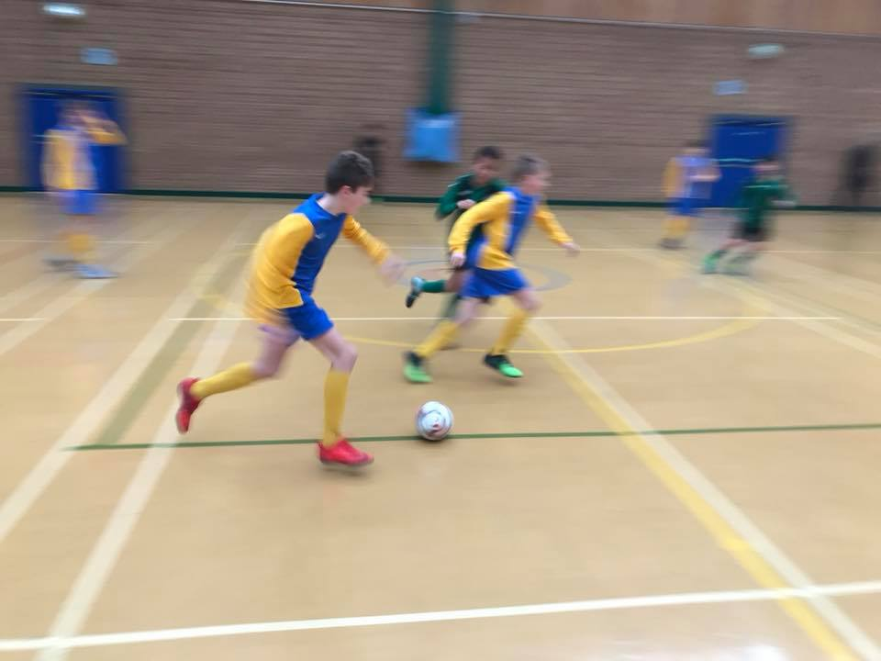

**Futsal** is a superb team and social sport. As there are only 5 players on court per team, each player is important and involved in **attacking**, **defending** and **counter-attacking** and must understand the different roles within the team. Roll on and off subs means every player is used throughout the game. Due to the speed of the game this encourages children to **work together** as a group to **maximise their chances of success**.

