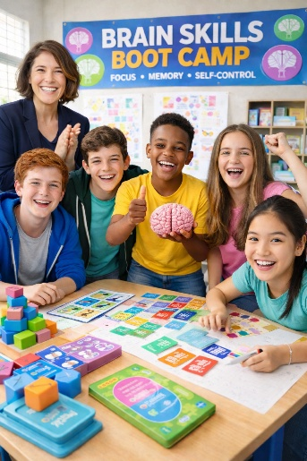
📅 June 15–19, 2026
(Mon–Fri)
⏰ 8:00 AM – 12:00 PM
💲 Cost: $150
Led by: Dr Lisa Ross

Help Your Child Build the Skills They Need to Succeed
Does your child struggle with:
- Staying focused
- Acting before thinking
- Remembering instructions or schoolwork
- Staying organized or completing tasks
Brain Skills Boot Camp is an engaging, structured summer program designed to strengthen the core thinking skills children need for success in school—and in life.
What Makes This Camp Different?
This is not just a camp—it’s brain training with real-world results.
Children participate in:
- Interactive Brain Training (Lumosity & BrainHQ)
- Hands-On Games & Challenges

Skills We Build
- Attention & Focus
- Impulse Control (Stop–Think–Act)
- Working & Long-Term Memory
- Planning & Organization
- Emotional & Cognitive Self-Regulation

Daily Themes
Day 1: Meet Your Brain (Focus & Attention)
Day 2: Impulse Control Ninjas
Day 3: Memory Masters
Day 4: Executive Function Experts
Day 5: Brain Champions

Who Is This For? 4th-8th Graders who:
- Have difficulty focusing or staying on task
- Struggle with impulsivity
- Need support with memory or organization


Learning To Lead Education Center
5497 Hart Rd, Sutherland VA 23885

