***Changing Fates Equine Rescue of Delaware***

31283 Old Cabin Road * Laurel, DE 19956 * 302-339-5065

[www.changingfatesequinerescue.org](http://www.changingfatesequinerescue.org) OR [cferdelaware@gmail.com](mailto:cferdelaware@gmail.com)

“***Changing Fates and Changing Lives One Horse at a Time.”***

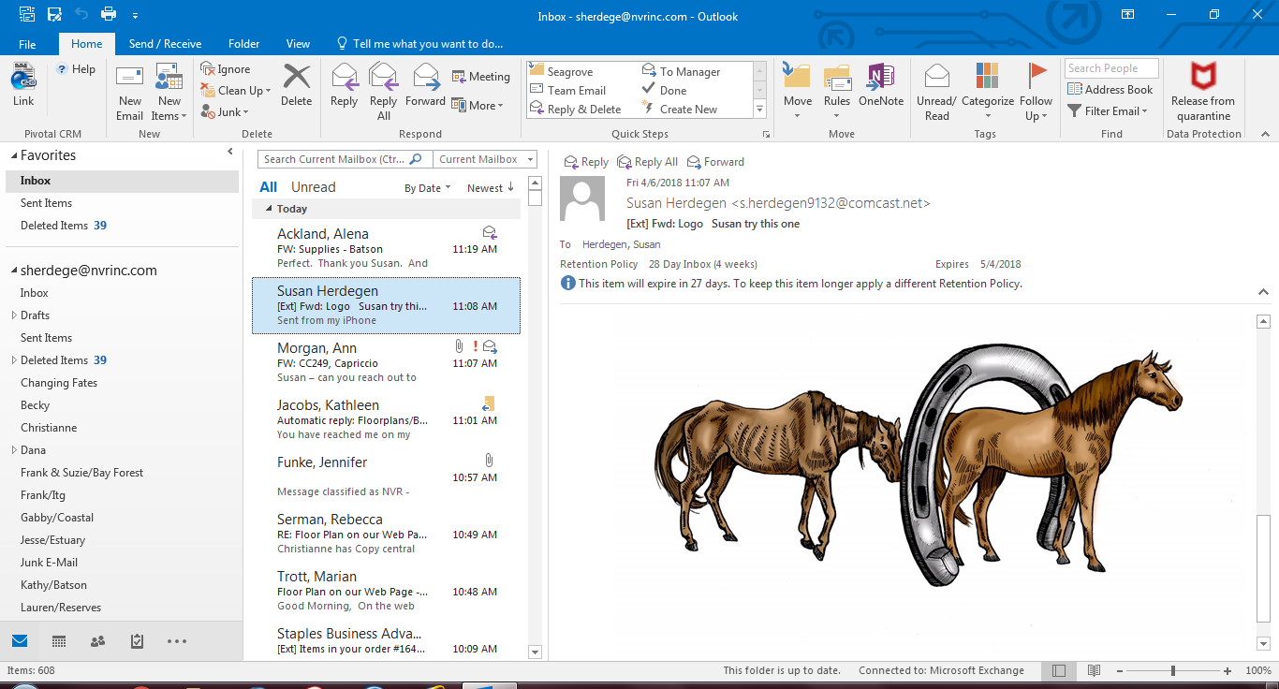

**VOLUNTEER APPLICATION**

**Date:**

**Name:**

**Address:**

**Email:**

**Home/Cell Number:**

**Emergency Contact:** **Relationship:**

**Emergency Contact Number:**

**Are you a minor (under the age of 18 years old)?**  **Yes Age**        **No**

*\* Volunteers must be at least 12 years of age. Volunteers under 18 must be accompanied by a parent/legal guardian throughout the volunteer shift.*

**Parent/Legal Guardian:**

**Contact Number:**  **Cell:**

**Work:**

**Home:**

**__________________________________________________________________________________________**

**CFERD asks that our volunteers commit to a minimum of 3 hours per month. General volunteer hours are scheduled every Saturday from 9:30 AM to 12:30 PM (summer) or 12:30 PM to 3:30 PM (winter), unless cancelled. If you are part of the Feed Team, hours and times vary. You may be part of the Saturday volunteer group and/or part of the Feed Team. Are you able to meet this minimum requirement?**

**Yes  No If “No”, how many hours can you commit to:**

**__________________________________________________________________________________________**

**How did you learn about volunteering at Changing Fates Equine Rescue of Delaware (CFERD)?**

Advertisement in local paper  Website/Online  Flyer  Friend  Other:

**Are you interested in volunteering:**

**On Saturdays at the Rescue**  **Feed Team\***  **Other (describe):**

**\*** This requires a solid commitment of at least one day per week, one of two shifts, morning (between 8 a.m.-10 a.m.) or afternoon (between 4 p.m.-6 p.m.). You may volunteer for more than one shift.

**__________________________________________________________________________________________**

**What objectives do you have in becoming a CFERD Team Member?**

**Please check any of the following skills you would like to offer CFERD.**

Accounting/Finance/Bookkeeping General Handyman

Administration/Computer Skills  General Contractor

Amateur Photographer Graphic Designer (InDesign, Illustrator, Photoshop**)**

Carpentry Skills General Horse Care

Catering/Hospitality Skills Marketing

Copy Writing/Proofing Skills Mucking/Raking Stalls/Run-ins

Craft Skills Painting

Database Management Plumbing

Electrician Professional Photographer

Event Planning/Fundraising Retail Skills

Feed Crew Web Designer/Master

Fundraising Other:

Social Media

**Are there any skills/gifts not listed above that you would like to share with CFERD?**

**__________________________________________________________________________________________**

**Horse experience is not required at CFERD. However, if you have horse experience, please indicate:**

Grooming  Leading  Cleaning stalls/run-ins  Training  Lunging  Riding  Trailering

Administering Shots  Farrier work  Veterinarian/Vet Tech  Other:

**Please describe any horse involvement you have had in the past:**

**__________________________________________________________________________________________**

**What date are you available to start?**

**__________________________________________________________________________________________**



**I understand** that when on the premises of Changing Fates Equine Rescue of Delaware, Inc., or any sponsored event, I must abide by the guidance of the Volunteer Coordinator(s), Senior Volunteers and/or Members of the Board of Directors as well as follow all safety guidelines.

___________________________________________ __________________________________

Volunteer Applicant Signature Date

**FOR MINOR VOLUNTEER APPLICANTS UNDER THE AGE OF 18 YEARS OLD:**

As a parent/guardian of this minor Volunteer Applicant, **I understand** that I must accompany the Volunteer Applicant for his/her entire shift. In addition, I understand that when on the premises of Changing Fates Equine Rescue of Delaware, Inc., or any sponsored event, I must abide by the guidance of the Volunteer Coordinator(s), Senior Volunteers and/or Members of the Board of Directors as well as follow all safety guidelines.

___________________________________________ __________________________________

Parent/Guardian Signature Date

May 12, 2024