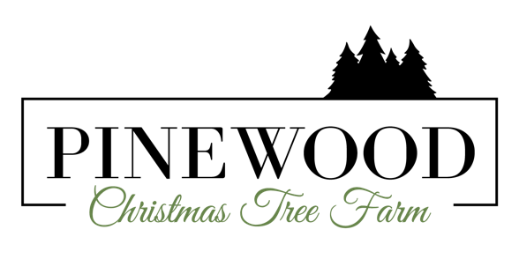
We are looking for a few good Elves to join our Pinewood FARMily!

It is our mission to have a vital part in creating Christmas memories and traditions through a unique farm experience and personal connections from the moment the guest steps on our farm to the moment they leave.
We expect Elves in all positions to be holly, jolly, and full of contagious Christmas spirit and to consistently deliver excellent customer service. Elves will be knowledgeable about the history of the farm. This information will be provided to the Elves before opening. All Elves must be 16 years old or older. We provide a smoke and vaping free environment on our farm so guest can enjoy the natural aspects of visiting a working farm, please make that a consideration as we do not provide smoking areas or smoking breaks. We do however provide a hot delicious homemade lunch for our employees on Saturdays and a hot chocolate bar to keep you warm inside and out.

Elf positions are seasonal and Elves need to be available to work most of our opening dates. Please see application for days we are open.

We are currently interviewing to fill the following positions
Assistant Tree Elf – the Assistant Tree Elf will assist customers in picking out trees, will answer questions about trees, and will help carry the chosen trees to the tree processing area. This position assists the Head Tree Elf. Since tree transportation is part of this job, the Assistant Tree Elf must be able to help lift and carry the trees which may weigh 50–60lbs.
Head Tree Processing Elf MUST BE 18+ YEARS OF AGE – The Head Tree Processing Elf will run all functions of the tree processing tent. This includes shaking the dead needles from the tree using the tree shaker, putting a fresh cut on the tree with a chainsaw, drilling the tree if the customer has a pin stand, and running the tree through the baler. The Head Tree Processing Elf will have the help of the Assistant Tree Processing Elf to accomplish this process. Safety of other elves and guests must be the first priority. Since processing the trees is part of this job, the Head Tree Processing Elf must be able to help lift and carry the trees which may weigh 50–60lbs.
Assistant Tree Processing Elf – The Assistant Tree Processing Elf will assist in functions of the tree processing tent. This includes shaking the dead needles from the tree using the tree shaker, drilling the tree if the customer has a pin stand, and running the tree through the baler. Safety of other elves and guests must be the first priority. Since processing the trees is part of this job, the Assistant Tree Processing Elf must be able to help lift and carry the trees which may weigh 50–60lbs.
Assistant Tree Transporter Elf – The Assistant Tree Transporter Elf will assist the Head Tree Transporter Elf in transporting and loading processed trees onto guests’ vehicles. Since tree transportation is part of this job, the Assistant Tree Transporter Elf must be able to help lift and carry the trees which may weigh 50–60lbs.
Greeter Elf – The Greeter Elf is the face of the farm. This Elf will need to be cheerful and provide ample information about navigating the farm and the available activities. This Elf will be knowledgeable about the history of the farm. This information will be provided to the Greeter Elf.
Retail Specialist Elf – The Retail Specialist Elf will assist Laura Faircloth (owner) in collecting payment for trees, wreaths, and other products. This Elf will be knowledgeable about the products we sell and be able to answer any questions about them. This Elf will receive training on The Square App and will need to be fluent on how to use it and troubleshoot when needed.
Hayride Driver Elf – MUST BE 18+ YEARS OF AGE. The Hayride Driver Elf must have a jolly and joyful personality, must be able to give directions and hold employees’ and guests’ safety above all else. This elf will be trained on driving the tractor, but experience driving a small tractor is preferred.

