|  |
| --- |
|  |

Several years ago, Kelly and I were faced with a devastating loss that gave us an option: We could choose to spiral down into resentment and bitter pain, or we could choose to spiral up into forgiveness and HOPE.

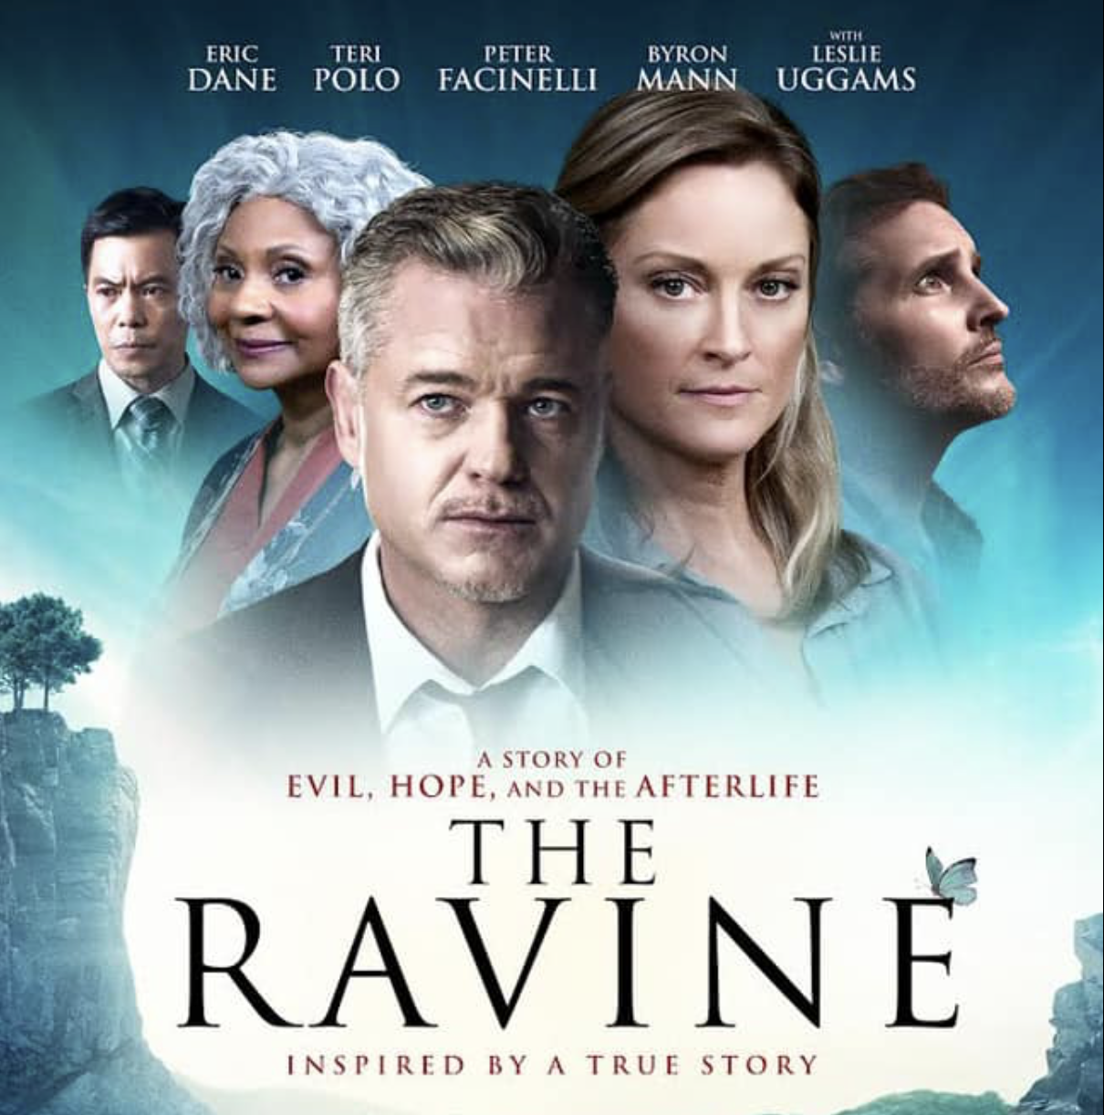

The future is where hope begins.  So, we chose to spiral up.

As we locked in on this hopeful future, we understood that we were catalysts in a powerful story that had to be shared. Over the next 10 years, as we experienced the ups and downs of bringing this story to the big screen, we often wondered why it was taking so long… but now we know the timing of this movie's release couldn't be more perfect.

If anything is needed right now in ALL our lives, it's hope. We're all being called to spiral up, to trust in a hopeful future of renewed connection, community and light.

**Our world is yearning for hope.** **Please help us share this story.**

**﻿**

Please consider buying tickets to *The Ravine* release on Easter weekend at[B&B Theatres in Kansas](https://www.bbtheatres.com) City, Des Moines and Sioux City. We are also doing a limited release in Des Moines and Sioux City Easter weekend. Then, please share this message with at least 10 people in your network and ask them to do the same.

Our goal for opening weekend is to sell every seat for every showing. This is paramount to kickstart greater outreach and showings to thousands of more people.

Your participation now can help transform lives.  Join us. Be a part of the ripple effect, the ripple of hope.

🦋  For tickets go to [bbtheatres.com](https://www.bbtheatres.com) and select Easter weekend dates April 2-4! 🦋

For a sneak preview, view the official trailer [online](https://www.youtube.com/watch?v=bk1l5IyQOpI) at TheRavine.Info   *#RippleOfHope*

|  |  |  |  |
| --- | --- | --- | --- |
| |  | | --- | | Kelly and Robert Pascuzzi  *Producers | The Ravine Movie*  [@TheRavineMovie](https://www.instagram.com/theravinemovie/)  [TheRavineBook Facebook](http://www.facebook.com/TheRavinebook)  [TheRavine.info](https://theravine.info/movie/) | | |  | | --- | |  | |