OPEN
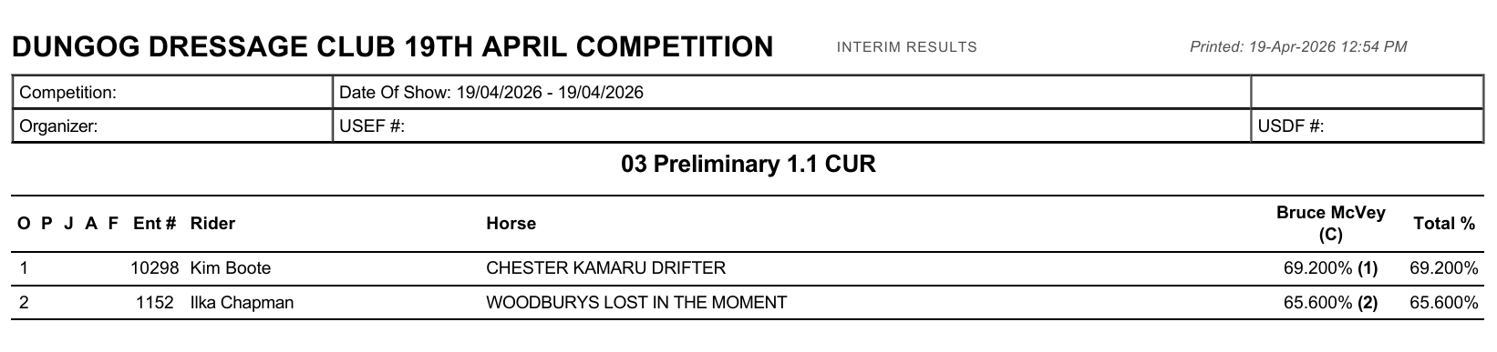
JNR/YTH
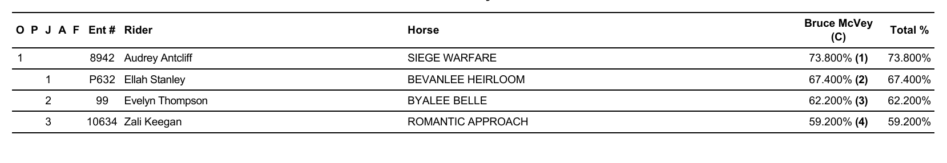

PONY
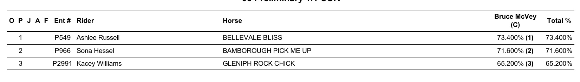
AOR
