OPEN
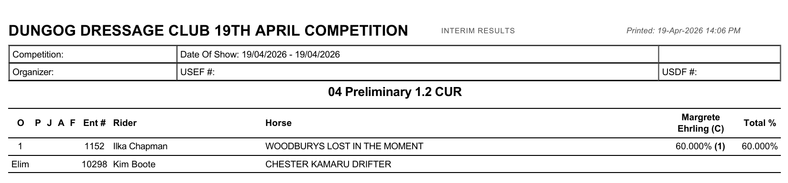
JNR/YTH
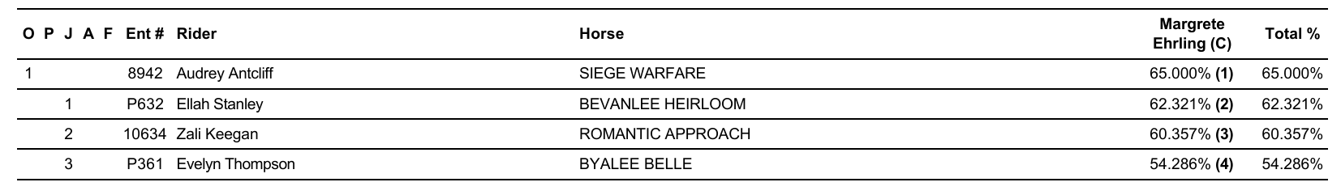
PONY
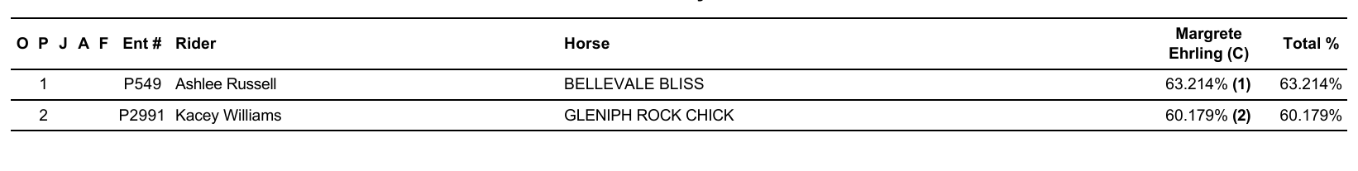
AOR
