Kenyon Gregory Jr

The Academic Competition Organization: How this club saved our lives
Every Monday and Thursday, the Academic Competition Organization meets in the back of Squires from 5 to 8 p.m. to test their knowledge of trivia.
“I want my friends to feel that every time they show up, they are going to have the best three hours of their life,” said Will Cardullo, president of the Academic Competition Organization.
ACO, as it is often abbreviated, is an academic team that participates in intercollegiate Quizbowl competitions and hosts high school and collegiate competitions. They also strive to make Quizbowl more accessible at both the high school and collegiate levels.
“I liked to define ACO as team-oriented Jeopardy because we use the buzzer system like the game show and all of our members like trivia,” said McEwan Keyser, vice president of the Academic Competition Organization.
ACO team members passion for Quizbowl began for them in high school. Will Cardullo, McEwan Keyser, and Zachary Bornstein received scholarships for their participation in Quizbowl.
Cardullo, Keyser and Bornstein have dubbed themselves the “ACO Boys” because all three serve in leadership positions in ACO and they earn the most points for the team at academic competitions.

“Those guys are like brothers, I can’t see one without seeing the other and all three are incredibly smart and win a lot of points for our team,” said Christine Strout, ACO team member.
Throughout all their success, when the ACO Boys are not competing in academic competitions they struggle with their mental health. Cardullo has anxiety and both Keyser and Bornstein have depression.
According to The Clay Center, 73% of college students experience some sort of mental health crisis. Zachary Bornstein experienced heightened depression due to the workload of classes and adapting to a new experience as a first-year student.
“I felt overwhelmed and helpless,” Borstein said. “It felt like I was drowning in a pool and no one was coming to save me.”
Bornstein’s sister was scared that her brother would not get the best college experience because of his depression.
“As his big sister I know that it is my responsibility to look after him but there are some days where I am afraid that he is struggling and not reaching out to me,” said Lisa Bornstein.
Bornstein joined ACO after Gobblerfest; it was in ACO were he found solace in Cardullo and Keyser who told him about their own battles with mental health.
“For those guys to reach out to me and tell me their experience; it helped me know that I was not alone and it made me form a new connection with them,” Borstein said.
Cardullo certainly did not know if he wanted to tell Bornstein about his anxiety because he had never told anyone before.
“I did not know how my friends would perceive me because of my anxiety,” Cardullo said. “I know that many of my older friends in school bullied me because of it, which just made my anxiety worse because I felt that nobody would see me as the same person.”
According to Healthline, “63% of college students in the United States report having anxiety.”
ACO team members describe Cardullo as someone who is kind, caring and displays leadership skills but admire him even more for telling Bornstein about his anxiety.
“He did not have to share that information with anyone,” said Hailey Page, ACO team member. “For him to do that to help Zach was a special thing for him to do.”
Cardullo struggled with his anxiety during the pandemic. He started to experience feelings of loneliness because he lost his job and could not be around his friends because he feared catching the coronavirus. Cardullo transferred to Virginia Tech in the Spring of 2020, which means he had to take online classes and did not have any interaction with other students.
“Somedays I would be in my cold, dark room all alone thinking about my future,” said Cardullo. “ Transferring during the pandemic did not help because college was making it worse and I was having negative thoughts at the time.”
Derek Cardullo watched how the pandemic affected his little brother’s mental health.
“It was hard to watch because I know my brother is very smart but seeing the sad looks he had on his face and hearing the mundane tone in his voice made me feel for him,” said Derek Cardullo.
Cardullo arrived at Virginia Tech in the Fall of 2021 and joined ACO a few months later. This is where he found his group of people, who were impressed by his intelligence.
“I was astonished by his intellect when he started to get five questions in a row,” said Chris Payne, ACO team member. “No wonder we asked him to be president after our fifth practice.”
Cardullo enjoys ACO but recognizes his anxiety is still a part of his life.
“I have good days and I have bad days, but when I am with my ACO family I feel happier than ever,” Cardullo said.
Keyser agrees with Cardullo’s statement because ACO helped him with his depression as well.
“I had some of the same negative emotions that Zach was feeling initially my sophomore year,” Keyser said. “I was dealing with more stress than usual; it was a combination of what was going on in school and at home and it was making me sadder by the day.”
Keyser’s girlfriend started to see a change in him and tried to see if there was anything that she could do to help him.
“I was trying to see what was going on and he simply shut me down and became avoidant and unresponsive,” said Christa Williams.
At one point Keyser went to the Cook Counseling Center believing that someone there could help him; however, he still could not shake the feelings of sadness he had.
“It didn’t really work for me because I did not feel ready to explain everything to anyone,” Keyser said. “I still felt that someone had locked me in a cage and threw away the key and that no one could get me out of this situation.”
The trigger point for Keyser was Bornstein opening up about his depression during one practice. Once Keyser heard Bornstein’s story, he knew he had to tell his to help his friend.
“It was an instant reaction to what Zach said,” Keyser said. “It felt like a lightbulb went off in my head and I just poured everything out for them to hear.”
Keyser appreciated his friends for listening to him because he felt he had no one else to turn to.
“ACO became my therapy session,” Keyser said. “I felt that this was the group of people I needed to talk to after that practice.”
Williams has seen a new change from Keyser since he opened up to the guys.
“He is a little bit happier than before and he smiles at me a lot more than he used to.”
The ACO Boys have formed a tight-knit brotherhood with each other after sharing their experiences. They plan to check in on each other to make sure everybody is alright and help each other when someone needs it.
“After opening up like that, I am proud to call them my brothers,” Cardullo said. “I would not have it any other way.”
For now, the ACO Boys want to focus on the upcoming Quizbowl season. They want to get back to what makes them happy and hitting that buzzer when they know the correct answer.

Target Audience:
- Students
- Ages 18-22
- Who have a mental health diagnosis
Pictures:
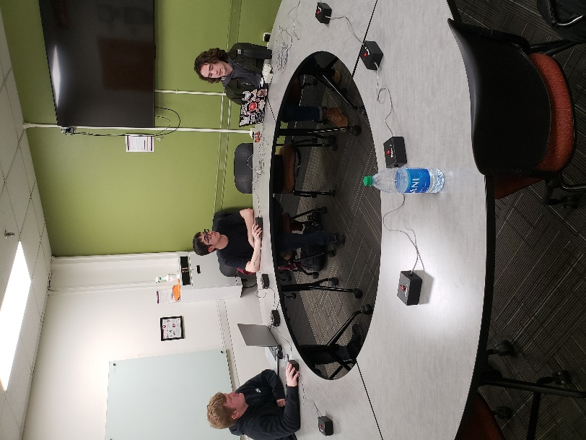
- The ACO Boys: McEwan Keyser (left), Zachary Bornstein (center), and Will Cardullo (right) Insert after paragraph five
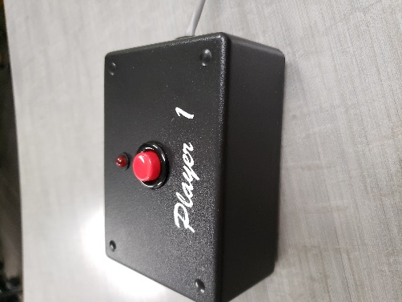
- Buzzer used during ACO practice. Insert after paragraph four

