Kenyon Gregory Jr

Students gather at Owens to enjoy NCAA March Madness
On Saturday, March 19, the Office of Student Center Recreation with Student Engagement and Campus Life hosted its March Madness Watch Party inside Owens Ballroom.
“ So, thinking about how March Madness is of high interest to folks, we wanted to give students a space where they can be in community with each other,” said Molly Bower, assistant director for Student Center Recreation with Student Engagement and Campus Life.
Forty students attended the watch party, which ran from 6 p.m. to 10 p.m. They were treated to pizza, games and NCAA basketball. The basketball games were shown on three projectors around the ballroom. Many students were playing games such as corn hole, pop-up shot, word searches and card games in between commercial breaks.
The event was promoted on flyers in Squires Student Center and outside Owens Hall as well as on social media, but the bulk of this event came in the planning process.
“Putting this event together required logistics and planning to determine the date of the watch party, what food will be served during the watch party and what games students wanted to play,” Bower said.
The basketball games bonded many students who did not know each other. During a timeout, students were cheering, applauding and high fiving each other in enjoyment of watching the games.
“We wanted students to come to our event and have a good time,” Bower said. “We knew that we could attract students who love basketball to our event, but we wanted to have other activities for students who come to our event that are not as interested in sports because we wanted them to have a good time as well.”
Junior students Joseph Canan and Dillon Shake were excited to come to the watch party because they enjoy March Madness.
“I think March Madness is unique because it brings people together to just watch basketball for a few hours,” Canan said. “I’ve met so many people here tonight that I probably would not have ever met if it was not for our love of basketball.”
“Yeah, I would say even though the Hokies are out I still wanted to come here and hang out with my friends because we enjoy every aspect of March Madness,” Shake said.
Junior students Andrea Logan and Jessica Ramirez were at the event to just hang out with friends and meet new people.
“So, I was hesitant to come to this event because I do not follow college basketball that much unless it is Tech [Virginia Tech], but I’m glad I did because it allowed me to meet new people,” Logan said. “We played Scrabble and pop-up basketball together.”
“I wanted to come to hang out with my friends and enjoy the free food and meet new people,” Ramirez said.
Molly Bower was happy to see how well the event came together because she was unsure if students would show up because of what happened the previous day. “When both the men’s and women’s basketball teams lost, I was a bit anxious because I did not know what the turnout would be as a result of both the teams losing,” Bower said. “However, I am glad that people wanted to come and hang out and watch basketball together.”
The popular game amongst the students was the pop-up shot. The game test students’ shooting accuracy under a time limit. Whoever makes the most baskets when the timer expires wins the game.
Sophomore students Shajaesza Diggs and Evan York enjoyed playing the game together because it allowed their competitive nature to come out.
“Evan and I are very competitive, and he always wins every time we play against each other,” Diggs said.
“I wouldn’t say I am that competitive, it's just that Shajaesza can’t beat me in anything,” York said.
The first time they played each other York won 32-13. The second time they played Diggs won 30-17. So, they determined whoever won the third game would be the winner. Diggs won the game 25-22, finally beating her friend.
“I was just so happy to beat him at something because he beats me at everything,” Diggs said.
When asked how it felt to lose to his friend for the first time, York responded by saying “No comment” sarcastically.
Students who attended the event said that they would want to come back if organizers decide to put this event on again, which Molly Bower hopes to do.
“I hope I can put on this event again; it was so much fun watching people hang out and enjoying each other’s company while playing games and watching basketball,” Bower said.
However, some students said that they will come back to this event if only their Hokies advanced in the NCAA tournament next year.
“Yeah, I’ll come back to this event if Tech makes it past the first round,” Canan laughs.

Target Audience:
- College students
- Ages 18-24
- Who live in the New River Valley

Photos

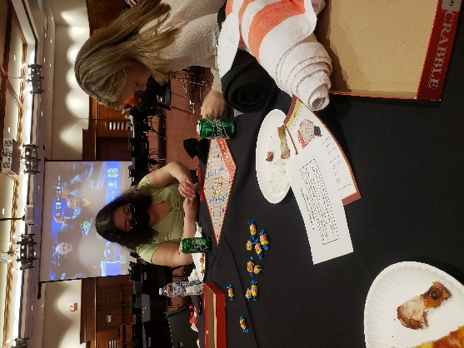

- Jessica Ramirez (left) and Andrea Logan (right) playing Scrabble. Insert in paragraph 12
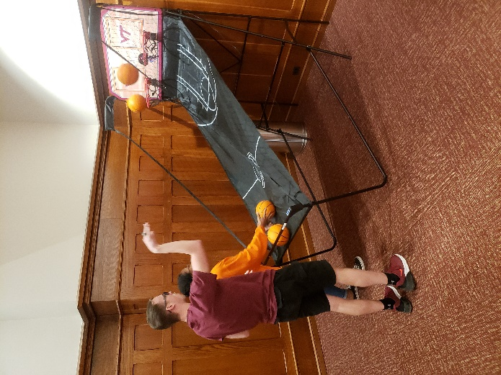
- Shajaesza Diggs and Evan York playing Pop-up shot. Insert in paragraph 16

