**Vegan Pineapple Fried Rice**

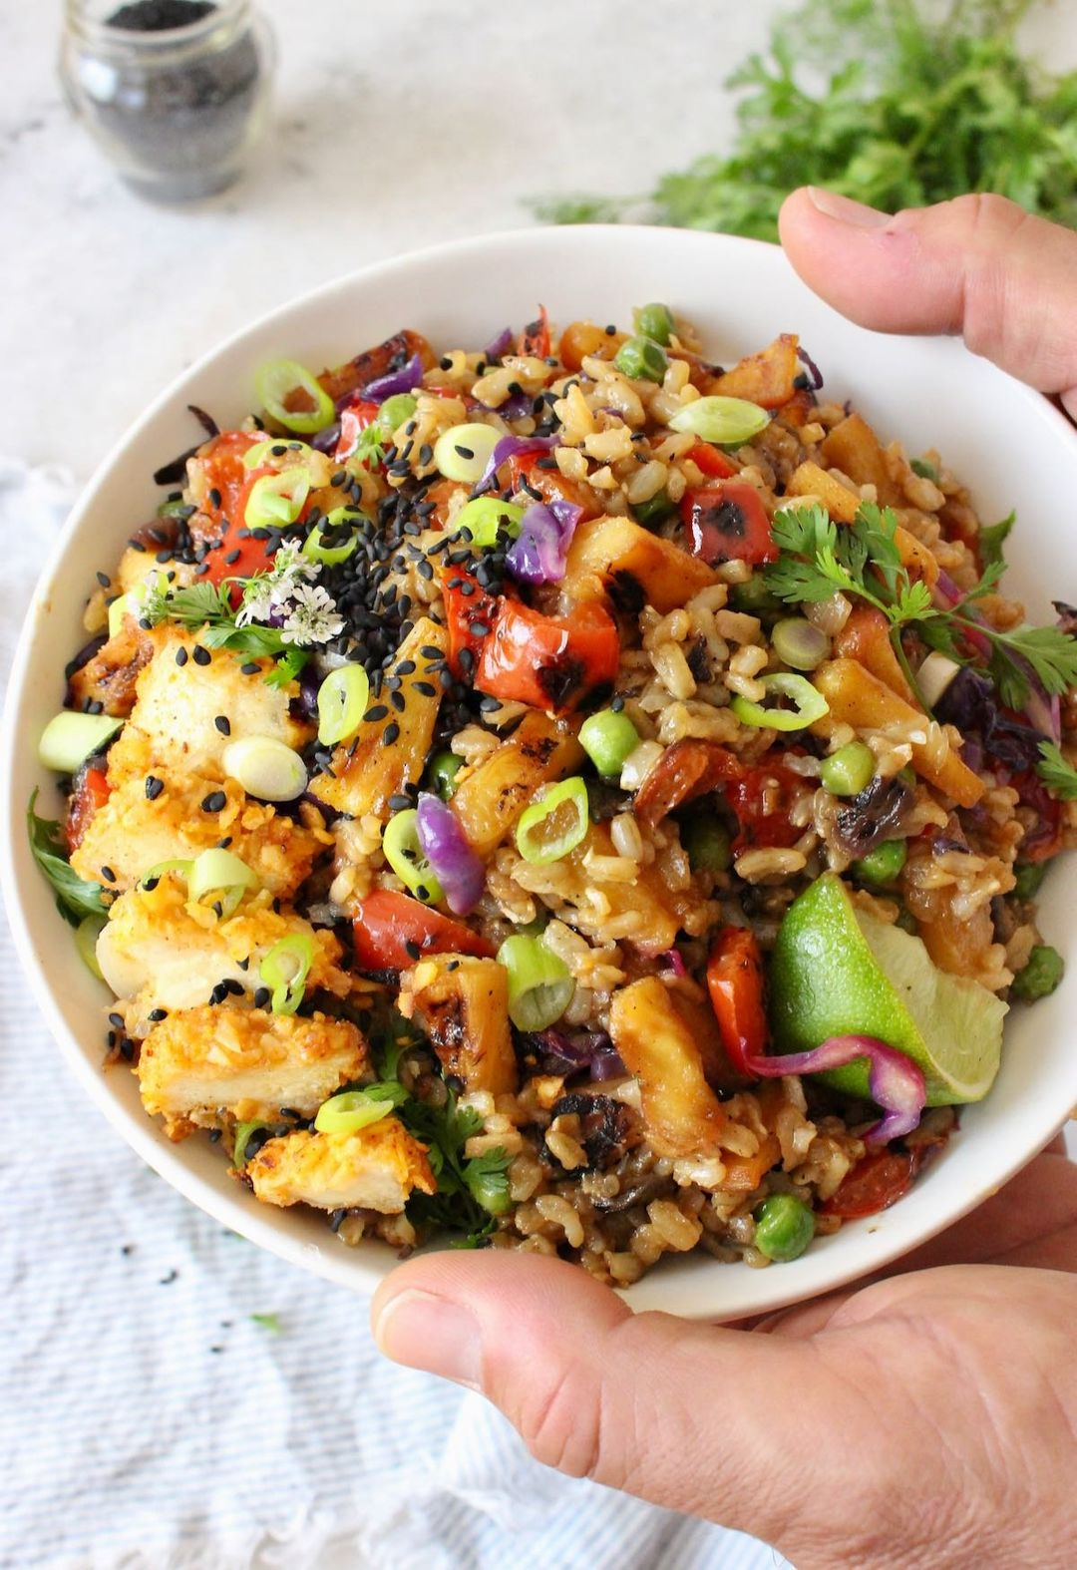

**INGREDIENTS**

* **Ingredients**
* **4-5 cups brown rice cooked and chilled**
* **2 cups pineapple chunks fresh or frozen**
* **1 red bell pepper diced**
* **3/4 cup green peas (frozen & thawed in hot water)**
* **1 cup purple cabbage shredded**
* **1/2 red onion diced**
* **3 cloves garlic minced**
* **Stir Fry Sauce**
* **4 tbsp tamari**
* **1.5 tbsp maple syrup**
* **1/2 tsp garlic powder**
* **3/4 tsp hot sauce or red chili flakes**
* **1/2 tsp ground ginger optional**
* **Garnishes: scallions, sesame seeds, lime wedges, fresh cilantro, fresh chili peppers.**
* **Cooking Instructions**
* **In a small bowl whisk together all the stir-fry sauce ingredients and set aside.**
* **Start with a hot cast iron skillet that has been seasoned well, this way you won’t need to even use any oil. Quickly sir-fry / the pineapple chunks until little caramelization takes place. Once the desire color is achieved transfer to a bowl. (If you don't have a seasoned cast iron skillet use whatever skillet you have available with a drizzle of sesame oil or a drop of water).**
* **Add the bell pepper and onion to the hot skillet stirring quickly until they start to get some color. Work quickly and take good care not to burn anything. If you feel the pan is getting too hot and anything sticks just add a little splash of water to get things moving. Scoop out the onion and pepper and reserve together with the pineapple.**
* **In the same skillet add the purple cabbage and stir fry just a minute or so until it starts to wilt. Move it to the side and add a little drop of oil (use water for WFPB & Plantricious diets) and add the garlic. Cook until just fragrant quickly stirring so it won’t burn.**
* **Add the cooked rice to the skillet together with the green peas and pour in the sauce.**
* **Remove from heat and add in the reserve veggies gently mixing everything.**
* **Sprinkle in some fresh cilantro, scallions and sesame seeds and enjoy with a fresh squeeze of lime!!**
* **Notes**
* **To make it oil-free WFPB and Plantricious compliant all you need to adapt the recipe is to stir fry / Sautee your veggies with a little drop of water or veggie broth instead of oil. Make sure to use a whole grain rice like brown, black or red. Make it soy-free by replacing the tamari sauce with equal parts of coco aminos and don’t add any tofu to the recipe. Alternatively, you can use this peanut sauce i make for my ramen noodle salad.**

**Easy vegan pineapple fried rice made with perfectly stir-fried veggies, a simple sweet and savory tamari sauce and tons of flavor. Healthy,**

**filling, gluten free and makes perfect leftovers.**

**Course Main Course**

**Cuisine Chinese**

**Keyword fried rice, plant based, vegan**

**Prep Time 10 minutes**

**Cook Time 20 minutes**

**Total Time 30 minutes**

**Servings 4 people**

**Calories 839kcal**