**Classic Italian Meatballs**

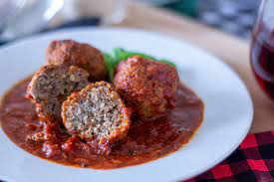

# **Classic Italian Meatballs**

**INGREDIENTS**

**1 lb. ground beef**

**1/2 cup dried bread crumbs**   
**1/2 cup whole milk ricotta**

**1 large egg**

**1/2 cup grated Romano cheese**

**1/2 tsp. freshly ground black pepper**

**1/4 cup grated yellow onion**

**1/4 cup finely diced fresh garlic**

**1/4 cup finely chopped fresh Italian parsley leaves 1/4 cup finely chopped fresh basil leaves**

**Preheat oven to 350 degrees.**

**Spray a baking sheet with olive oil cooking spray.**

**Mix all ingredients thoroughly in large bowl.**

**Roll meatballs about the size of a golf ball and place on baking sheet.**

**Place into preheated oven for approximately 30 minutes, turning meatballs over at halfway time.**

**Add to cooked sauce or serve plain as an appetizer.**