**CALIFORNIA ‘FRIED’ CHICKEN SANDWICH**

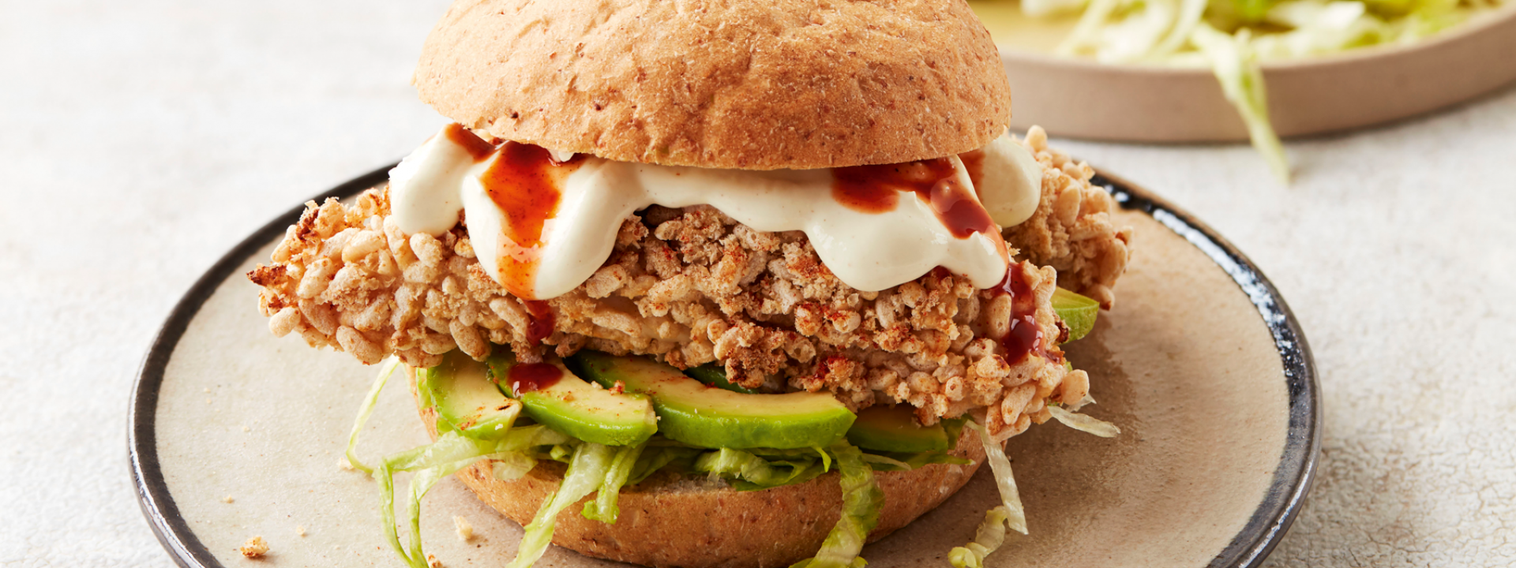

**INGREDIENTS**

* **50g wholemeal flour**
* **200ml buttermilk (or 2 eggs, beaten)**
* **150g puffed rice**
* **2 tsp garlic powder**
* **2 tsp onion powder or granules**
* **4 tsp paprika**
* **1 tsp dried sage**
* **8 mini chicken breast fillets**
* **4 wholemeal buns**
* **1 ripe avocado, peeled, stoned and sliced**
* **½ iceberg lettuce, shredded**
* **Sea salt and freshly ground black pepper**
* **Mexican hot sauce such as Cholula (optional), to serve**
* **FOR THE YOGHURT DRESSING**
* **75ml Greek yoghurt**
* **½ garlic clove, crushed**
* **1 tsp cider vinegar**

**COOKING INSTRUCTIONS**

* **Preheat the oven to 180˚C/gas 4.**
* **Put the flour, buttermilk and puffed rice into three shallow bowls. Season the flour with salt and pepper. Add the garlic powder, onion powder, paprika and dried sage to the buttermilk and mix well. Crush the puffed rice with your hands so that the pieces are broken down slightly but not powdered.**
* **Dip a piece of chicken into the flour so that it is completely covered. Remove and shake off any excess, then dip into the buttermilk. Allow any excess buttermilk to drip off, then put the chicken pieces into the puffed rice. Turn over to make sure they are completely coated, then place on a baking tray. Repeat with the remaining chicken pieces.**
* **Put the tray into the preheated oven and bake for 25–30 minutes, until golden and cooked through, turning halfway through cooking.**
* **Meanwhile, make the yoghurt dressing; mix together the yoghurt, crushed garlic and vinegar with a little salt and pepper. Taste and add more vinegar if needed.**
* **Slice open the buns and divide the avocado slices between them. Top with shredded iceberg lettuce.**
* **Once the chicken is cooked, place on top of the lettuce and spoon over dollops of the yoghurt dressing, as well as a drizzle of hot sauce, if desired. Close the buns and serve immediately.**