
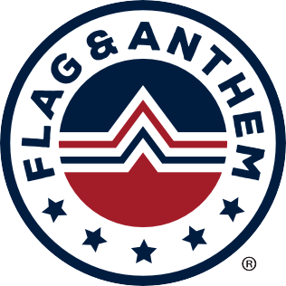


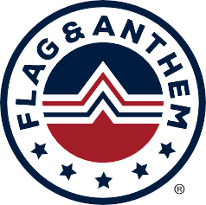
OUR BRAND
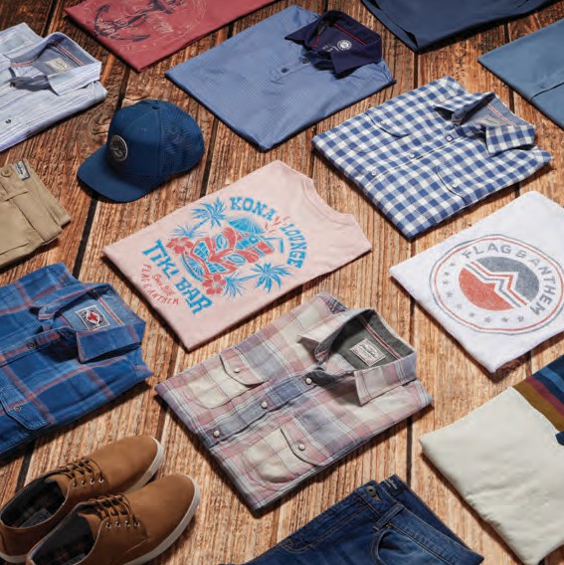
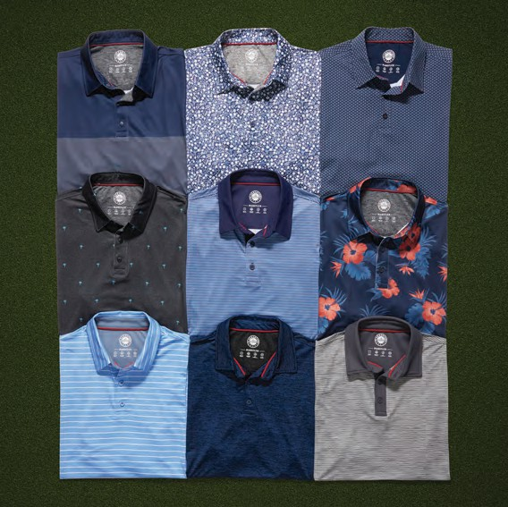

HERITAGE

Founded in 2016, Flag & Anthem is a premium lifestyle brand. Our attention to quality, detail, and fit at an affordable price sets us apart from the rest. The brand exemplifies a refined, rugged look with an authentic, vintage aesthetic and features collections for both men and women.
PERFORMANCE

MadeFlex Golf is our line of versatile performance gear, featuring some of the best technologies to maximize comfort and mobility. Made from soft, breathable, lightweight fabrics to keep you comfortable on the course, the MadeFlex Golf Collection was designed for every kind of player.

FLAGANDANTHEM.COM

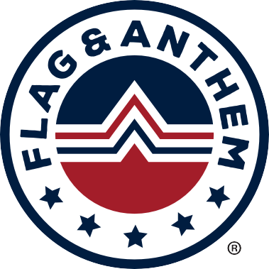
Corporate Styles


CORE ITEMS
AVAILABLE ALL SEASON

Pinehurst Solid Performance Polos

92% Polyester 8% Spandex - 495025

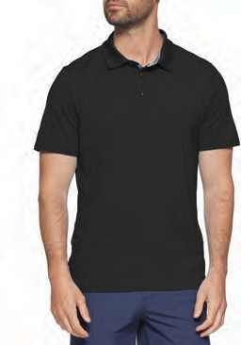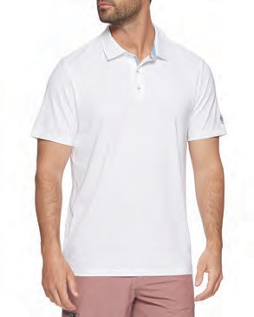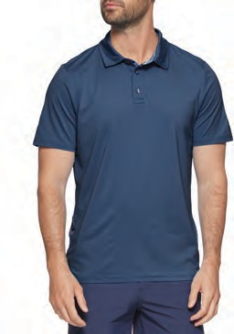

M-COREKT1519 PINEHURST BLACK
M-COREKT1519 PINEHURST WHITE
M-COREKT1519 PINEHURST NAVY

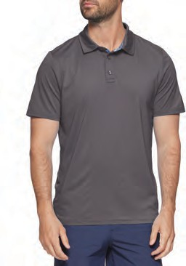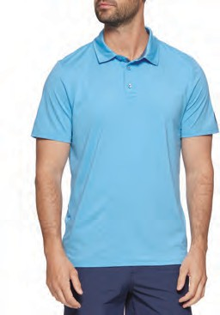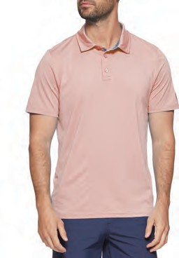

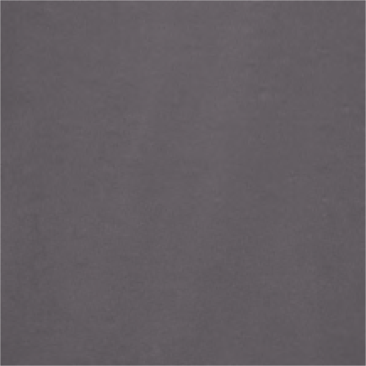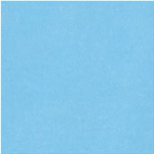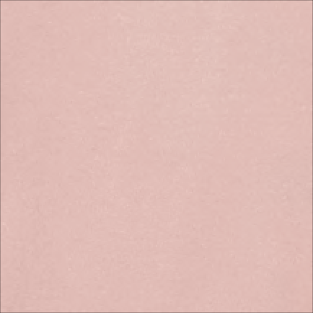

M-COREKT1519 PINEHURST CHARCOAL
M-COREKT1519 PINEHURST
MEDIUM BLUE HTHR
M-COREKT1519 PINEHURST CORAL

Pinehurst Solid Performance Polos

92% Polyester 8% Spandex - 495025
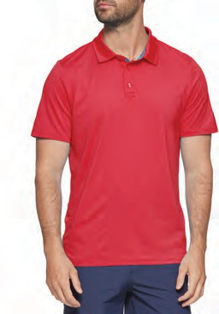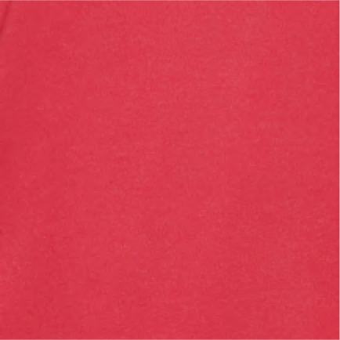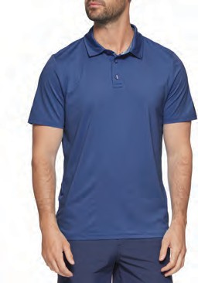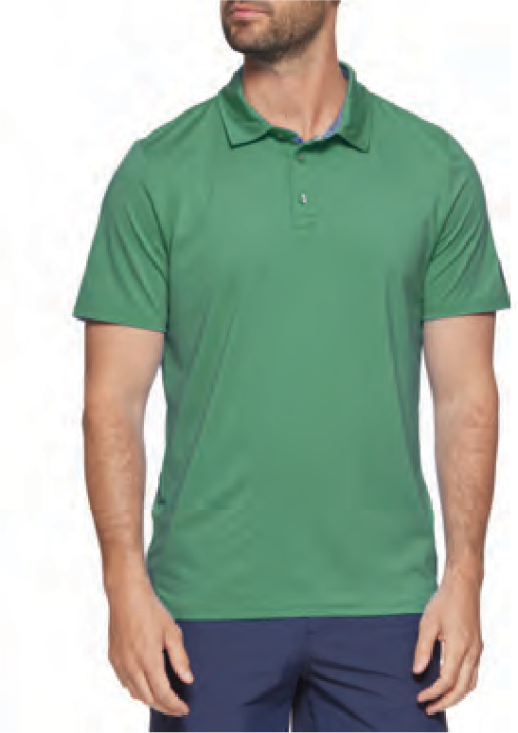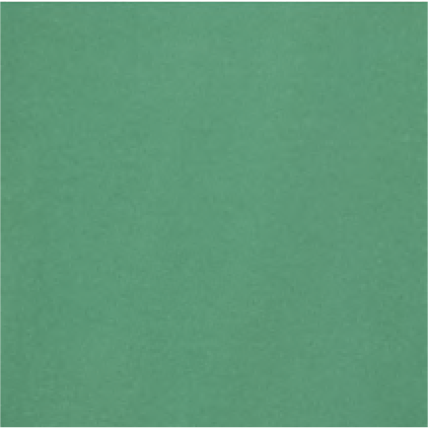

M-COREKT1519 PINEHURST RED
M-COREKT1519 PINEHURST ROYAL BLUE
M-COREKT1519 PINEHURST
KELLY GREEN HTHR

Naples Striped Performance Polos

91% Polyester 9% Spandex - 595025
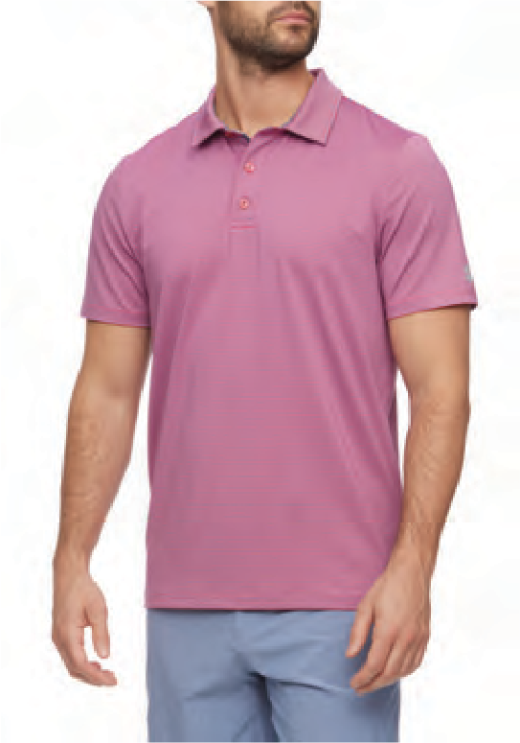
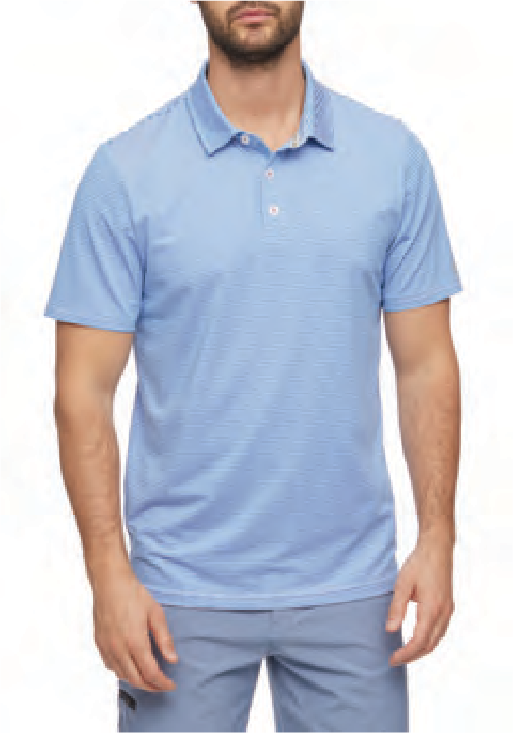
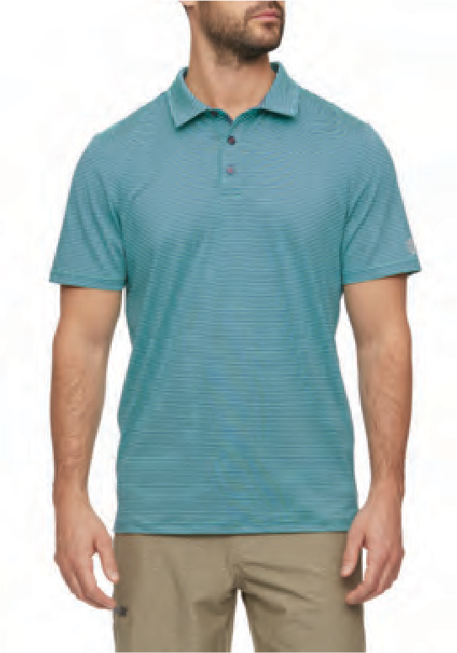

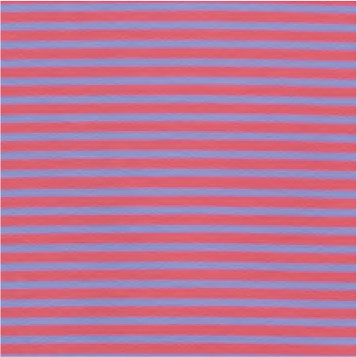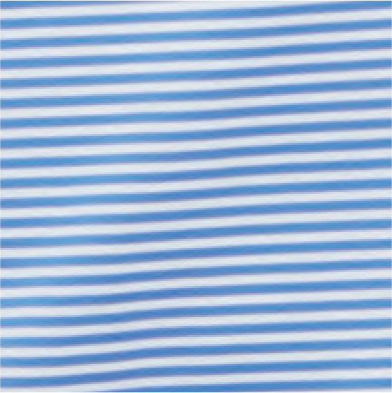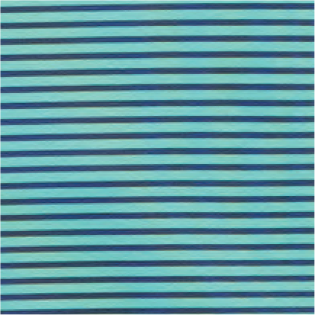

M-COREKT1522 NAPLES MINI STRIPE RED/BLUE
M-COREKT1522 NAPLES MINI STRIPE WHITE/BLUE
M-COREKT1522 NAPLES MINI STRIPE GREEN/BLUE

Naples Striped Performance Polos

91% Polyester 9% Spandex - 595025

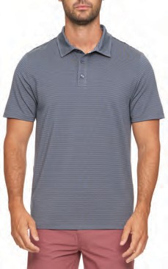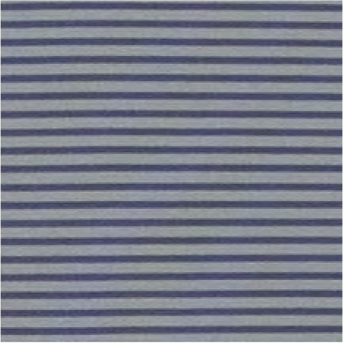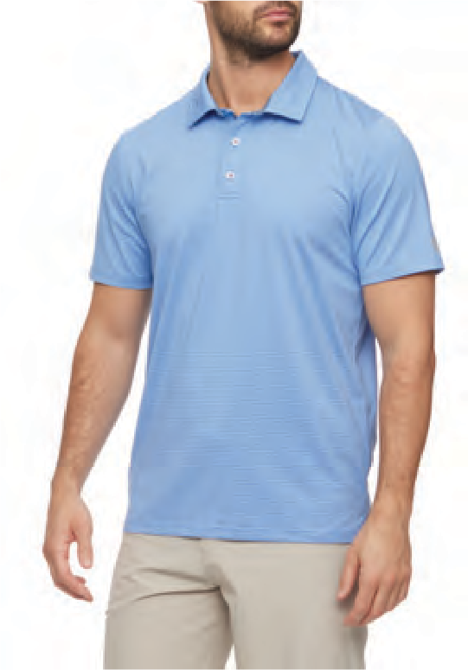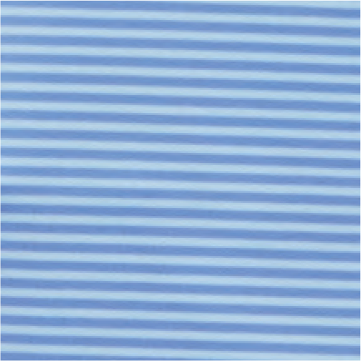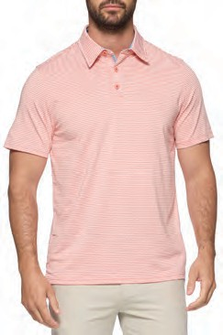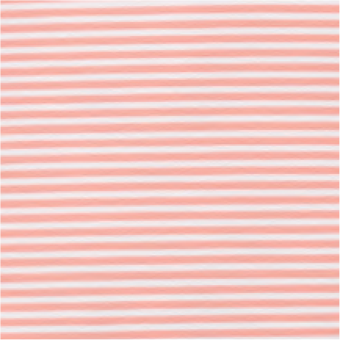

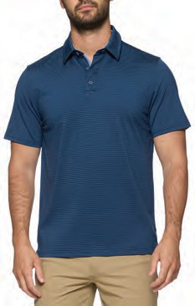
M-COREKT1522 NAPLES MINI STRIPE CHARCOAL/BLACK
M-COREKT1522 NAPLES MINI STRIPE LT BLUE/BLUE
M-COREKT1522 NAPLES MINI STRIPE CORAL/WHITE

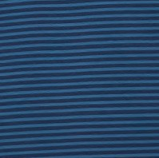
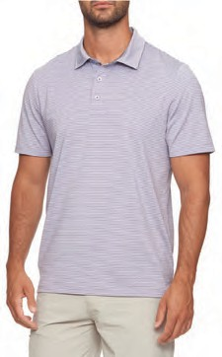

M-COREKT1522 NAPLES MINI STRIPE NAVY/BLUE
M-COREKT1522 NAPLES MINI STRIPE PINK/BLUE

Wilmington Striped Performance Polos

93% Polyester 7% Spandex - 595025

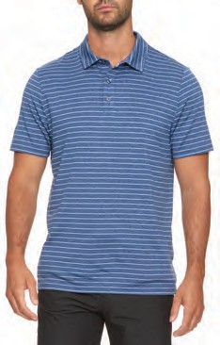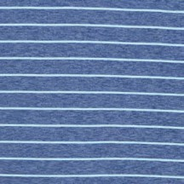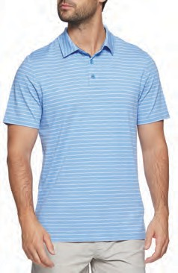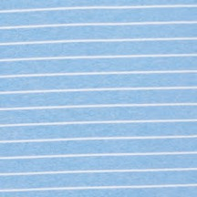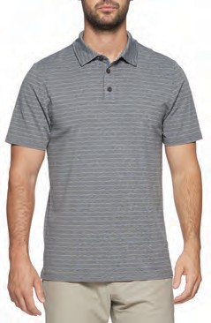

M-COREKT1564 WILMINGTON HEATHERED STRIPE
NAVY COMBO
M-COREKT1564 WILMINGTON HEATHERED STRIPE
BLUE HTHR
M-COREKT1564 WILMINGTON HEATHERED STRIPE
CHARCOAL HTHR COMBO

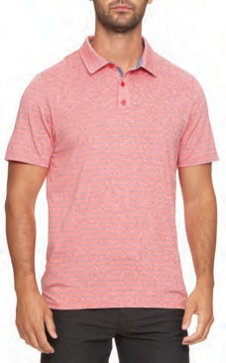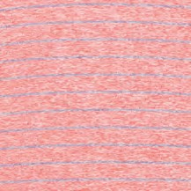
M-COREKT1564 WILMINGTON HEATHERED STRIPE
RED COMBO

MVP Cobbtown Floral Print Performance Polos

89% Polyester 11% Spandex - 595025
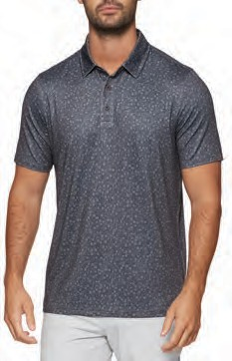
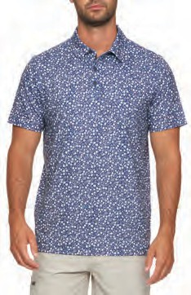
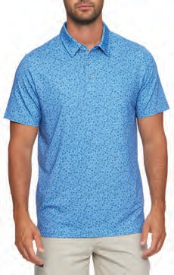

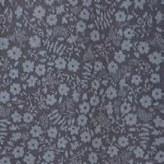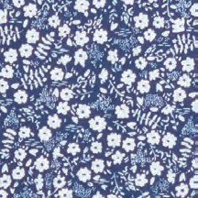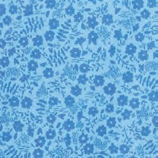

M-COREKT1606
MVP COBBTOWN FLORAL PRINT BLACK/CHARCOAL
M-COREKT1606
MVP COBBTOWN FLORAL PRINT NAVY COMBO
M-COREKT1606
MVP COBBTOWN FLORAL PRINT BLUE COMBO

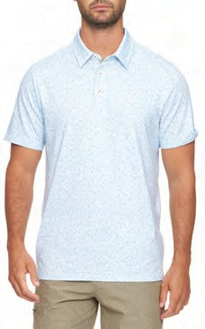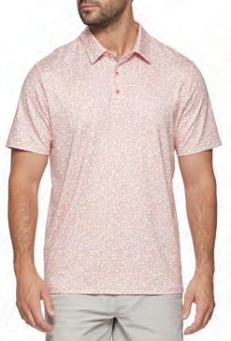

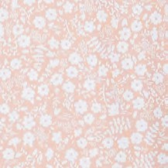

M-COREKT1606
MVP COBBTOWN FLORAL PRINT WHITE COMBO
M-COREKT1606
MVP COBBTOWN FLORAL PRINT CORAL

MVP Cashiers Geo Dot Performance Polos

89% Polyester 11% Spandex - 595025
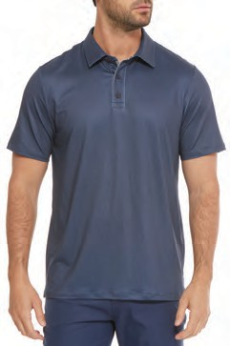
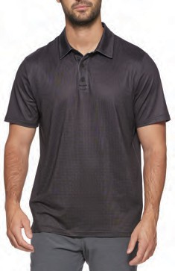
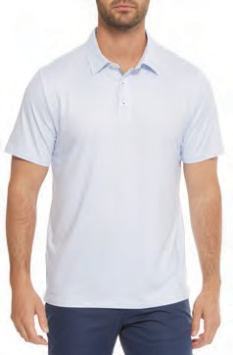

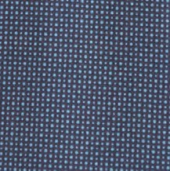

M-COREKT1779
MVP CASHIERS GEO DOT PRINT NAVY COMBO
M-COREKT1779
MVP CASHIERS GEO DOT PRINT BLACK
M-COREKT1779
MVP CASHIERS GEO DOT PRINT WHITE COMBO

MVP Kiawah Contrast Collar Striped Performance Polos

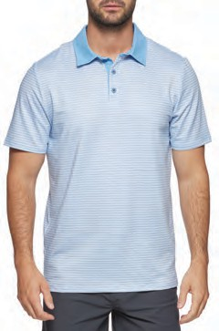
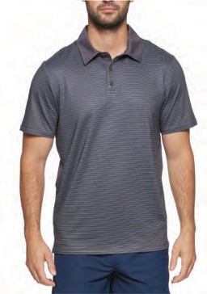
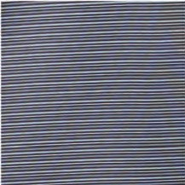
89% Polyester 11% Spandex - 595025
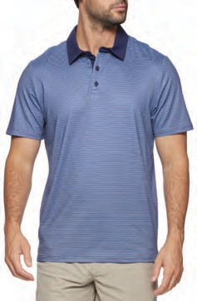

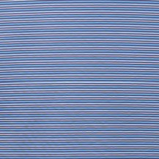
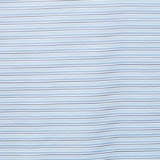
M-COREKT1870
MVP KIAWAH STRIPE CONTRAST COLLAR NAVY/BLUE/AQUA
M-COREKT1870
MVP KIAWAH STRIPE CONTRAST COLLAR WHITE/AQUA/NAVY
M-COREKT1870
MVP KIAWAH STRIPE CONTRAST COLLAR BLACK COMBO

Journey 1/4-Zip Performance Pullover

54% Nylon 46% Spandex - 795025
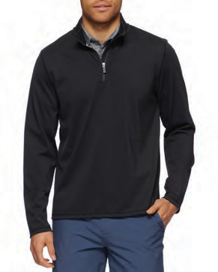
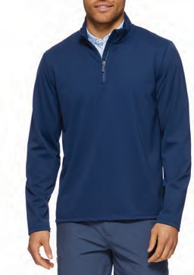
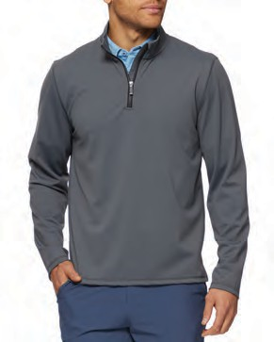
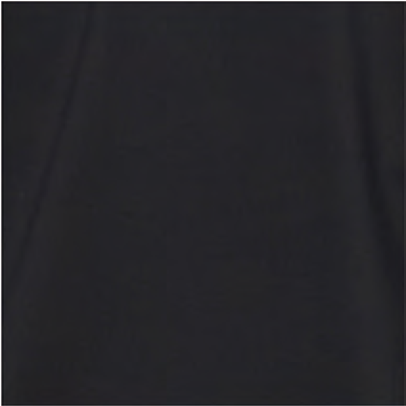
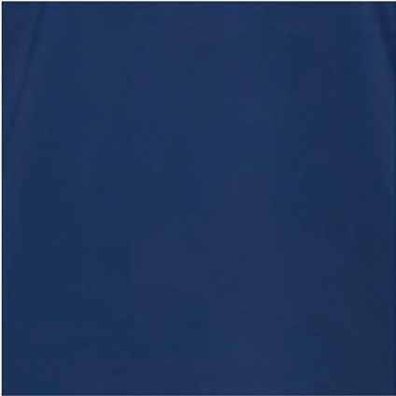
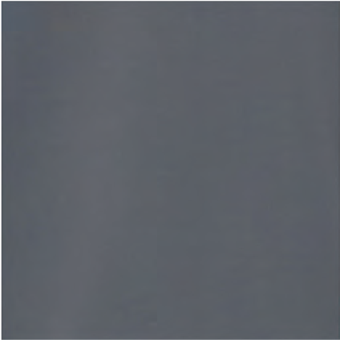

M-COREKT1960 JOURNEY 1/4 ZIP PULLOVER
BLACK

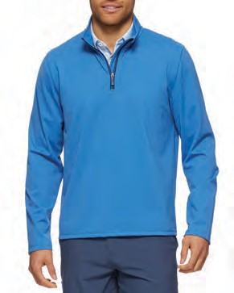


M-COREKT1960 JOURNEY 1/4 ZIP PULLOVER
MEDIUM BLUE
M-COREKT1960 JOURNEY 1/4 ZIP PULLOVER
NAVY

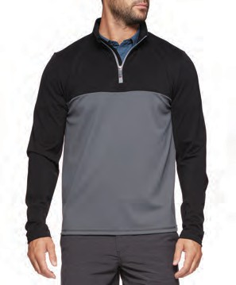
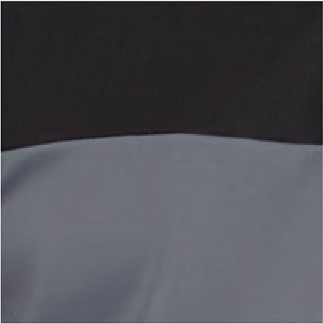

M-COREKT1837
JOURNEY 1/4 ZIP BLOCKED PULLOVER CHARCOAL / BLACK
M-COREKT1960 JOURNEY 1/4 ZIP PULLOVER
CHARCOAL

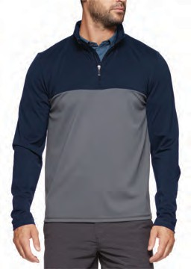

M-COREKT1837
JOURNEY 1/4 ZIP BLOCKED PULLOVER NAVY / CHARCOAL

Journey 1/4-Zip Performance Pullover

54% Nylon 46% Spandex - 795025
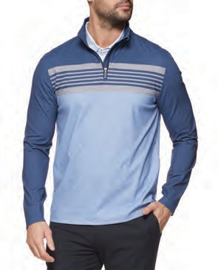
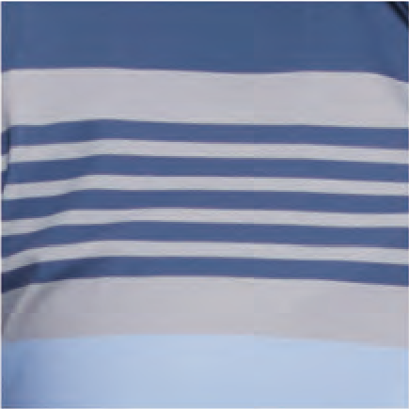
M-COREKT1982
JOURNEY BLOCKED STRIPE 1/4 ZIP PULLOVER NAVY COMBO

Beemer Dot 1/4-Zip Performance Pullover

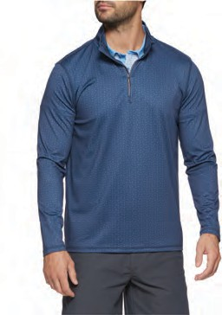
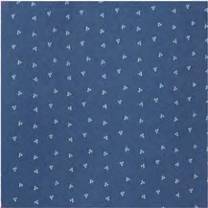
86% Polyester 14% Spandex - 795025
PLACEHOLDER

M-COREKT1838 BEEMER DOT 1/4 ZIP PULLOVER
NAVY

Victory Performance Hoodie

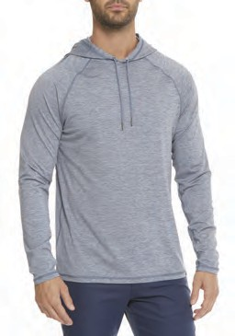
88% Polyester 12% Spandex - 595025
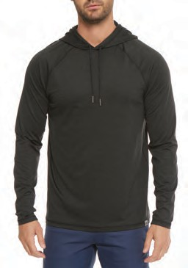
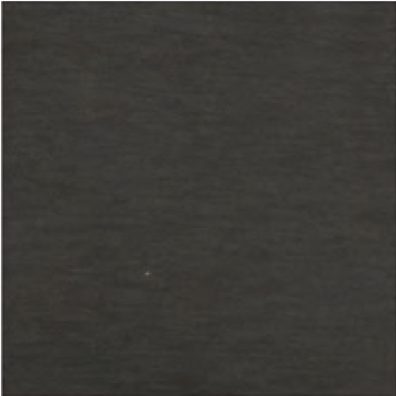
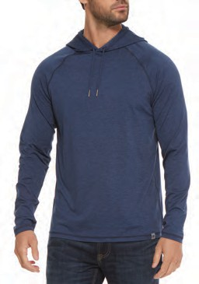

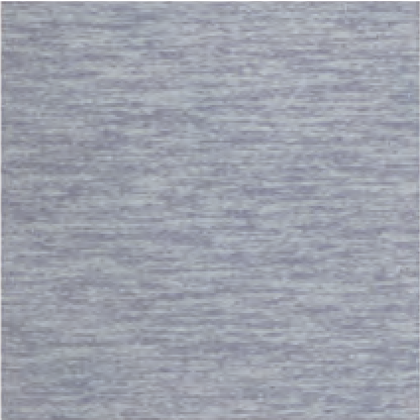
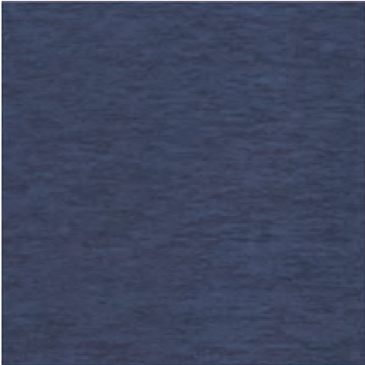
M-COREKT1752 VICTORY PERFORMANCE HOODIE
CHARCOAL HTHR
M-COREKT1752 VICTORY PERFORMANCE HOODIE
NAVY HTHR
M-COREKT1752 VICTORY PERFORMANCE HOODIE
SLATE HTHR

CORE HOODIES

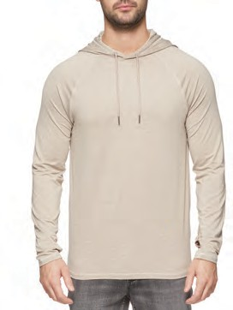
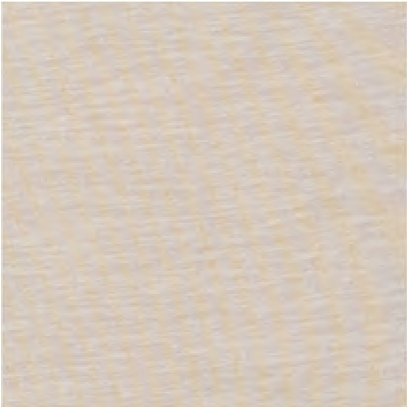
M-COREKT1752 VICTORY PERFORMANCE HOODIE
OATMEAL HTHR

LS Journey Shirts

76% Nylon 24% Spandex - 695025
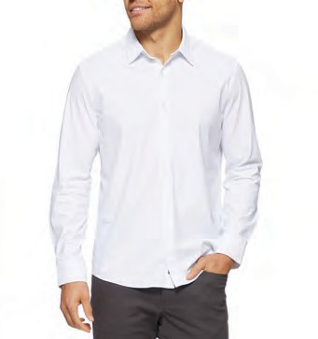
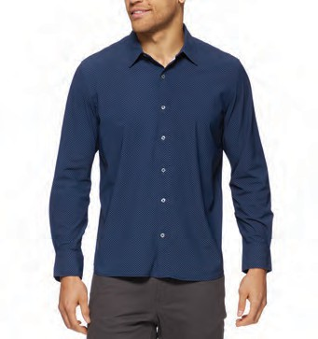
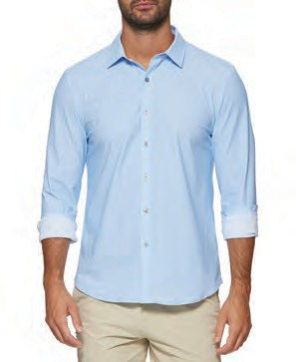

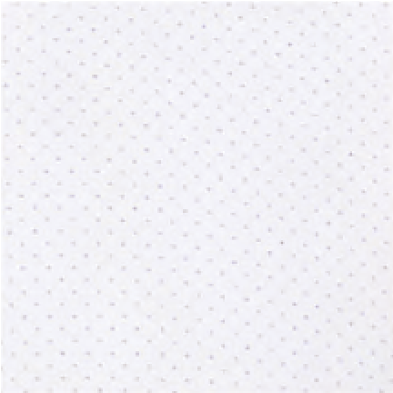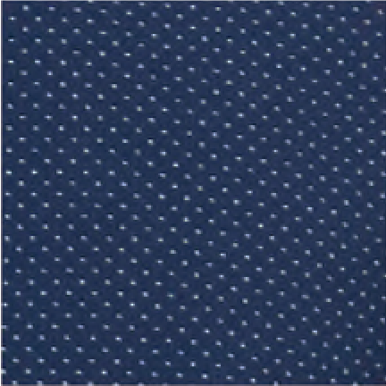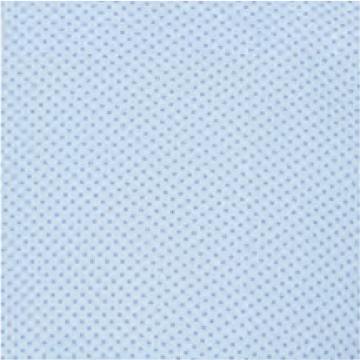

M-SP24WS1859 LORETTO LS DOT JOURNEY SHIRT
WHITE
M-SP24WS1859 LORETTO LS DOT JOURNEY SHIRT
NAVY
M-SM24WS2038 HARTLAND LS JOURNEY SHIRT
LIGHT BLUE

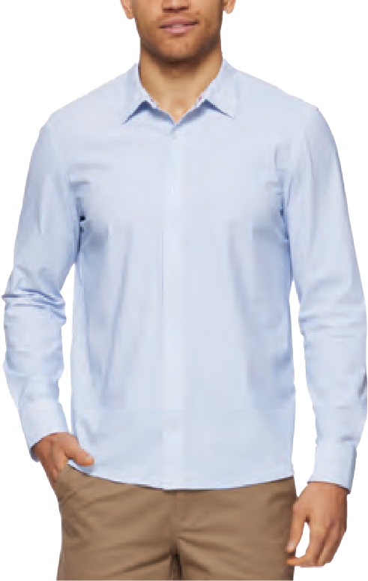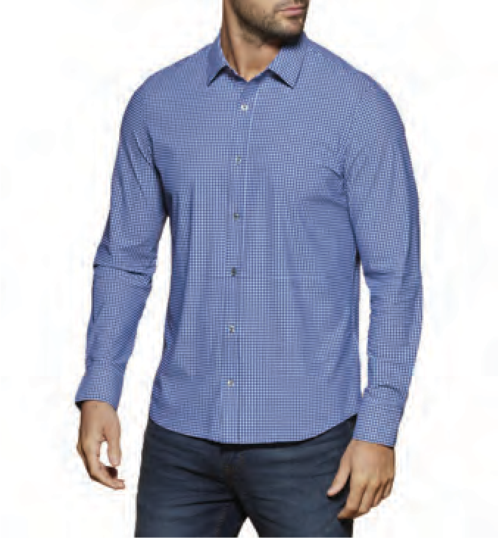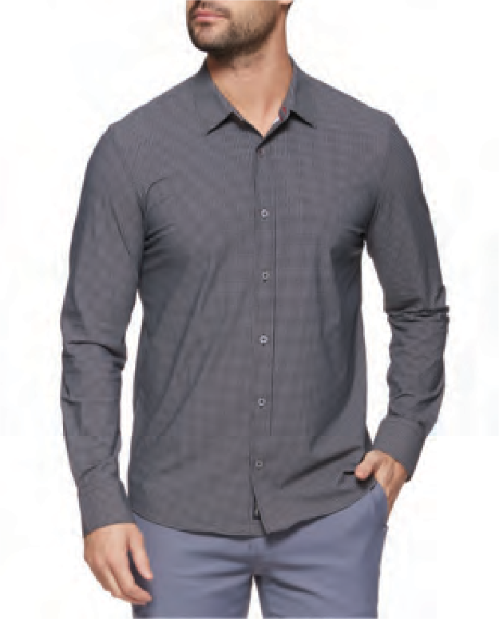

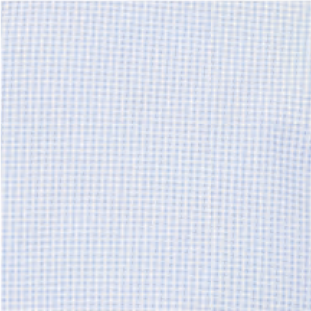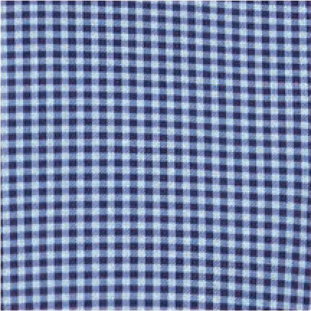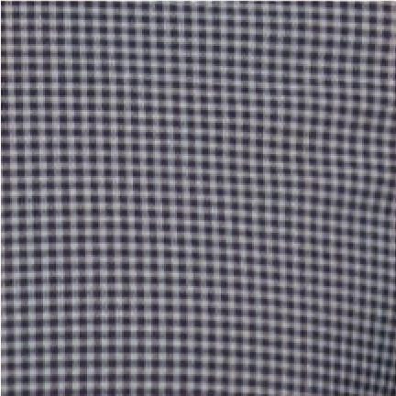

M-SP24WS1896
CORE LS JOURNEY SHIRTS
PATTON LS GINGHAM JOURNEY SHIRT BLUE
M-SP24WS1896
PATTON LS GINGHAM JOURNEY SHIRT BLUE/BLACK
M-SP24WS1896
PATTON LS GINGHAM JOURNEY SHIRT BLACK/GREY

Performance Jackets & Vests
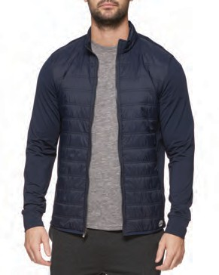
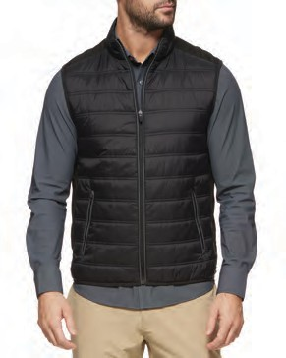
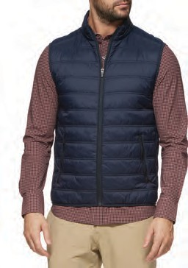
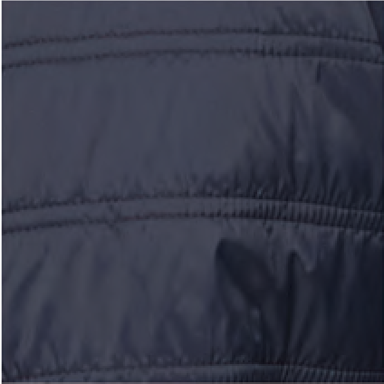
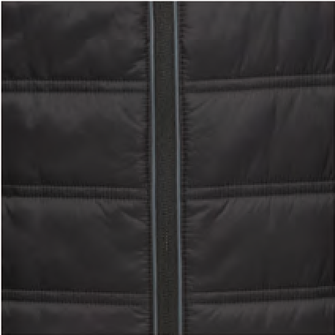
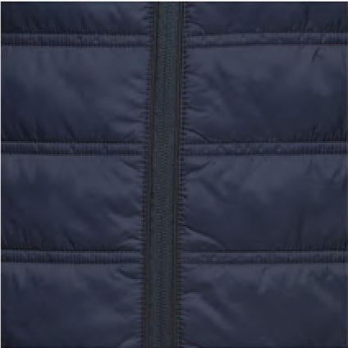

M-SP24OW1978 WORTHINGTON PUFFER JACKET
NAVY
100% Polyester
995025
M-HO23OW1772 WORTHINGTON PUFFER VEST BLACK
100% Polyester
895025
M-HO23OW1772 WORTHINGTON PUFFER VEST NAVY
100% Polyester
895025

CORE LAYERING
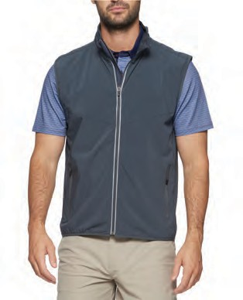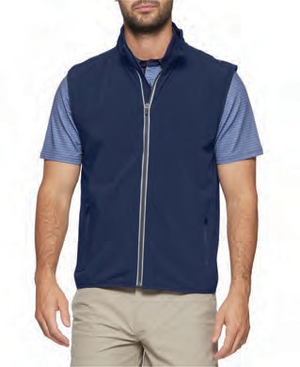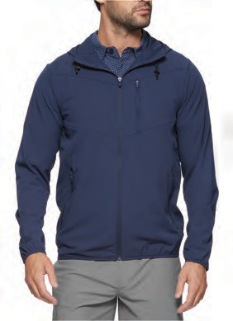
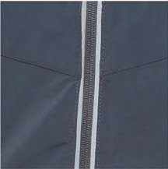
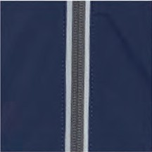
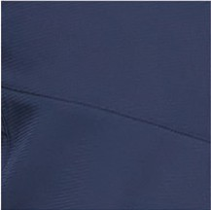

M-SP25OW2410  PIVOT VEST GREY | M-SP25OW2410  PIVOT VEST NAVY | M-SP25OW2406  PIVOT JACKET NAVY
100% Polyester | 100% Polyester | 100% Polyester
895025 | 895025 | 995025

Pivot Performance Pant

90% Polyester 10% Spandex - 795025

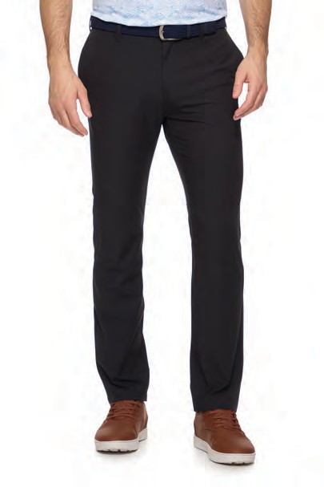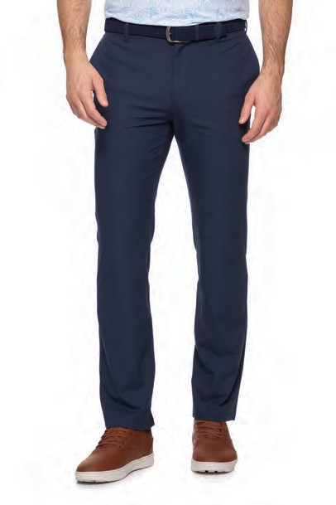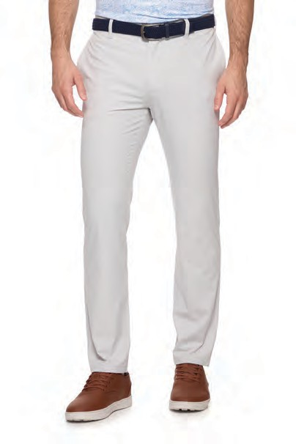

M-COREPT2065
PIVOT PERFORMANCE PANT BLACK
M-COREPT2065
PIVOT PERFORMANCE PANT NAVY
M-COREPT2065
PIVOT PERFORMANCE PANT LIGHT GREY

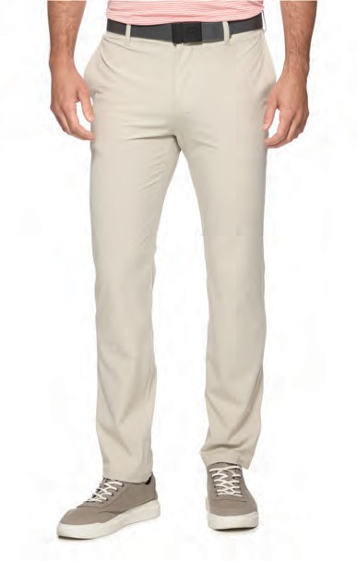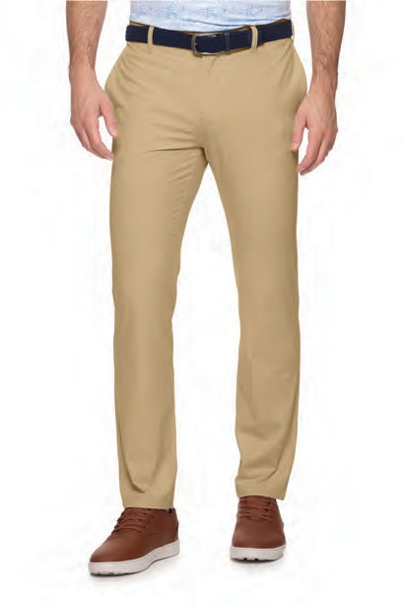

M-COREPT2065 PIVOT PERFORMANCE PANT
KHAKI
M-COREPT2065 PIVOT PERFORMANCE PANT
STONE

Range Performance Pant

100% Polyester - 795025

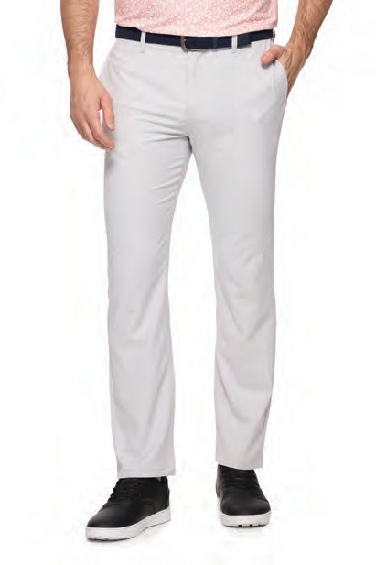
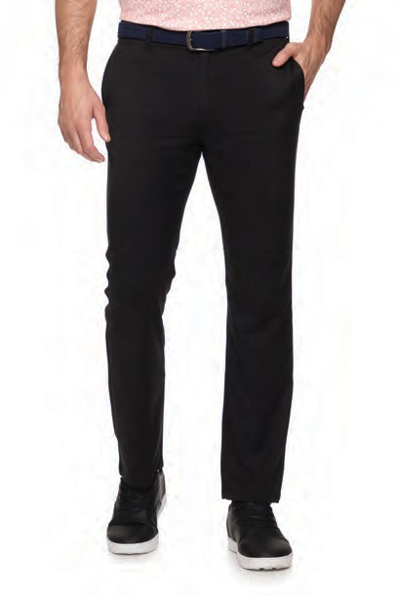
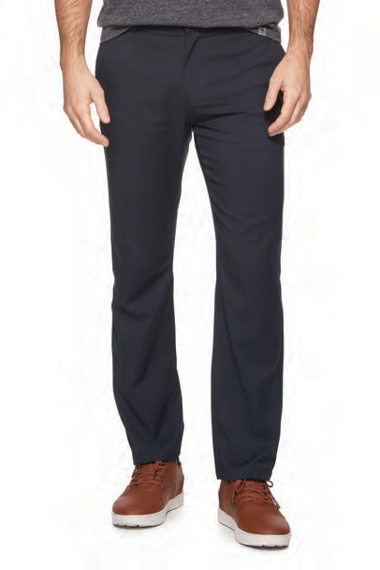
M-COREPT2067 RANGE PERFORMANCE PANT
BLACK
M-COREPT2067 RANGE PERFORMANCE PANT
NAVY
M-COREPT2067 RANGE PERFORMANCE PANT
LIGHT GREY

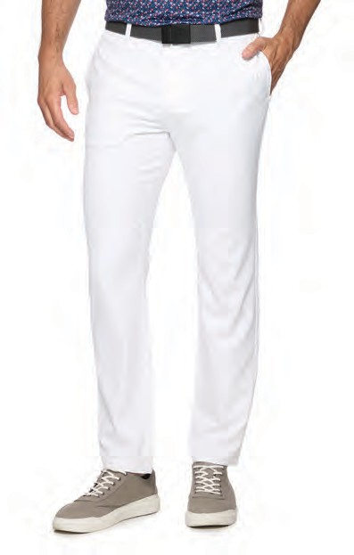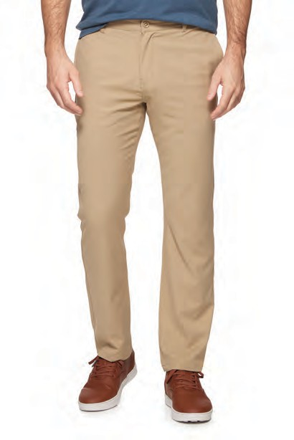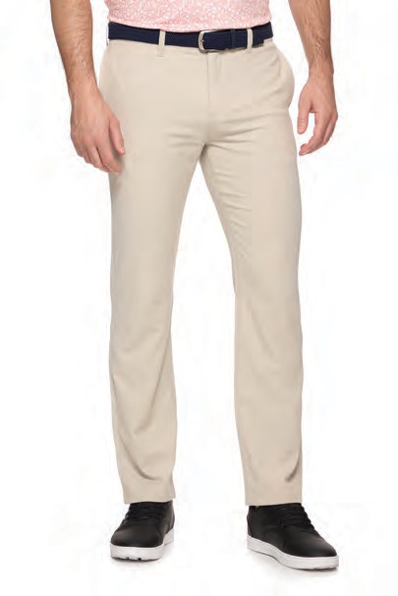

M-COREPT2067 RANGE PERFORMANCE PANT
KHAKI
M-COREPT2067 RANGE PERFORMANCE PANT
STONE
M-COREPT2067 RANGE PERFORMANCE PANT
WHITE

Journey 5-pocket Performance Pant

100% Polyester - 795025

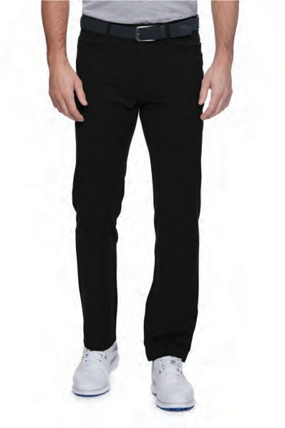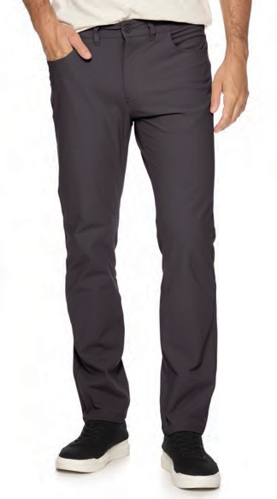

M-COREPT1763 JOURNEY 5-POCKET PANT
BLACK
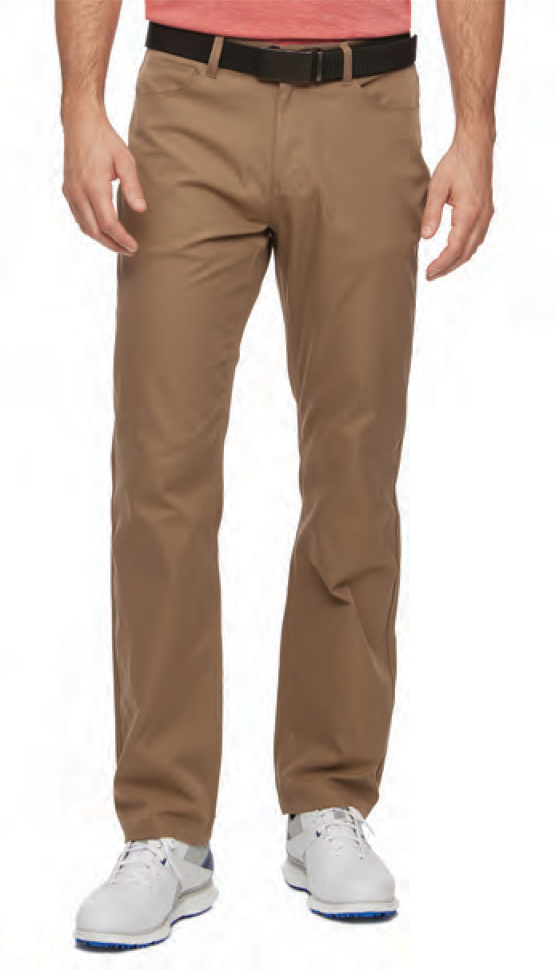

M-COREPT1763 JOURNEY 5-POCKET PANT
KHAKI
M-COREPT1763 JOURNEY 5-POCKET PANT
CHARCOAL

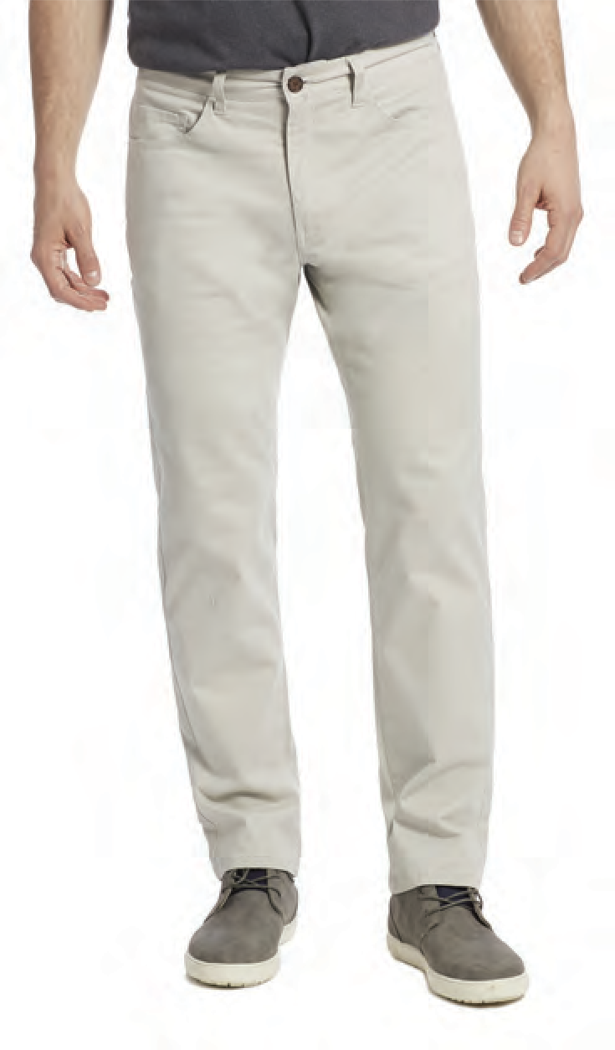
M-COREPT1763 JOURNEY 5-POCKET PANT
STONE
M-COREPT1763 JOURNEY 5-POCKET PANT
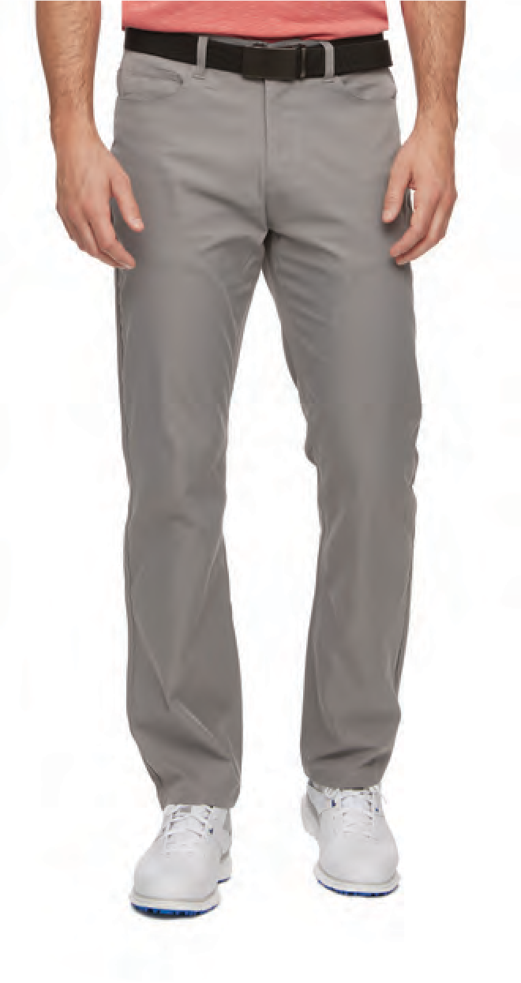
GREY

Pivot Performance Short - 8” Inseam

90% Polyester 10% Spandex - 595025

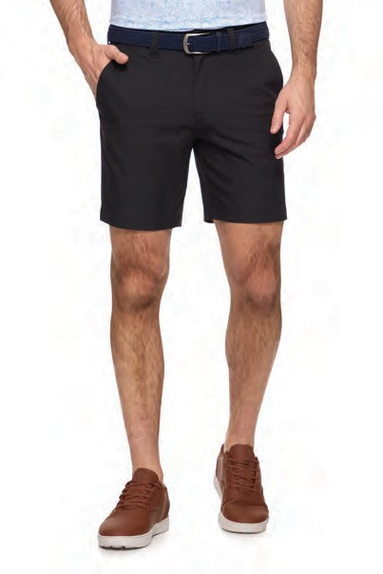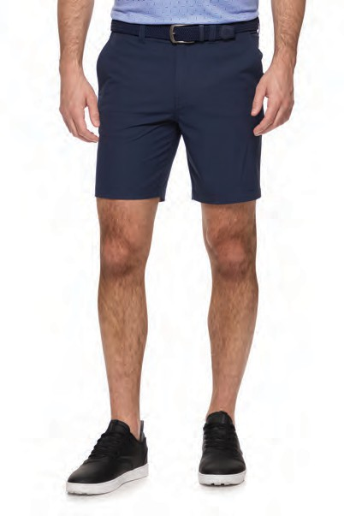

M-CORESH2066
PIVOT 8” PERFORMANCE SHORT BLACK
M-CORESH2066
PIVOT 8” PERFORMANCE SHORT NAVY
M-CORESH2066
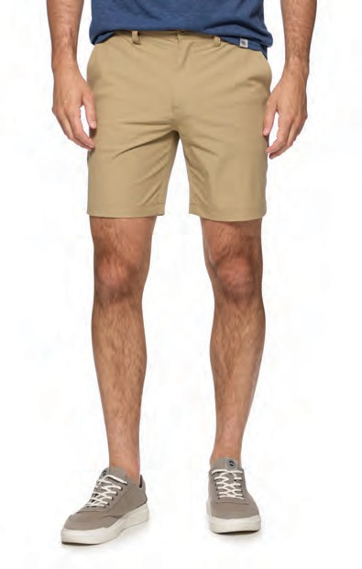
PIVOT 8” PERFORMANCE SHORT KHAKI

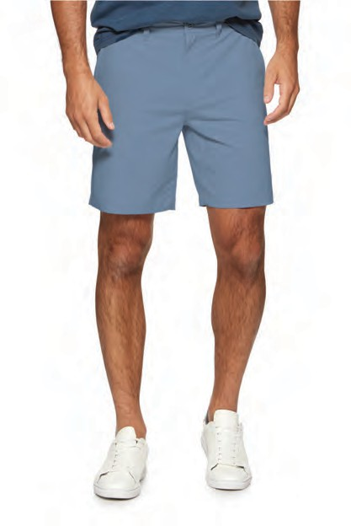
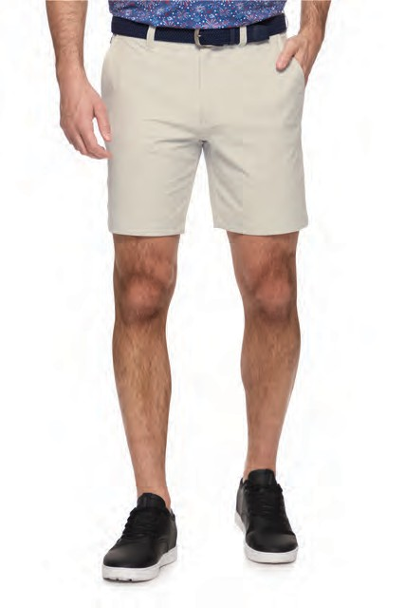
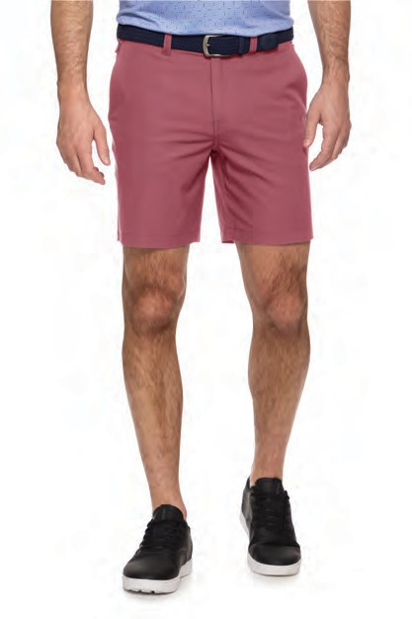
M-CORESH2066
PIVOT 8” PERFORMANCE SHORT STONE
M-CORESH2066
PIVOT 8” PERFORMANCE SHORT LIGHT BLUE
M-CORESH2066
PIVOT 8” PERFORMANCE SHORT DUSTY MAUVE

Pivot Performance Short - 10” Inseam

90% Polyester 10% Spandex - 595025
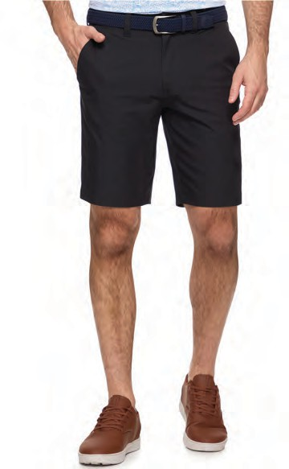
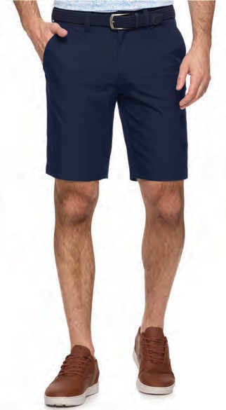
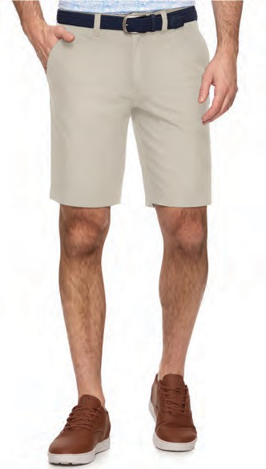

M-CORESHE2348
PIVOT 10” PERFORMANCE SHORT BLACK
M-CORESHE2348
PIVOT 10” PERFORMANCE SHORT NAVY
M-CORESHE2348
PIVOT 10” PERFORMANCE SHORT STONE

Range Performance Short - 8” Inseam

100% Polyester - 595025

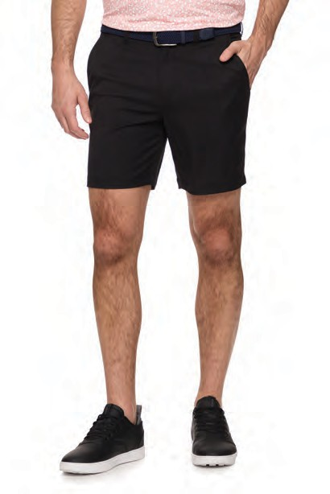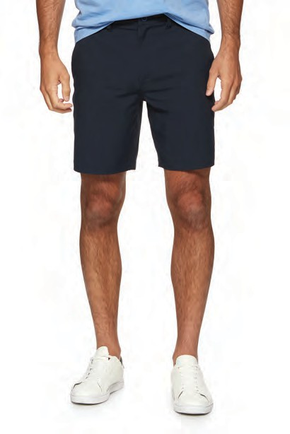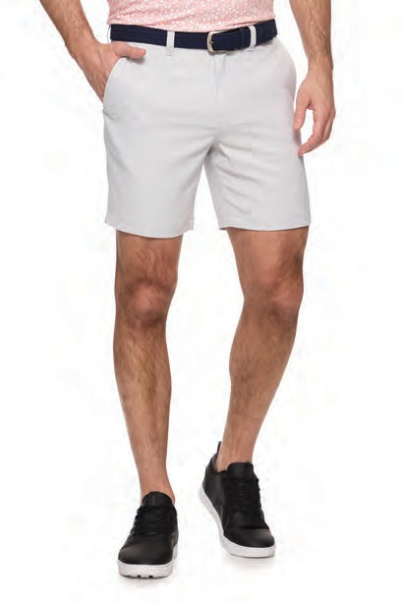

M-CORESH2068 RANGE PERFORMANCE SHORT
BLACK

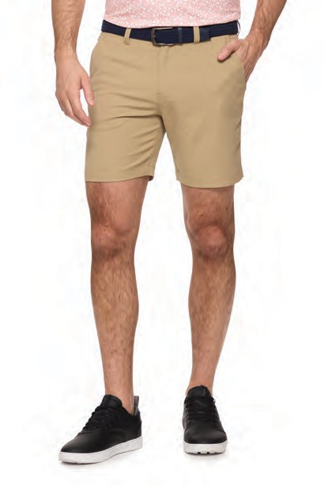
M-CORESH2068 RANGE PERFORMANCE SHORT
KHAKI
M-CORESH2068 RANGE PERFORMANCE SHORT
NAVY

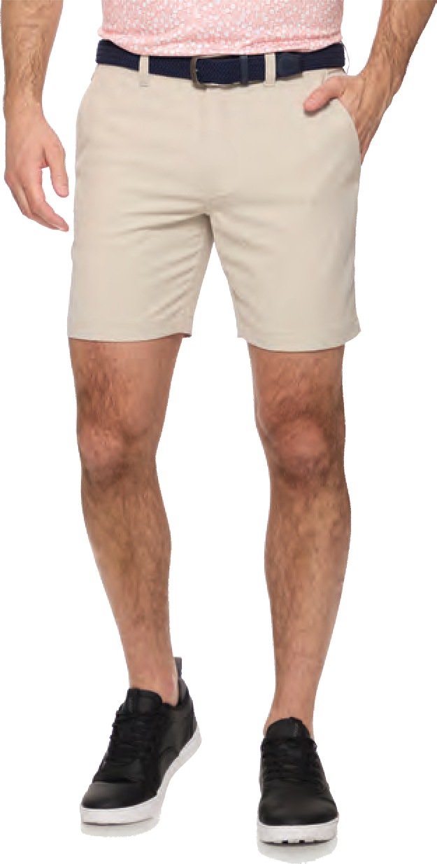
M-CORESH2068 RANGE PERFORMANCE SHORT
STONE
M-CORESH2068 RANGE PERFORMANCE SHORT
LIGHT GREY
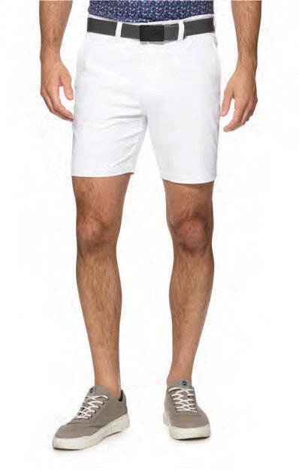
M-CORESH2068 RANGE PERFORMANCE SHORT
WHITE

