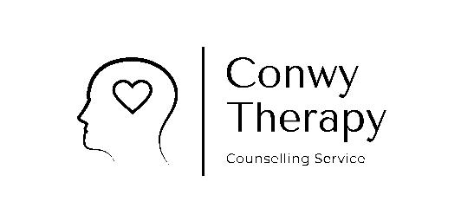
Charlotte Rawlingson
Conwy Therapy

Our Counselling Contract (Face to Face)
Counselling is a process shared by both counsellor and client, it requires commitment and courage. You may feel distressed at times during the counselling as you come in contact with feelings that have you have been out of touch with for some time. Self-care, and being in touch with supportive friends and or family can often help to ease your experience.
All of our Counselling sessions will be confidential. However, there are certain circumstances where that confidentiality may need to be broken. These may be
- Where you share information, which indicates you may seriously harm yourself or others.
- Where you share information, which indicates a child or vulnerable adult may be at risk of serious harm or is being abused in some way.
- Where you share information pertaining to terrorism, drug trafficking or money laundering.
I am a member of the British Association for Counselling and Psychotherapy,(BACP) and so am bound by the BACP`S Ethical Framework for Good Practice. For more information please visit: www.bacp.co.uk
Basic notes will be written about our session and will be kept in a locked secure place they and your personal details (as below) remain confidential and accessible on request according to the 2018 GDPR Data Protection Act.
I am registered with the ICO (Information Commissioner’s Office) and therefor follow their guidelines to ensure all client information is stored in line with the current Law.
In accordance with the BACP Ethical Guidelines I attend regular supervision, this enables me to offer you my best professional practice.
If we are faced with each other in a public space I shall avoid eye contact unless you wish to approach me, then I will be polite but brief. This is to enable us to maintain your confidentiality, this extends to after your sessions have ended. Our sessions will last 1 Hour.
Payment if made through private arrangement is payable at the end of each session, cash or BACS preferred. Thank you.
If you are not able to come along to your session I would appreciate at least 48 hrs notice where possible. In some cases where less than 24hrs is given you may lose that session (if under work scheme) or you will still be charged as I have ongoing costs and overheads.
In the event of my having to cancel our session I will give you as much notice as possible and an alternative date for your missed appointment.

Name |  | Address
Email |  | Contact Number
Emergency Contact |  | GP Surgery Details

If you wish to negotiate any changes I will be happy to discuss before you sign. This agreement is fully understood and agreed to and is signed as it stands by:

Clients signature: ______________________________________ Date :______________

Counsellors signature: __________________________________ Date :______________

