Anna

Warner

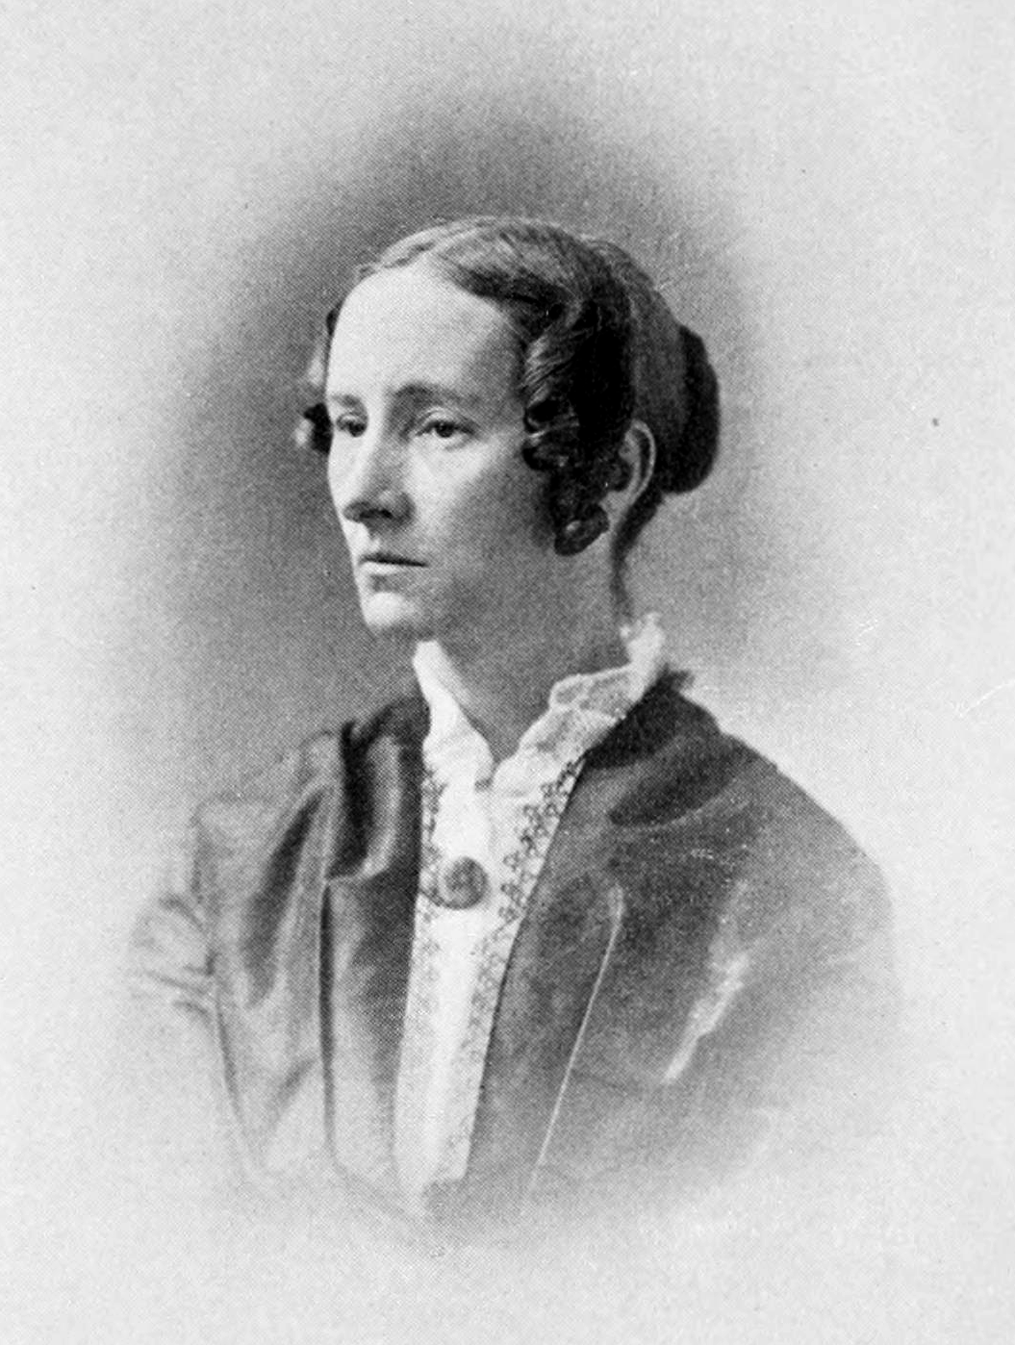

Author

Hymn Writer

Master Gardener

American Patriot

A small green rectangle to divide sections of the document

# About Anna

Anna Warner, along with her sister Susan, was an author and hymn writer during the 19th century. She is most remembered for writing the hymn “Jesus Loves Me.” Since the two sisters lived on Constitution Island, just across the Hudson River from West Point, New York, they were able to have a thriving outreach to the cadets attending the academy for over 40 years.

A small green rectangle to divide sections of the document

# About the Program

The program is offered by History Come to Life. By addressing the audience as a historical personality, in period dress, History Come to Life's presenters engage the minds and imaginations of audiences in a way that draws them into the subject at hand, weaving a combination of facts and principles into a compelling narrative.

A small green rectangle to divide sections of the document

# Details

|  |
| --- |
| Date  Time  Location |

Find out more about History Come to Life by visiting our website at: [*historycometolife.com*](https://www.historycometolife.com/)