**Corrie**

**Ten Boom**

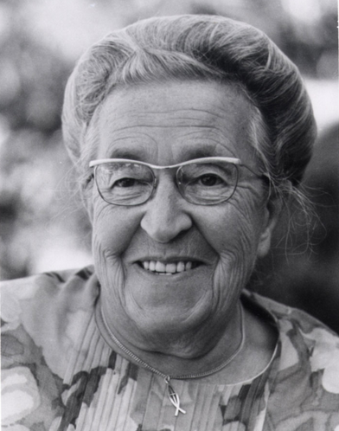

“The measure of a life, after all, is not its duration, but it’s donation.”

A small green rectangle to divide sections of the document

# **About Corrie**

Corrie ten Boom and her family helped many Jewish people flee the terror of the Nazis. As a result, her family members were sent to concentration camps, where most of them died. She later travelled the world with the message, “There is no pit within God's will where His great love is not deeper still.”

A small green rectangle to divide sections of the document

# **About the Program**

The program is offered by History Come to Life. By addressing the audience as a historical personality, in period dress, History Come to Life's presenters engage the minds and imaginations of audiences in a way that draws them into the subject at hand, weaving a combination of facts and principles into a compelling narrative.

A small green rectangle to divide sections of the document

# **More Details**

|  |
| --- |
| Date  Time  Location |

Find out more about History Come to Life by visiting our website at: [*historycometolife.com*](https://www.historycometolife.com/)