Fanny
Crosby
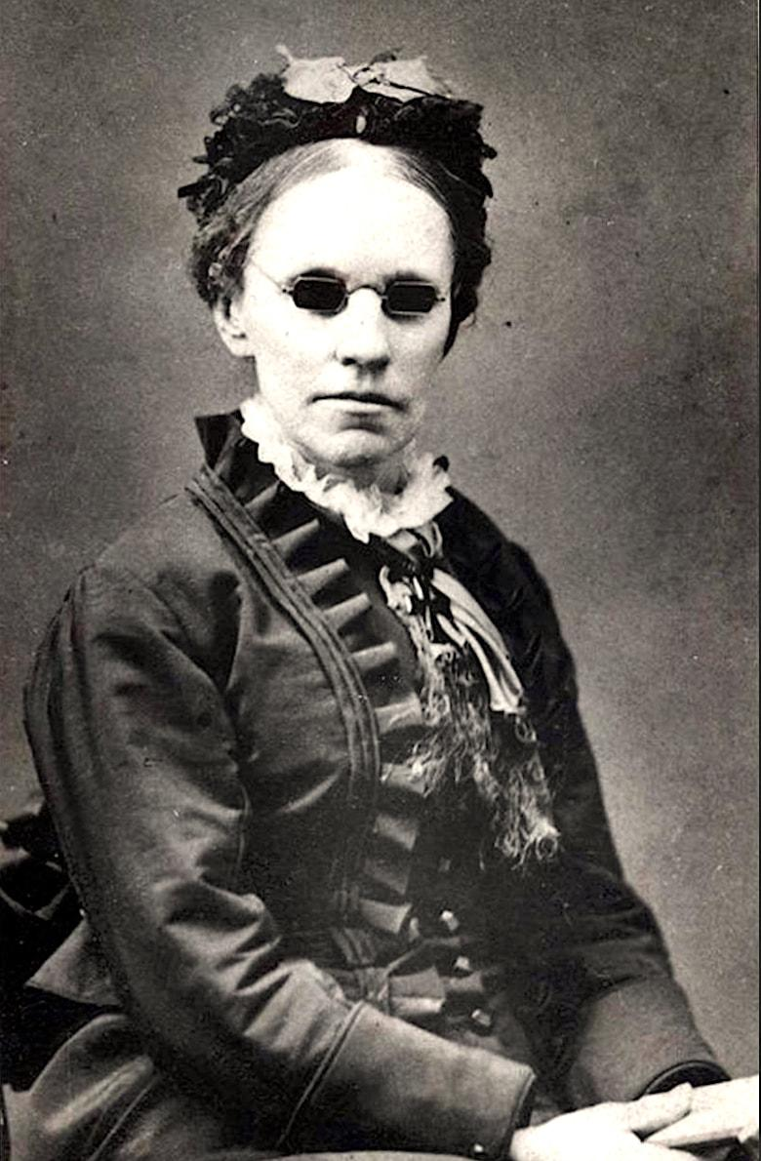
She was much more than just a hymn writer.

About Fanny
Blinded as an infant by an incompetent doctor, Fanny never pitied herself because of her condition. She attended, and later taught at, New York Institute for the Blind, where her gift for writing poetry came into full blossom. The first woman to address Congress, friend of Presidents, and one who deeply loved children, her 6,000 hymns such as "Blessed Assurance," "Rescue the Perishing," and "To God be the Glory," have inspired untold millions.

About the Program
The program is offered by History Come to Life. By addressing the audience as a historical personality, in period dress, History Come to Life's presenters engage the minds and imaginations of audiences in a way that draws them into the subject at hand, weaving a combination of facts and principles into a compelling narrative.

Details
Date
Time
Location
Find out more about History Come to Life by visiting our website at: historycometolife.com

