H.A.N.A

Board of Directors (2025-2027)

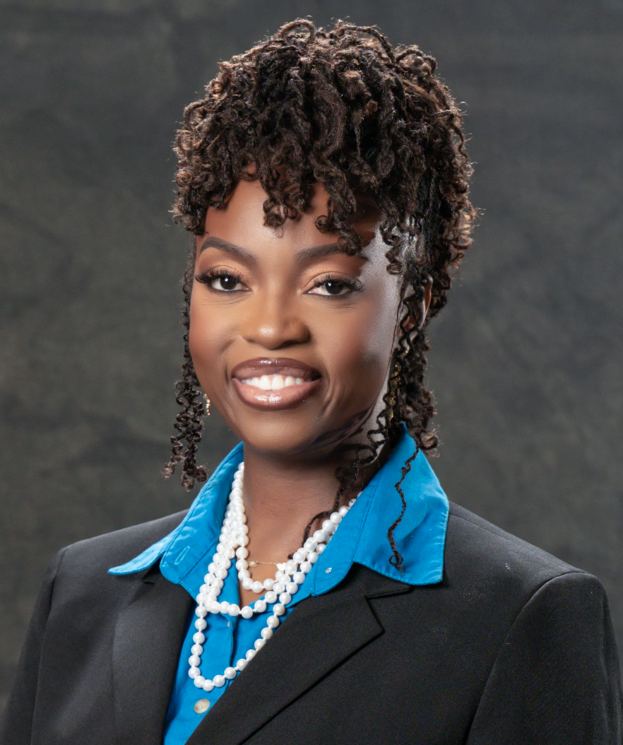
Myrnelle Fleur-Aime, MSN, AAPRN, FNP-C, PMHNP-BC
President


Caroline Saint-Fleur Elistin,
DNP, MBA, MSN-Ed, APRN, FNP-BC, PMHNP-BC
1st Vice-President

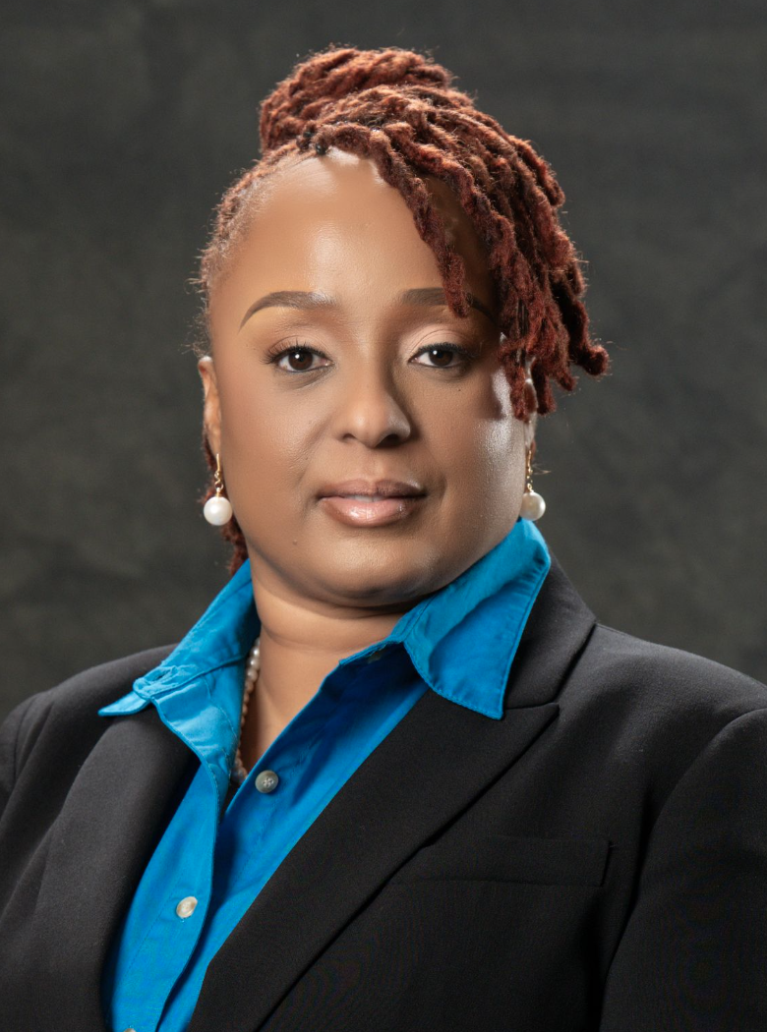
Guerline Verger-Coreus,
MBA, MSN, RN, RAC-CT
2nd Vice-President

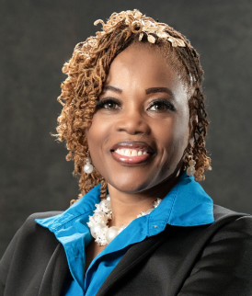
Josette Hylton,
MBA, MSN, APRN, PMHNP-BC, CLSSGB, CCMC
Treasurer


Angelique Antoine,
MSN, APRN, PMHNP-BC, CNL
Assistant Treasurer


Cindy Lespinase,
MSN, AGACNP-BC, CCRN
Secretary


Martine Gordon,
MSN-Ed, RN, CPN, LNC
Assistant Secretary
The Haitian American Nurses Association of Florida, Inc. (HANA) is pleased to announce its 42nd Annual Scholarship Fundraising and Awards Gala on April 25th, 2026. HANA’s Education Committee is currently accepting applications from students for the 2026 Nursing Scholarship Awards. Eligible students will receive a one-time scholarship, which will be awarded during the Fundraising gala.
Criteria for applicants are as follows:
1. The student must be of Haitian descent.
2. The student must be enrolled in an accredited Nursing program within the tri-county area (Miami Dade, Broward, & Palm Beach).
3. The student successfully completed one semester of core nursing courses
4. The student must have a minimum cumulative grade point average, (GPA)
of 3.0. An official transcript must be submitted with the scholarship application.
5. The student must submit a written APA format essay of at least one page, describing the reasons why he or she has selected Nursing as a profession. The essay must be received no later than March 15, 2026, by 11:59 pm (EST) by uploading it in the scholarship tab on HANA’s website.
6. An official transcript mailed to HANA’s P.O. Box 695069, Miami, Florida 33269, or an e-transcript sent to info@hanaofflorida.org by the institution.
7. The student must commit to volunteer a minimum of 20 hours of HANA organized activities by December 2026.
8. The student meeting the criteria will be professionally interviewed by HANA’s Education Committee and members to determine eligibility. Interviews will be held on Saturday, March 21st, 2026, before the HANA membership meeting.

The scholarship awards will be presented at formal HANA’s 42nd Annual Scholarship Fundraising and Awards Gala, which will be held on Saturday, April 25th, 2026, at Miami Marriot Biscayne Bay 1633 N Bayshore Drive, Miami, FL 33132

Myrnelle Fleur-Aime, MSN, AAPRN, FNP-C, PMHNP-BC
President, Haitian American Nurses Association of Florida, Inc.
2025 – 2027

