“ON THE ROAD AGAIN “ - IOWA CAMPING FRIENDS ANNUAL RV RALLY
JUNE 25-28, 2026 - AMANA, IA RV CAMPGROUND AND EVENT CENTER

We are no longer a Samboree, but an Iowa Camping Friends RV Rally. (Same folks, different name). All Campers are invited to attend, no membership required. Join us for Fun, Food, Entertainment. All full hookups. Early bird parking starts Monday, June 22, 2026, $37.00 per night. (Parking daily 8:00AM to 5:00PM). Arrive together to park together. Preregistration due by June 16, 2026. Registration includes hospitality daily, pancake breakfast, Sunday donuts, and entertainment nightly. Optional activities include silent auction, pastry walk, indoor & outdoor games, catered meal Sat, 50/50 drawings, as well as fund raisers by local chapters. Biscuits & gravy, hot dog lunch, and ice cream novelties.

Send registrations to Iowa camping Friends, Lorene Hynes Treas, 8538 Wildlife Ridge, Dubuque, IA. 52003 hynesjc@aol.com , 563 582-5573. Pre registration ends June 17, 2026.

Watch for Updates to this form on Iowagoodsam.com and Facebook Iowa Camping Friends
UPDATED 4-4-2026

On The Road Again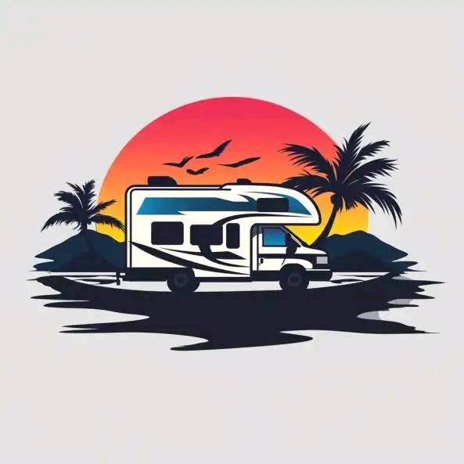June 25-28, 2026

Name_______________________________Address_________________________Email_____________
City_________________________State____ Zip__________ Phone#___________ Handicapped parking_______

Veteran_______ Branch of Service _________ Dates of Service__________War_______ Have you received a “Quilt of Valor”
Previously?_______

Pre Registered At Gate
1 Rig/2 Persons $105.00 $115.00
1Rig/1Person $100.00 $105.00
Extra Person in Rig $ 39.00 $ 59.00
Children 13-18 $ 10.00 $ 15.00
EARLY BIRD PARK $ 37.00 nite $ 37.00 nite

SATURDAY NIGHT CATERED MEAL (Amana Meat Market) $16.00 per person $_______
Craft Table $4.00 each $_______ Vendor Fee $10.00 (10x10 w/electric) $_________

Amount due & sent to Treasurer $________ Check #_____ (No confirmation sent)

The undersigned accepts full responsibility for the Welfare of their unit and persons with their unit while attending the Iowa Camping Friends RV Rally.
SIGNED___________________________Date_____________
Iowa Camping Friends RV Club Reserves the right to refuse admittance to and/or remove anyone from the RV Rally. Campers may not use the Iowa Camping Friends Rally Rate in Conjunction with any other discount or Special Rate. 11-13-2025

