WELCOME TO OUR RV RALLY AT AMANA

June 22-25. 2023

“MAKING NEW MEMEORIES”

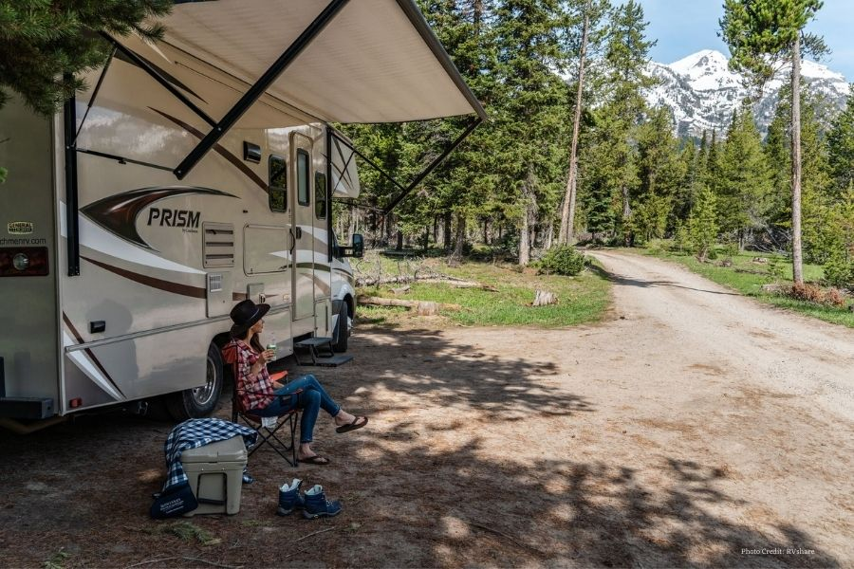

[This Photo](https://mommysnippets.com/category/reviews/travel/) by Unknown Author is licensed under [CC BY-NC-ND](https://creativecommons.org/licenses/by-nc-nd/3.0/)

IOWA CAMPING FRIENDS RV RALLY,

AMANA RV PARK

JUNE 22-25, 2023

OPEN TO PUBLIC - ALL ARE WELCOME

IOWA CAMPING FRIENDS

(Formerly Iowa Good Sam)

FOR MORE INFORMATION CALL: 515 681-3662 or 563 582-5573