**10 Ways to Help**

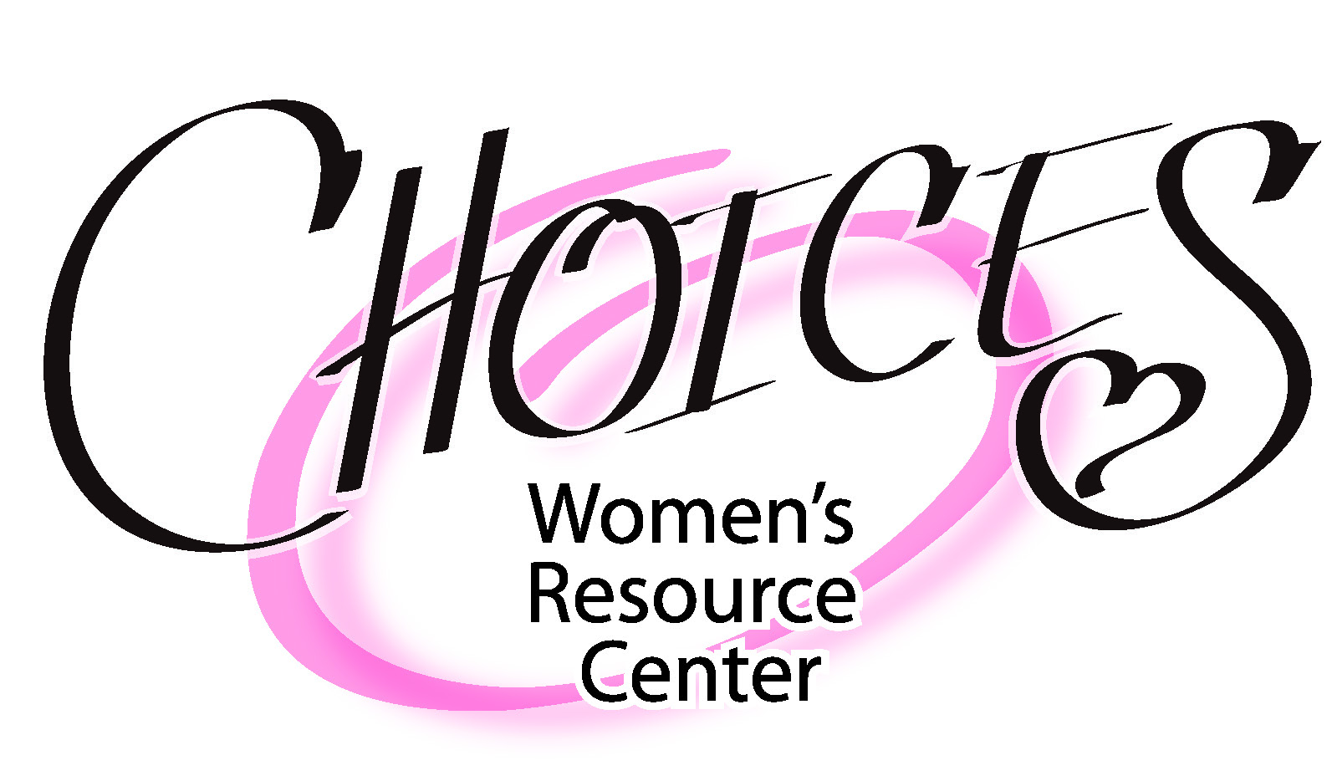 **at**

***“Speak up for those who cannot speak for themselves, for the rights of all who are destitute. Speak up and defend the rights of the needy”* ~Proverbs 31:8-9**

*There are many ways to get involved with CHOICES. Thank you for praying about serving with the CHOICES team! We are here to support a woman who finds she is facing an unexpected pregnancy.* We are here with compassion, resources and referrals to help her, each step of the way. We know that whatever her situation, God is able to make a way where there seems to be no way. *The Lord is faithful and loving to all he has made. (Psalm 145:13). His plans are good –to give a future and a hope. (Jeremiah 29:11) He gently leads those that have young. (Isaiah 40:11)The Bible says, “All who look to him are radiant, their faces are* *never covered with shame.”* (Psalm 84) *O LORD of Hosts, how blessed is the one who trusts in You!* (Psalm 84:12)

At *CHOICES*, we offer life-affirming options and education about her pregnancy choices in an effort to see her experience God’s abundant life. We also offer caring support to a woman who has experienced a past abortion. God is the *Healer* and *Restorer* of souls. *The Lord is****close to the brokenhearted****and* *saves those who are crushed in spirit.(Psalm 34:18)*

*CHOICES* is blessed to have churches who regularly support the mission of being a voice for the unborn. We are ever looking to strengthen these church partnerships and build relationships with new churches. *CHOICES’* mission is *Saving Lives, Restoring Hope and Sharing the**Love of Christ*! **We can only stay connected with women and men who need our services through the ongoing support of committed volunteers, faithful donors and purposeful prayer!**

1. **Church Ambassadorship**

A Church Liaison is the bridge between *CHOICES* and his or her church and brings awareness of *CHOICES’* life-saving work to their church community. Liaison means *connect* and *relationship*. This role is a vital *life* link:

* January “Sanctity of Human Life Month”-Have a table with *CHOICES’*  information (provided)
* Baby Bottle Campaign-hand out and receive baby bottle donations. This “offering” offsets ministry expenses
* Spring Tea and Fall Banquet-Get out flyers prior to these fundraising events
* Encourage church participation by inviting pastoral staff for a tour of Center and attending a spring or fall event

2) **Bible Study Leadership**- *CHOICES* offers a healing study to those who have experienced childhood sexual abuse and/or a past abortion. Current group facilitators will train and mentor new leaders and assistants. “Comfort with the comfort you have been given.” (2 Corinthians 1)

3) **Client Advocacy**- the role of the “C.A.” is to take the “L.O.V.E.” approach through listening and presenting clients with all of their pregnancy options, and casting a vision for life, all the while trusting in the LORD to guide the conversation with “meekness and respect.”

4) **Parenting Class Volunteer**- Come alongside a woman who has chosen to parent. Our Earn While You Learn Parenting classes help equip and prepare these young moms and dads for their precious little ones on the way.

5) **Nursing**- RN’s who will provide urine pregnancy tests to patients and educate on fetal development and abortion procedures and risks and facilitate ultrasounds. She will be under the supervision of the Nurse Manager. *I am fearfully and wonderfully made ~ Psalm 139*

6) **College Outreach**-This is a great opportunity to *speak the truth in love*! Dozens of students from local college campus pass the *CHOICES* College Outreach education table which brings awareness to *our* services and presents opportunity to converse about *life* issues. This team meets twice a month during the school year.

7) **Special Events Team**-This group will help the Events Coordinator for *CHOICES’* Spring Tea and Fall Banquet. Participation may include: planning; decorations; serving; helping with calls; coordination of table sponsors; set-up; clean up; flyers and more.

8) **Center Support**-This is helping out in the Center such as: counting baby bottle donations, prepping baby bottles for campaigns, various office tasks like answering phones and preparing mailings, organizing baby closet and office housekeeping. Regular volunteers can elect to help weekly or on an as needed basis.

9) **Handyman**- We have occasional need for things such as hanging a heavy picture or replacing ceiling lights and various other tasks to keep the Center functioning.

10) **Prayer Team-**We meet monthly at *CHOICES* on the last Thursday of the month. This is so vital and foundational to *everything* we do at *CHOICES* as we praise and ask for: God’s help, provision and guidance, decisions for life of the unborn, protection against spiritual forces of darkness, soul-winning, healing for Bible Study participants and building partnerships for *life*.

**Ways to Partner in Your Giving**

* Become a Monthly Donor-This is essential for the life-saving work by maintaining monthly operational expenses including rent
* Provide a One-Time donation for Critical Budget Relief
* Underwriting for Events-Support to expand community awareness
* Parenting Class Upgrades-Keeps program relevant with annual upgrades to Earn While You Learn Parenting Program
* Monthly Pro-Life Literature and “Precious Ones” handheld life-like babies (For fetal development education and outreach)
* Training for Medical and Center Staff –NIFLA’s Ultrasound training and Annual Heartbeat Conference
* Housekeeping and Medical Supplies-Cleaning supplies and medical resources
* Water bottles for clients and staff
* Software Maintenance- For repairs and updates
* Gift Cards- For Center Staff to purchase baby item rewards for parenting class participants

For more information on any of these areas or to become a monthly donor contact us at 909.444.2999

