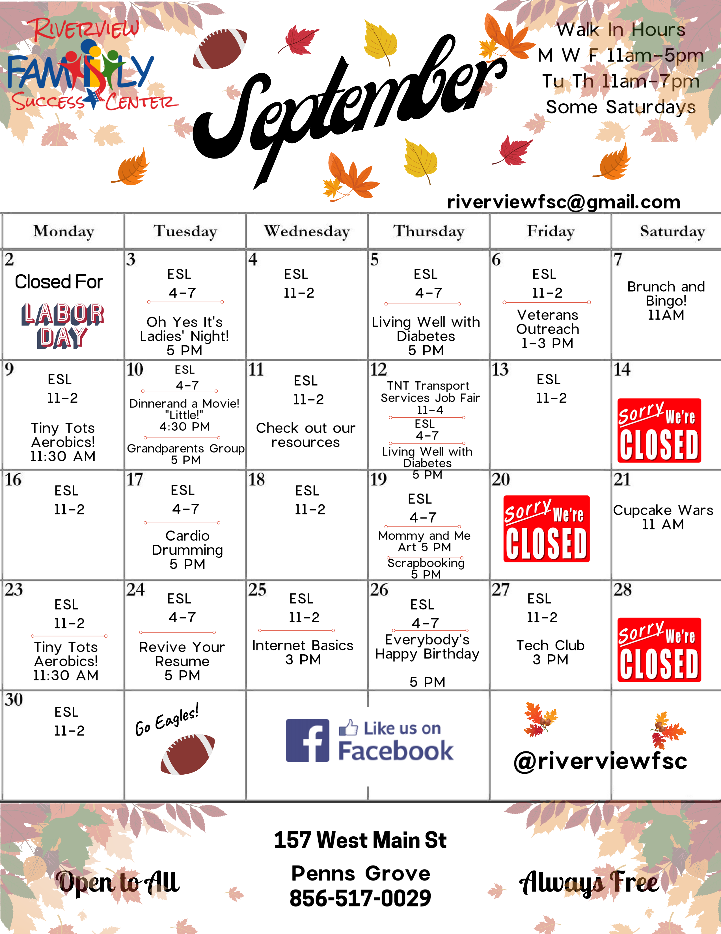
Center Highlights Family Fun

Oh Yes its Ladies Night!
Its therapeutic, its fun it's just a grand time with the Ladies! This month it's Breakfast for Dinner and a Movie!!
Living Well with Diabetes
We're partnering with the South Jersey Food
Bank to bring you this series on eating healthy with diabetes! Yes there will be cooking!

TNT Transport Services Job Fair
Pop Up One Day Only Job Fair!
Applications and interviews on site!
Dinner and a Movie: "Little"
Bring the whole family out for this hilarious movie and pizza!
Everybody's Happy Birthday!
If you are a September Baby, come on in for a celebration of YOU! And learn what in the world was going on the day you were born!

Classes

Brunch and Bingo
Come out and bring the family to a scrumptious brunch and Fun with Bingo! Tiny Tots Aerobics
Bring the tiny tots 1-6 years old! Movement and Fun, they will love it!
Mommy and Me and Art!
Create a memorable keepsake with your child! Refreshments will be served!
Let's Get Scrapbooking!
This is an awesome way to gather family photos, special writings and organize them for generations to come!
Cupcake Wars!
It's on and popping
with the best decorated cupcake!
Tech Support

Tech Club
Bring your Device and we learn to master it!
Internet Basics
Learn your way around the Internet!

ESL: English As A Second Language
English as a Second Language is offered through The Salem County Vo-Tech for beginner and intermediate level English learners.
Introduction to Spanish
Ever wanted to learn to speak Spanish?
This class will start you on the path to becoming bi-lingual!
Grandparents Group
Support and Encouragement can be found in this group
of grandparents raising relatives!
Veterans Outreach
Thank you for your service! Now there is support for you here!

