**“Progressive purity on crime is coming at the expense of public safety”**

**(September 25, 2023) Opinion by Brett Tolman, Opinion Contributor**•

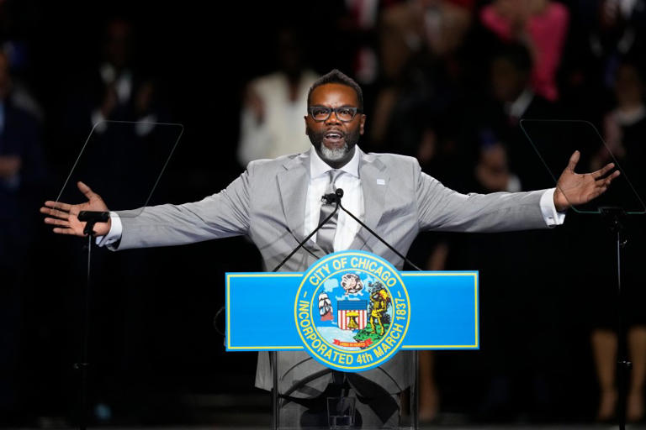

**Pictured: Brandon Johnson, Mayor of Chicago**

On just one Saturday night this month, three DePaul University students, all women, [were robbed](https://abc7chicago.com/chicago-robbery-depaul-university-crime-news/13759642/) within half an hour on the school’s Lincoln Park campus in Chicago. One of the women was hit in the face by her assailant.

Across town, numerous [armed robberies](https://abc7chicago.com/chicago-crime-robberies-bar-robbery-liquor-store/13766811/) and murders were taking place at the same time. In all, Chicago reported at least [22 people shot and five killed](https://abc7chicago.com/shootings-in-chicago-last-night-this-weekend-gun-violence/13762654/) over the weekend of Sept. 8.

Chicago Mayor Brandon Johnson has taken steps to address crime — to be specific, he has[sued auto manufacturers](https://www.foxnews.com/media/chicago-mayor-mocked-suing-automakers-car-thefts-criminals-run-rampant-kia-problem) for making catalytic converters too easy to steal.

That’ll teach those criminals!

Progressives like Johnson fail to understand that their policies are fueling the crime wave, not fighting it. The evidence is clear: Crime is deterred by increasing the odds of prosecution. Increasing penalties has relatively little effect on crime rates; it’s really all about whether police and prosecutors will do their jobs. That’s a legitimate question in areas where [police are defunded](https://www.axios.com/local/chicago/2023/03/17/chicago-election-brandon-johnson-defund-police) and [prosecutors are pursuing social justice instead of the rule of law.](https://heinonline.org/HOL/LandingPage?handle=hein.journals/branlaj58&div=25&id=&page=)

As the [Justice Department itself points out](https://nij.ojp.gov/topics/articles/five-things-about-deterrence), “It is the certainty of being caught that deters a person from committing crime, not the fear of being punished or the severity of the punishment. Effective policing that leads to swift and certain (but not necessarily severe) sanctions is a better deterrent than the threat of incarceration.”

What are the outcomes under liberal politicians such as Johnson, California Gov. Gavin Newsom (D) and others? Even their Democratic constituents have had enough.

In Oakland, for example, the NAACP — which is certainly not a Trumpy, MAGA organization — [has called out the city’s failed leadership](https://www.cnn.com/2023/08/08/us/oakland-crime-increase-naacp-residents/index.html) and policies that are hurting minority communities.

“African Americans are disproportionately hit the hardest by crime in East Oakland and other parts of the city,” a letter to the mayor from a Black pastor and other NAACP officials reads. “But residents from all parts of the city report that they do not feel safe.”

They added that such policies have created “a heyday for Oakland criminals.”

Oakland officials responded by trying to cancel the NAACP for not being woke enough.

“We are disappointed that a great African American pastor and a great African American organization would take a false narrative on such an important matter,” the Alameda County district attorney’s office [said in a statement](https://www.cbsnews.com/sanfrancisco/news/frustrated-oaklanders-confront-alameda-county-da-over-surge-crime/).

In other words — who are you going to believe, the armed robber standing in front of you or the progressive agenda?

Oakland residents, like other Californians, are fleeing what can more and more be described as a failed state.

“I’m not looking for the perfect safe place. I’m looking for a place where the elderly, and women with children aren’t targeted,” [Kristen Cook told CNN](https://www.cnn.com/2023/08/08/us/oakland-crime-increase-naacp-residents/index.html), as movers loaded up a truck with her family’s belongings. “Right? I think we can all agree that that needs to change.”

[Retailers are fleeing](https://www.newsweek.com/san-francisco-retail-exodus-old-navy-1803511), as well. A big factor is the fact that in California, only [a fraction of crimes are solved](https://www.ppic.org/blog/a-large-proportion-of-crime-goes-unsolved-in-california/).

But not every big city official is getting it wrong these days. In Dallas, Mayor Eric Johnson is targeting high-crime areas and working with — instead of against — his police department.

“DPD has been targeting violent street crime, specifically aggravated assaults (non-family violence), robberies and homicides,” [CBS News reports](https://www.cbsnews.com/texas/news/violent-crime-drops-further-second-year-dallas-police-department-violent-crime-reduction-plan/). “In its first year of the program, violent crime in the city’s targeted hot spot grids dropped by 11 percent from the months before the program.”

And police presence works. As the [Justice Department explains](https://nij.ojp.gov/topics/articles/five-things-about-deterrence), “A criminal’s behavior is more likely to be influenced by seeing a police officer with handcuffs and a radio than by a new law increasing penalties.”

We know what works to deter crime: Make prosecution and punishment a certainty. The progressive mindset, unfortunately, is making victims of criminals and criminals of victims. Hence the crime wave that is crashing upon our cities.

[Brett Tolman](https://rightoncrime.com/about/team/brett-tolman/) is executive director of [Right On Crime](https://rightoncrime.com/) and a former U.S. Attorney.

Retrieved September 25, 2023 from <https://www.msn.com/en-us/news/politics/progressive-purity-on-crime-is-coming-at-the-expense-of-public-safety/ar-AA1hdUFP?ocid=cf-launch> (Copied and ads removed for educational purposes only)