***NEW FAITH MINISTRIES NEWSLETTER***

***AUGUST 2024***

April: We ministered in Oklahoma and Texas where we encouraged the believers, helped in a funeral, and counseled. Preached in New Florence, MO, ministered to a dying hospice patient, organized team for upcoming mission trip.

May: Counselled over the phone with a man in the Dominican Republic, counseled a pastor in Mexico over WhatsApp, preached in a tent revival in Wellsville, MO, and Elsberry, MO.

June: Preached ordination service in Warrenton, MO, ordered thousands of Spanish tracts for upcoming mission trip, and organized flights and hotel for the trip. (A big thank you to Jolene McCoy, a great travel agent). Preached to a group of men around the US. over a Zoom Call.

July: Ministered in Mississippi, Alabama, Kansas, and Colorado, including the church we started in our home in 1976 -- Faith Fellowship of Hanston, Kansas. They are still a growing and vibrant church!

August: We took a group of 11 to do missions in Cancun, Mexico.

The Cancun church picked us up at the airport in this van that some of you helped buy.

The first thing we did was buy a 100 lb. sack of beans and sack of rice. We divided it up into smaller bags to take door to door along with Gospel tracts and evangelized in different neighborhoods.

We went 3 hours south of Cancun to a Mayan Indian village. This photo shows a church member cooking our breakfast over an open fire inside the pastor’s house.

This next photo is the outside of the house, walls made of sticks and roof is palm leaves.

And here is a photo of the owner and wife in front of the house.Their short stature is due to them being Mayan Indian.

After breakfast we walked around the village passing out beans and rice and gospel tracts and evangelizing. The photo below shows Elaine and me and some of the team praying over a lady to receive Christ. A group of people standing outside

We gathered most of the children in the village to a Vacation Bible school which included a puppet show, songs, games, refreshments and a Bible story. We used a watermelon as an object story to explain the gospel. The black seeds represent sin, but sin can’t go into Heaven, so we need our sins washed away. The red part of the melon represents Jesus’ blood that cleanses us when we ask for it. The white rind represents the clean heart. The green represents our growing in our new life in Christ. The melon blossom which is gold represents the streets in Heaven.

After Bible school we gathered at the church building (hut) in the village for a worship service and Roger preached. We went outside for a baptism service. When we were here a year ago a villager named Roberto received Jesus. This time he wanted to be baptized. In this photo he only has 1 leg. So, it took 2 of us to baptize him. We also baptized one other person.

The next day, Sunday, we were in Cancun at the mother church. Roger preached while the ladies did Children’s Church. At the end of the service Roger baptized 4 people including this young man in the photo who is a professional football player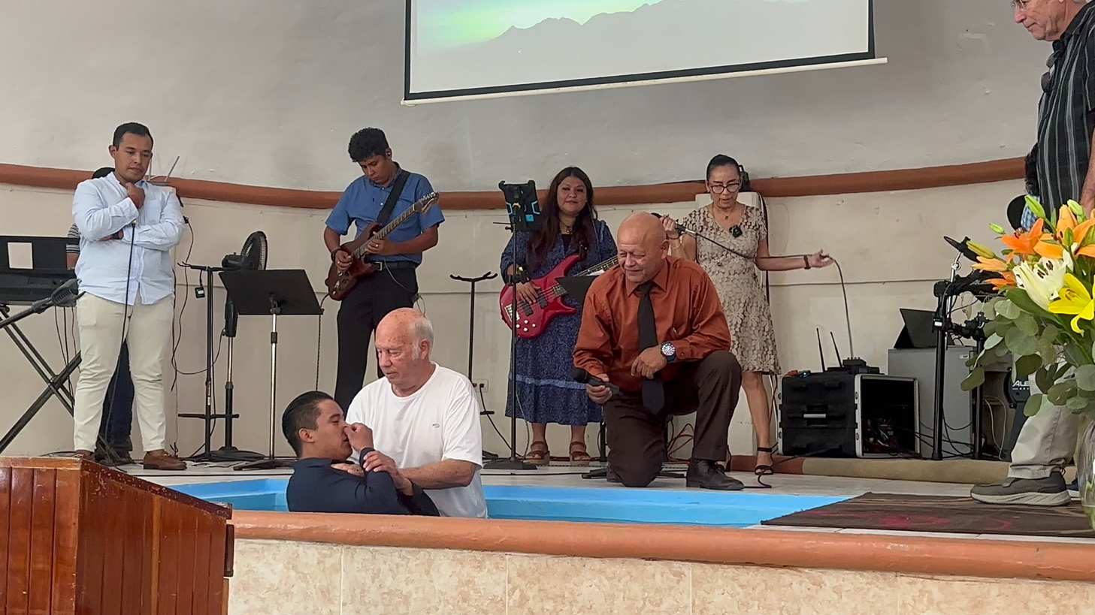. Holding the mic is Carlos, pastor of Antioquia Baptist Church. (which we helped build after it was hit by a hurricane in 1988).

After this the ladies went to another room where Elaine had laid out jewelry which many of you donated.

This is just another way to bless them. This jewelry ministry all started after my sister, Joyce, died and her husband gave me her costume jewelry to be used in the ministry.

The next day, Monday, we went to a mission church in town to repair their roof that had been damaged by a recent hurricane. While part of the team did construction the rest of us went door to door passing out beans anA person on a ladder
d rice and tracts, and evangelizing.

On Tuesday we went to the open-air plaza downtown Cancun and went from person to person giving them a gospel tract and telling them how they could have a personal relationship with Jesus. They all gladly received the tracts and listened attentively with the exception of 1 person. This photo shows a man praying asking Jesus into his heart.

By the end of the week of the Cancun mission trip, we saw about 60 people get saved!

We are presently trying to finalize a date for a mission trip to Puerto Penasco, Mexico soon.

We are also trying to make preparations to start a Hispanic ministry here in a nearby town. A new meat packing plant is being built which will hire about 1500 new employees, many of whom speak Spanish.

We give God praise for all His blessings that you have just been reading about. Thank you for your part in this with your prayers and financial gifts. Because you give, we can go. Because you pray the Kingdom of God advances.

In Jesus Name,

Roger and Elaine Alford

126 Lamplighter Way, O’Fallon, MO 63368

[www.newfaithministries.net](http://www.newfaithministries.net)

[rgralford@yahoo.com](mailto:rgralford@yahoo.com)

620-285-1102