
NEW FAITH MINISTRIES NEWSLETTER August 2025
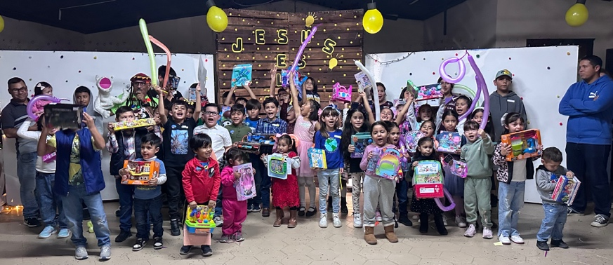
Our team (Ron and Deb Hane from here, Angel and Chary from Tijuana, MX) went to Puerto Peñasco, Mexico. We prepared meals for the needy. We asked what kind of meat was in the soup because it tasted like chicken, it was stingray their cheapest meat that they get from the ocean. We took some of it to feed people who live at the dump. Several received Christ.

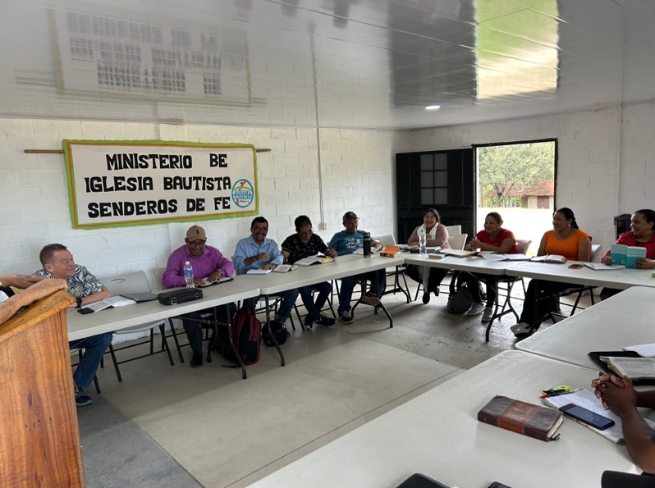
We had an event for the children of the town. We gave them all a Christmas gift funded by people from our church. Many kids were saved. We also taught a Marriage Conference. Elaine also took jewelry and shared with the ladies after the church service to show them how special they are. Next was a ministry tour to TX where Roger preached in a Cowboy Church. We continued South to the TX -MX border and ministered there.
Roger went to Honduras with Pastors Glenn Sparks and Dave Martin to teach 2 pastors’ conferences, one on each side of the mountain range. This snake came into our classroom reminds me that the devil likes to sneak into our lives.
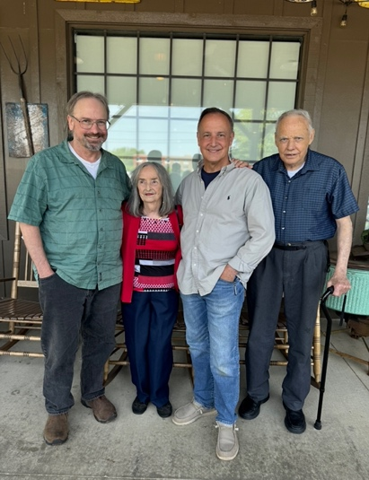
We went with Tom and Chrissy Hudson to Birmingham, AL to meet with church leaders to discuss coming there for future revival meetings, one in English and one in Spanish. Pray for this project.
Then on to the Southeastern part of our country on a ministry tour. Roger preached in the home of Donnie Porter in NC. Among those attending was Donnie’s dad Don, who taught Roger how to walk in the Spirit years ago when he was in the Army. In the picture is Don, wife Judith and their 2 sons, Donnie and Derek. Roger preached near Chattanooga TN in the church of his old college roommate Mickey Whiting. We went to Amarillo, TX to preach a revival in the church of our pastor friend, Ron Boyer.
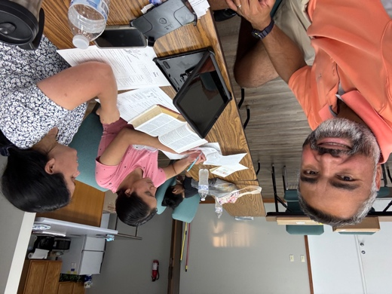
In June we contacted our friend, Jair who had moved to the US a few years ago from Venezuela to be a missionary to America. When we heard about a new meat packing plant being built in a nearby town that was hiring 1500 employees, many of whom are Hispanic. We realized that there was no church in the area who spoke Spanish. He came and stayed with us through the month of June. We visited the Hispanics in their homes, Mexican restaurants, and laundromats. He led 30 to faith in Christ and started 3 home Bible studies. He found a house to rent and went back to NC to gather his family and possessions to move here. Since then, he has won 20 more to Christ and has started Spanish church services on Sundays. It has been a blessing to work side by side with him and getting this new church going. Keep this in your prayers as we continue to reach more Hispanics. The picture is of Jair and wife Nohelia discipling their new convert.
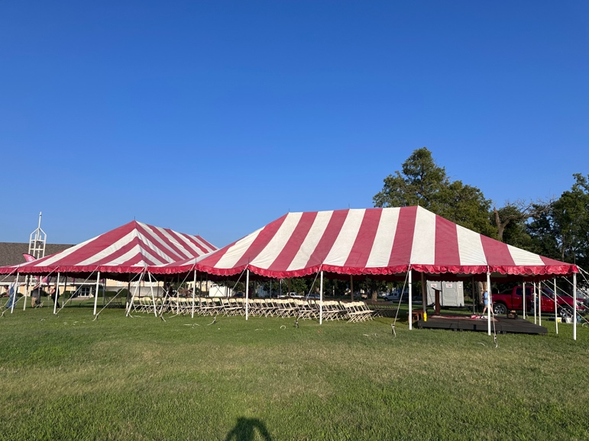
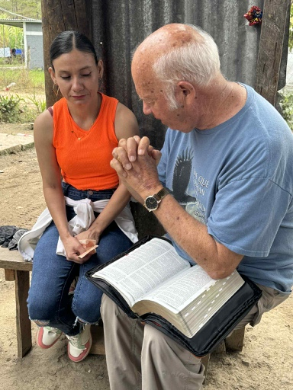
Also in June, we went back to Honduras. When we heard that our missionary contact there, Kelly Lawrence, had unexpectedly died of a heart attack at age 60. He had won several souls to Christ and started a church. He also founded one of the pastors’ conferences where we teach every year. We went to preach to that young church to be encouraged in their time of loss and challenged them to keep the work going. Elaine had a first this trip. (She has been on many mission trips). Trisha, Kelly’s wife, asked her to do a task that she hadn’t been able to get to. Of course, Elaine said she would. Trisha asked her to put a plastic tarp on the many gallons of paint that was in this storage room to keep the BAT POO off the paint cans. When we opened the door, bats were flying all around! She asked Trisha if there was another place they could take the paint? There was!! Elaine didn’t dare to look up and transported all the paint to another place. Elaine also took jewelry to share with the ladies at the church. Trisha took us to visit in the home of one of the church members. There was a lady, Yesica, visiting them. Roger felt impressed to witness to her. As he started, Trisha informed him Yesica was mute and could not speak. Roger has been in ministry for 50 years and never witnessed to a mute. He silently prayed, “Lord how am I supposed to witness to this lady if she can’t talk? How will I know if she is understanding me?” The Lord replied, “Just share God’s plan of salvation with her. I’ll handle the rest.” Roger would read a verse of Scripture and asked her to nod if she understood. Yesica nodded her head after each Scripture, until Revelation 3:20, where Jesus said, “Behold I stand at the door and knock; if any man hear my voice and open the door, I will come into Him.” She nodded her head that she did not understand. Roger thought,” Oh great, now what do I do?” the Lord impressed him to give a demonstration. So, he stepped outside the door (actually just an opening) of the room they were in. He knocked on the wall, and Trisha invited him to come into the house. Roger asked, “Do you see what just happened? I didn’t enter until Trisha invited me in. Jesus is waiting to come into your heart. Do you want to invite Him in?” She nodded yes. He explained that she needed to pray and ask Him in; and that she didn’t have to pray out loud, for God could read her mind. So, he bowed his head for a couple of minutes and then asked her if she had prayed. She nodded yes with a big smile on her face. We invited her to church the next morning, and she came! Nothing is impossible with God!
In August, Roger preached in a tent revival in McPherson KS. Even in 100 degrees heat, the warmth of the Holy Spirit was even greater! Several received prayer for various reasons: assurance of salvation, physical and emotional healing, to find God’s guidance, to be renewed, refreshed, and revived in their spiritual life. Well, as you have read, you can see that our God is still in the soul saving, life changing business around the world. We are just grateful that we still have the health to go around sharing His Word. And wherever we go, you also go -through your prayers and support. The Christian army is the only army that advances on its knees! All praise goes to Jesus, our Commander in Chief!

In Jesus Name,
Roger and Elaine Alford

