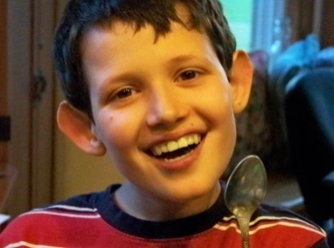9th Annual Alex Labbe Mini Golf Open

Alex was born with Hypo-plastic Left Heart Syndrome, (HLHS). He endured 5 open heart surgeries and 3 strokes in his short 13 years. Even with all his challenges he always had a smile and never felt different. Mini Golf was one of his favorite things to do. Not able to use a putter, he could roll the ball like a pro. He was very competitive and of course always won.

In the summer Alex attended the Brunswick Rec Department summer camp. He loved being with the other kids and the staff were very supportive of his disabilities. We are excited to bring this experience to other kids. With your help we can send kids to camp again this year, and also assist with the care of families, by supporting Ronald McDonald House Charities, all while having a great day playing mini golf.

When: June 23, 2023

Where: 4 Highland Road Brunswick Maine 04011 (Ray Labbe and Sons Office)

Time: Registration 10-10:30 Shot gun start 11:00am

Cost: $10.00 a person (up to 5 on a team) Cash or Checks made out to the Alex Labbe Foundation

Lots of PRIZES!!!! Please sign up early

Name____________________________________ phone #_________________

Name_____________________________________ phone#__________________

Name_____________________________________ phone #_________________

Name_____________________________________ phone#__________________

Name_____________________________________ phone#__________________

Mail to: Peter & Judy Labbe, 33 Patriot drive, Brunswick 725-5380, 522-1297(J), 522-1072(P) or

E-mail: [jap3l@yahoo.com](mailto:jap3l@yahoo.com) website alexlabbefoundation.life

Mary & Dick Lancaster, 68 Columbia Ave, Brunswick 798-1529 or

Email: [lanc4@comcast.net](mailto:lanc4@comcast.net)

Bowdoin Aggregate sales PO Box 308, Brunswick 666-8497 or

Email: peter@basales.rocks

A free hot dog lunch will be served. Please call with questions.

Thank you!