Accessory Zoning Permit Application
(For Sheds, Garages, Decks, Pools, Etc)
Address Of Project:
Type of Structure/Use: Shed Garage Deck Pool Other –
Applicant/Contractor Name:
Address:
Phone: Email:

Property Owner Name:
Address:
Phone: Email:

Sq. Ft. of Proposed Project: Height/Stories of Project:
Distance from Rear Property Line: Distance from side Property Line:
Distance from Principal Structure:
Number of Accessory Buildings on Site: Total Project Area (sq. ft):
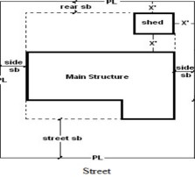By signing this application, I acknowledge I am authorized by the owner to make this application. The information presented is accurate. I agree to allow the Village of Fletcher Planning/Zoning Committee members to enter the property in order to complete necessary site walkouts. I agree to conform to all applicable ordinances of the Village of Fletcher.
Each Application must have a site plan showing the location of the project, or picture indicating accurate relevant dimensions. All Permits are issued to the applicant, unless otherwise specified. Please contact the Miami County Building Dept (937-440-8121) for additional permits required. *Processing Time: 7-10 Business Days
Signature: Date:
Site Plan with Setbacks: Yes/No Signed Application: Yes/No Fee: $25

